# PRACTICAL REPORT

## On Data Science

## &

**Soft Computing Techniques**

Submitted in fulfilment of the Requirement for the Award of the Degree of

## M.Sc. (Information Technology) - SEM I

### By

**NAME : SHRADDHA BANDHU GHORAD**

**SEAT NO : 1310654**



**Department Of Information Technology**

**Janseva shikshan Mandal’s**

**SHANTARAMBHAU GHOLAP ARTS ,SCIENCE AND**

**GOTIRAMBHAU PAWAR COMMERCE COLLEGE**

***(Affiliated to University of Mumbai)***

**SHIVALE**

**2023-2024**

# PRACTICAL REPORT

## On Data Science

Submitted in fulfilment of the Requirement for the Award of the Degree of

## M.Sc. (Information Technology) - SEM I

### By

**NAME: SHRADDHA BANDHU GHORAD**

**SEAT NO: 1310654**



**Department Of Information Technology**

**THE J.S.M. COLLEGE OF HIGHER EDUCATION**

***(Affiliated to University of Mumbai)***

**SHIVALE**

**2023– 2024**

**Janseva shikshan Mandal’s**

**SHANTARAMBHAU GHOLAP ARTS ,SCIENCE AND**

**GOTIRAMBHAU PAWAR COMMERCE COLLEGE**

**SHIVLE**

***(Affiliated to University of Mumbai)***

**DEPARTMENT OF INFORMATION TECHNOLOGY/**

**COMPUTER SCIENCE**



**NAAC Re Accredited with “B” Grade**

**CERTIFICATE**

**2023-24**

This is to certify that the practical journal of the

Subject DATA SCIENCE is bonafied work of Name of student SHRADDHA

BANDHU GHORAD bearing Seat number **1310654** submitted in partial

fulfillment of the requirements for the award of degree of **Masters in**

**Information Technology** from University of Mumbai in year 2023-24.

**Subject Teacher Coordinator**

**(HOD)**

**External Examiner**

**College Seal**

|  |  |  |  |
| --- | --- | --- | --- |
|  | **INDEX** | | |
|  | **Sr.No** | **Practical** | **Sign** |
|  | **1** | Creating Data Model using Cassandra. |  |
|  | **2** | Conversion from different formats to HOURS format.   1. Text delimited csv format. 2. XML. 3. JSON. 4. MySQL Database. 5. Video. 6. Picture (JPEG) to HORUS format 7. Audio. |  |
|  | **3** | Utilities and Auditing.   1. Fixers Utilities. 2. Data Binning or Bucketing. 3. Logging. **D.**Averaging of data. **E.**Outlier Detection |  |
|  | **4** | Retrieving Data.   1. Loading IP DATA ALL. 2. Program to retrieve different attributes of data. 3. Mysql. 4. Excel. |  |
|  | **5** | Assessing Data.   1. Missing Values in Pandas.    1. Drop the Columns Where All Elements Are Missing Values.    2. Keep Only the Rows That Contain a Maximum of Two Missing Values.    3. Fill All Missing Values with the Mean, Median, Mode, Minimum, and Maximum of the Particular Numeric Column.    4. Write a Python/R program to build directed acyclic graph. 2. Write python/R program to create the network routing diagram from the given data on routers 3. Write a python/R program to build acyclic graph |  |
|  |  | | |

|  |  |  |  |
| --- | --- | --- | --- |
|  |  | | |
|  |  | 1. Write python/R program to pick the content for BillBoards from the given data 2. Write a python/R program to generate GML file from given csv file 3. Write python/R program to plan location of warehouse from the given data 4. Write python/R program using data science via clustering to determine new warehouse using the given data 5. Using the given data Write python/R program to plan the shipping routers from best-fit international logistics 6. Write python/R program to delete the best packing option to ship in container from the given data 7. Write python program to create delivery route using the given data 8. Write python program to crate simple forex trading planner from the given data 9. Write python program to process the balance sheet to ensure the only good data is processing 10. Write python program to generate payroll from the given data |  |
|  | **6** | Build the time hub, links and satellites |  |
|  | **7** | Transforming data |  |
|  | **8** | Organizing data |  |
|  | **9** | Generating data |  |
|  | **10** | Data visualisation using power Bi |  |
|  |  | | |

**Practical:1 Creating Data Model using Cassandra.**

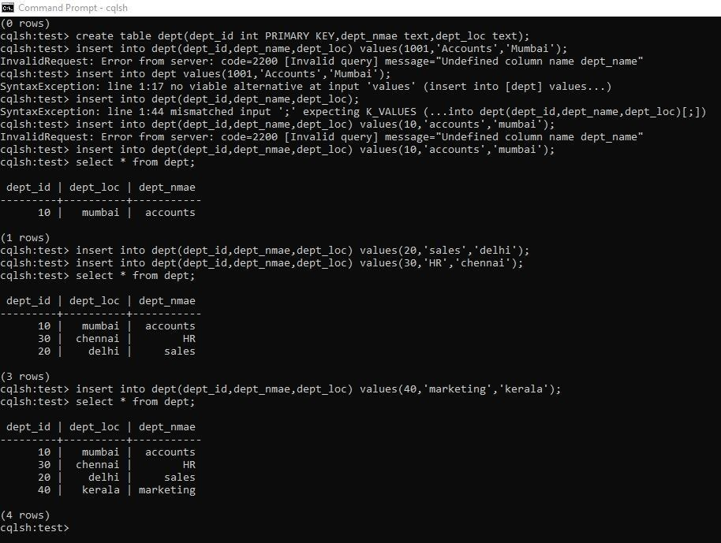

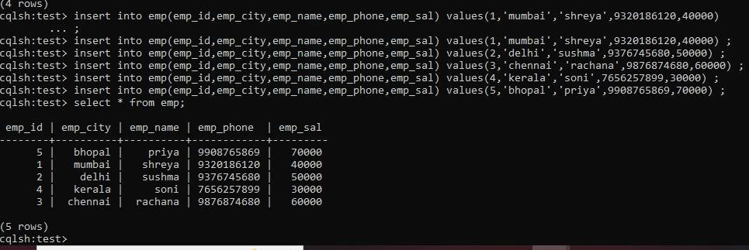

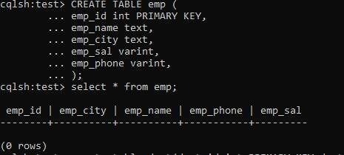

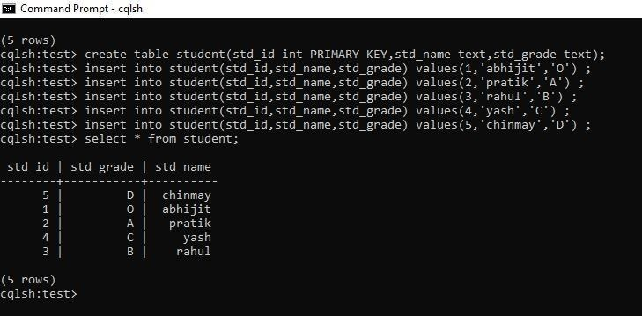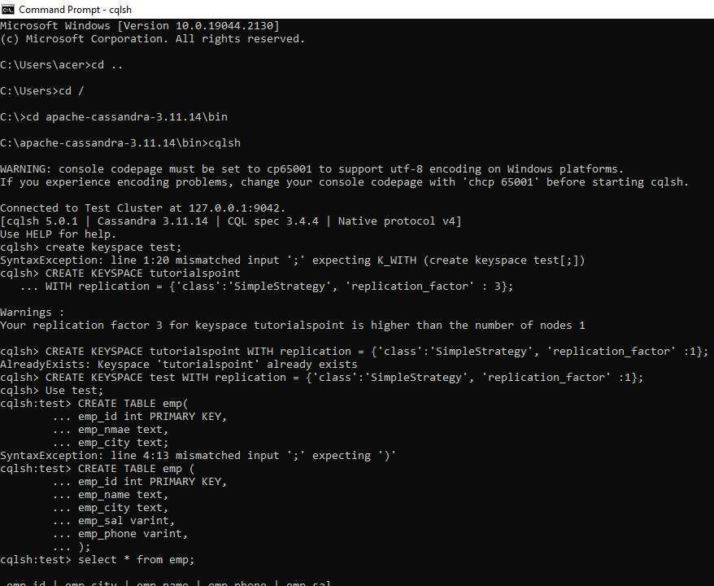

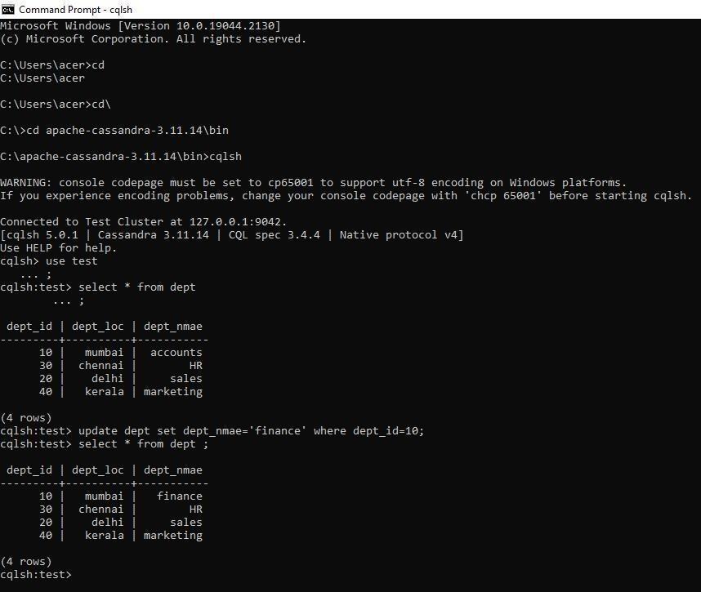

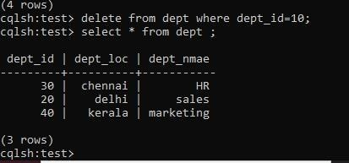

**Practical:2 Conversion from different formats to HOURS format.**

1. **Text delimited csv format. Code:**

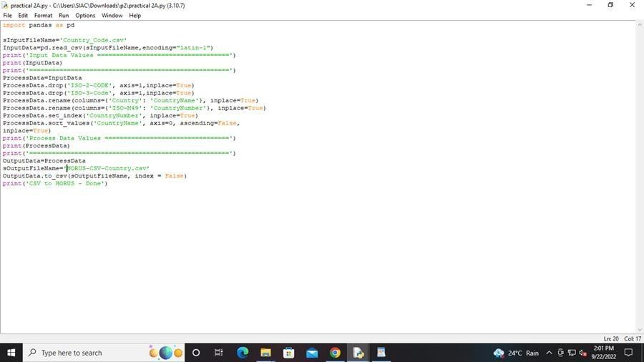

**Output:**

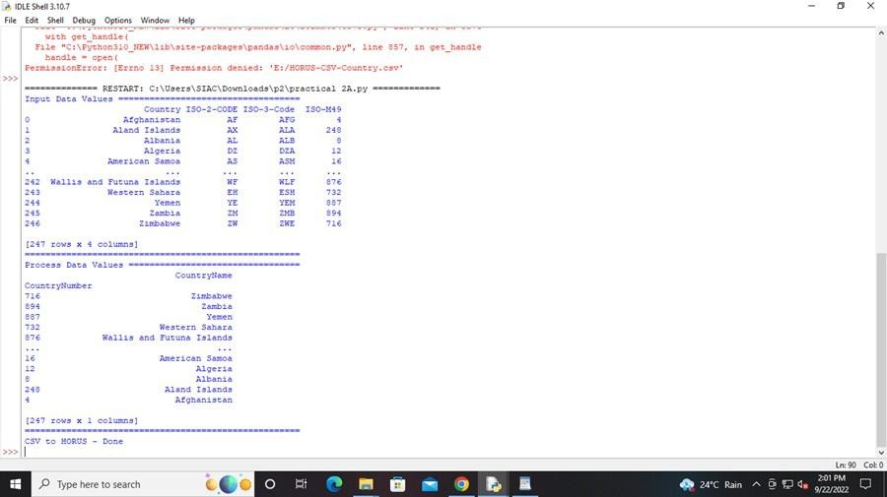

1. **XML. Code:**

# Utility Start XML to HORUS # Standard Tools

import pandas as pd

import xml.etree.ElementTree as ET def df2xml(data):

header = data.columns root = ET.Element('root')

for row in range(data.shape[0]):

entry = ET.SubElement(root,'entry') for index in range(data.shape[1]):

schild=str(header[index])

child = ET.SubElement(entry, schild) if str(data[schild][row]) != 'nan':

child.text = str(data[schild][row]) else:

child.text = 'n/a' entry.append(child)

result = ET.tostring(root) return result

def xml2df(xml_data):

root = ET.XML(xml_data) all_records = []

for i, child in enumerate(root): record = {}

for subchild in child: record[subchild.tag] = subchild.text

all_records.append(record)

return pd.DataFrame(all_records) # Input Agreement

sInputFileName='E:/Softwares_2021-22/MSCIT-II/practical-data-science-master/practical- data-science-master/VKHCG/05-DS/9999-Data/Country_Code.xml'

InputData = open(sInputFileName).read() print('=====================================================') print('Input Data Values ===================================') print('=====================================================')

print(InputData) print('=====================================================')

# Processing Rules ProcessDataXML=InputData # XML to Data Frame

ProcessData=xml2df(ProcessDataXML)

# Remove columns ISO-2-Code and ISO-3-CODE ProcessData.drop('ISO-2-CODE', axis=1,inplace=True) ProcessData.drop('ISO-3-Code', axis=1,inplace=True) # Rename Country and ISO-M49

ProcessData.rename(columns={'Country': 'CountryName'}, inplace=True) ProcessData.rename(columns={'ISO-M49': 'CountryNumber'}, inplace=True) # Set new Index

ProcessData.set_index('CountryNumber', inplace=True) # Sort data by CurrencyNumber

ProcessData.sort_values('CountryName', axis=0, ascending=False, inplace=True)

print('=====================================================')

print('Process Data Values =================================') print('=====================================================')

print(ProcessData) print('=====================================================')

# Output Agreement OutputData=ProcessData

sOutputFileName='E:/HORUS-XML-Country.csv' OutputData.to_csv(sOutputFileName, index = False) print('=====================================================')

print('XML to HORUS - Done') print('=====================================================')

# Utility done

**Output:**

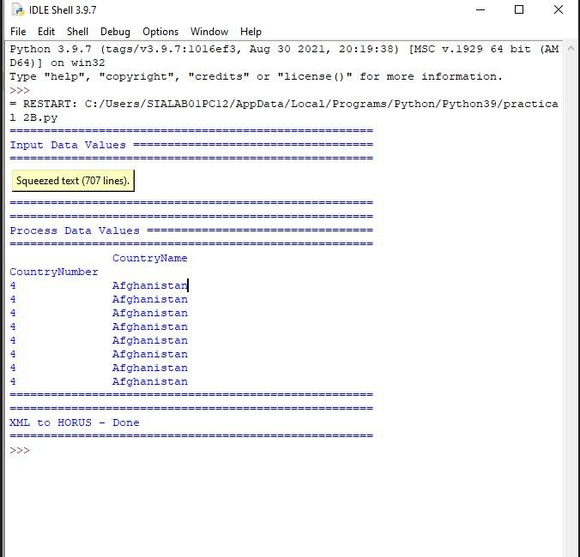

1. **JSON. Code:**

import pandas as pd sInputFileName='C:/Users/SIALAB01PC12/Downloads/Country_Code.json' InputData=pd.read_json(sInputFileName,

orient='index', encoding="latin-1")

print('Input Data Values ===================================')

print(InputData) print('=====================================================')

ProcessData=InputData

ProcessData.drop('ISO-2-CODE', axis=1,inplace=True) ProcessData.drop('ISO-3-Code', axis=1,inplace=True) ProcessData.rename(columns={'Country': 'CountryName'}, inplace=True) ProcessData.rename(columns={'ISO-M49': 'CountryNumber'}, inplace=True) ProcessData.set_index('CountryNumber', inplace=True) ProcessData.sort_values('CountryName', axis=0, ascending=False, inplace=True)

print('Process Data Values =================================') print(ProcessData) print('=====================================================')

OutputData=ProcessData

sOutputFileName='E:\M21005\DS\Practical 2\HORUS-JSON-Country.csv' OutputData.to_csv(sOutputFileName, index = False)

print('JSON to HORUS - Done')

**Output:**

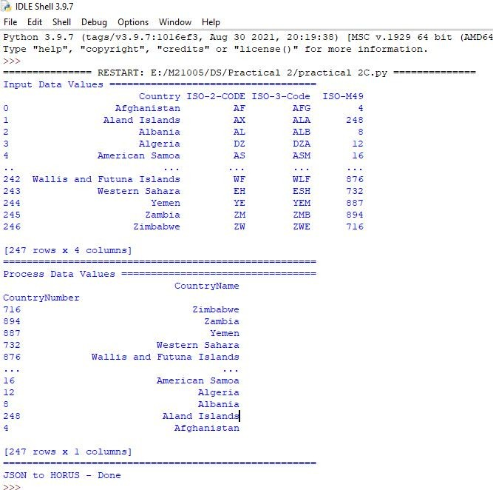

1. **MySQL Database. Code:**

# Utility Start Database to HORUS # Standard Tools

import pandas as pd import sqlite3 as sq # Input Agreement

sInputFileName='C:/Users/SIALAB01PC12/Downloads/utility.db' sInputTable='Country_Code'

conn = sq.connect(sInputFileName) sSQL='select * FROM ' + sInputTable + ';' InputData=pd.read_sql_query(sSQL, conn)

print('Input Data Values ===================================')

print(InputData) print('=====================================================')

# Processing Rules ProcessData=InputData

# Remove columns ISO-2-Code and ISO-3-CODE ProcessData.drop('ISO-2-CODE', axis=1,inplace=True) ProcessData.drop('ISO-3-Code', axis=1,inplace=True) # Rename Country and ISO-M49

ProcessData.rename(columns={'Country': 'CountryName'}, inplace=True) ProcessData.rename(columns={'ISO-M49': 'CountryNumber'}, inplace=True) # Set new Index

ProcessData.set_index('CountryNumber', inplace=True) # Sort data by CurrencyNumber

ProcessData.sort_values('CountryName', axis=0, ascending=False, inplace=True) print('Process Data Values =================================') print(ProcessData)

print('=====================================================')

# Output Agreement OutputData=ProcessData

sOutputFileName='E:/M21005/DS/Practical 2/HORUS-CSV-Country.csv' OutputData.to_csv(sOutputFileName, index = False)

print('Database to HORUS - Done')

**Output:**

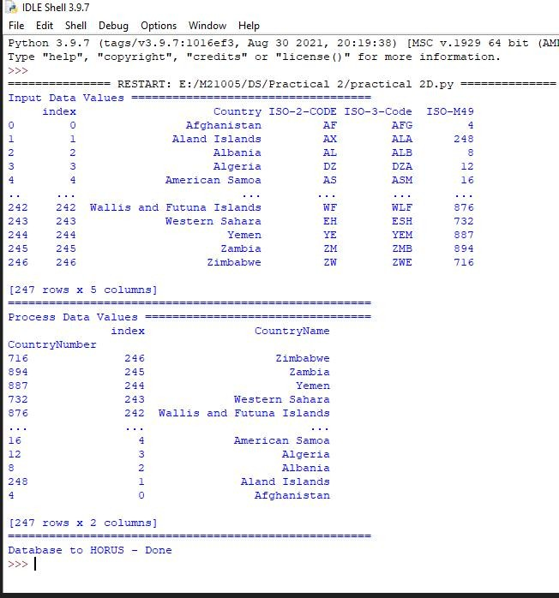

1. **Video. Code:**

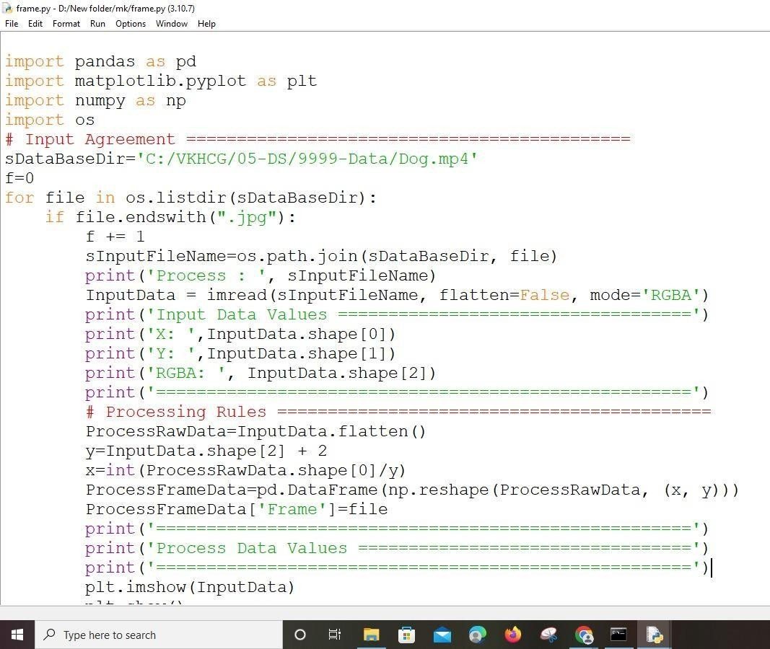

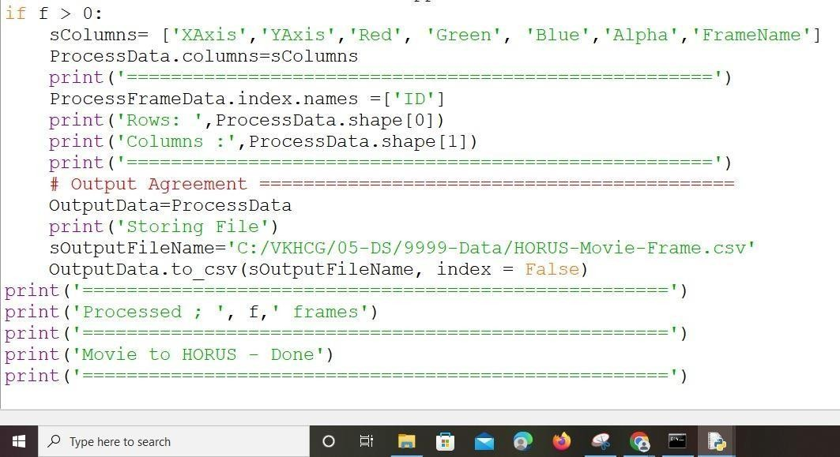

**Output:**

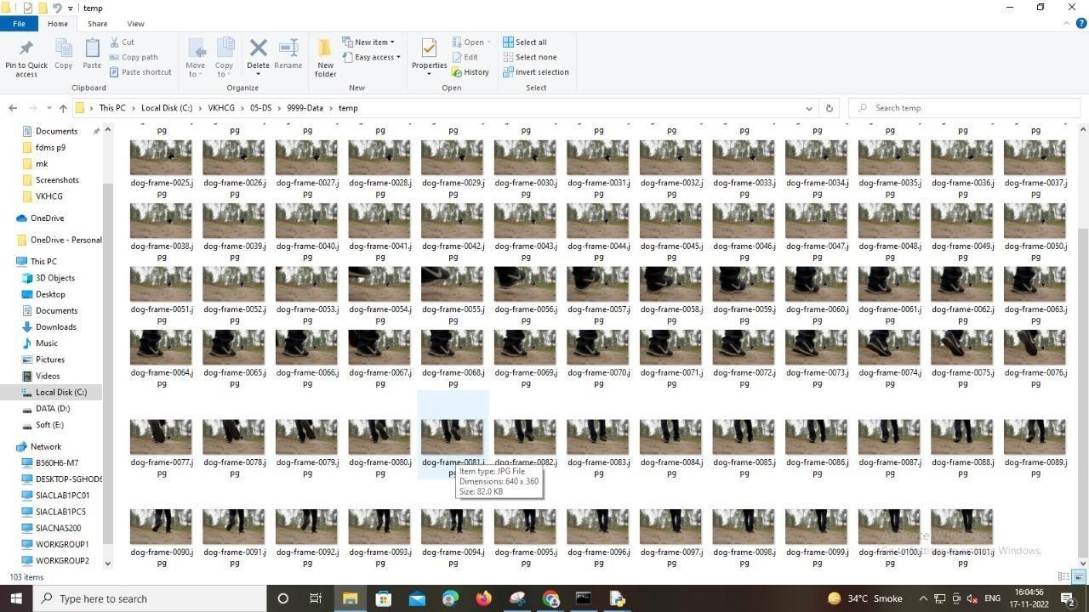

1. **Picture (JPEG) to HORUS format**

# Utility Start Picture to HORUS ================================= # Standard Tools

#============================================================= from

scipy.misc import imread

import pandas as pd

import matplotlib.pyplot as plt import numpy as np

# Input Agreement ============================================

sInputFileName='C:/VKHCG/05-DS/9999-Data/Angus.jpg'

InputData = imread(sInputFileName, flatten=False, mode='RGBA') print('Input Data Values ===================================')

print('X: ',InputData.shape[0])

print('Y: ',InputData.shape[1]) print('RGBA: ', InputData.shape[2])

print('=====================================================')

# Processing Rules ===========================================

ProcessRawData=InputData.flatten() y=InputData.shape[2] + 2 x=int(ProcessRawData.shape[0]/y)

ProcessData=pd.DataFrame(np.reshape(ProcessRawData, (x, y))) sColumns= ['XAxis','YAxis','Red', 'Green', 'Blue','Alpha']

ProcessData.columns=sColumns ProcessData.index.names =['ID'] print('Rows: ',ProcessData.shape[0]) print('Columns :',ProcessData.shape[1]) print('=====================================================')

print('Process Data Values =================================') print('=====================================================')

plt.imshow(InputData) plt.show() print('=====================================================')

# Output Agreement ===========================================

OutputData=ProcessData print('Storing File') sOutputFileName='C:/VKHCG/05-DS/9999- Data/HORUS-Picture.csv' OutputData.to_csv(sOutputFileName, index = False) print('=====================================================')

print('Picture to HORUS - Done') print('====================================================='

**OUTPUT:**

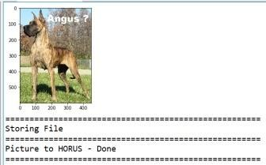

1. **Audio. Code:**

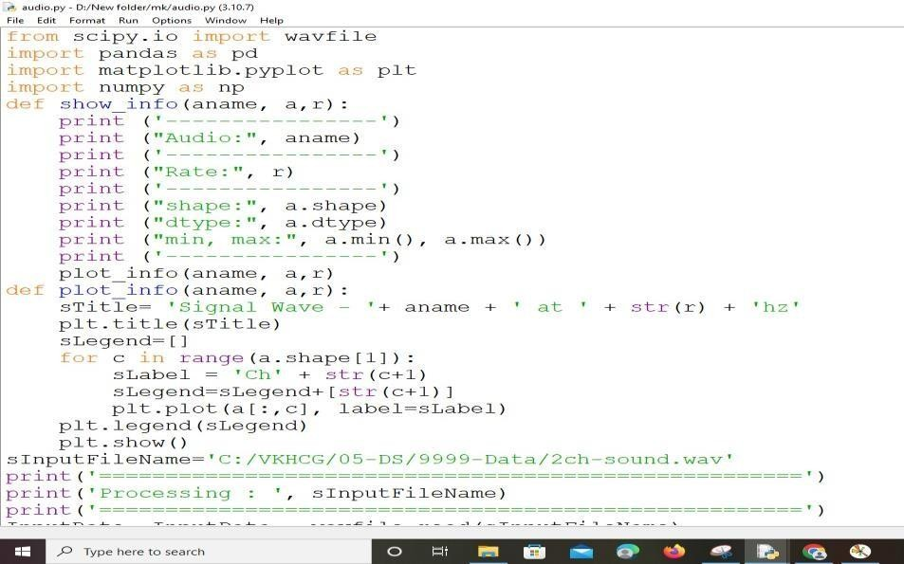

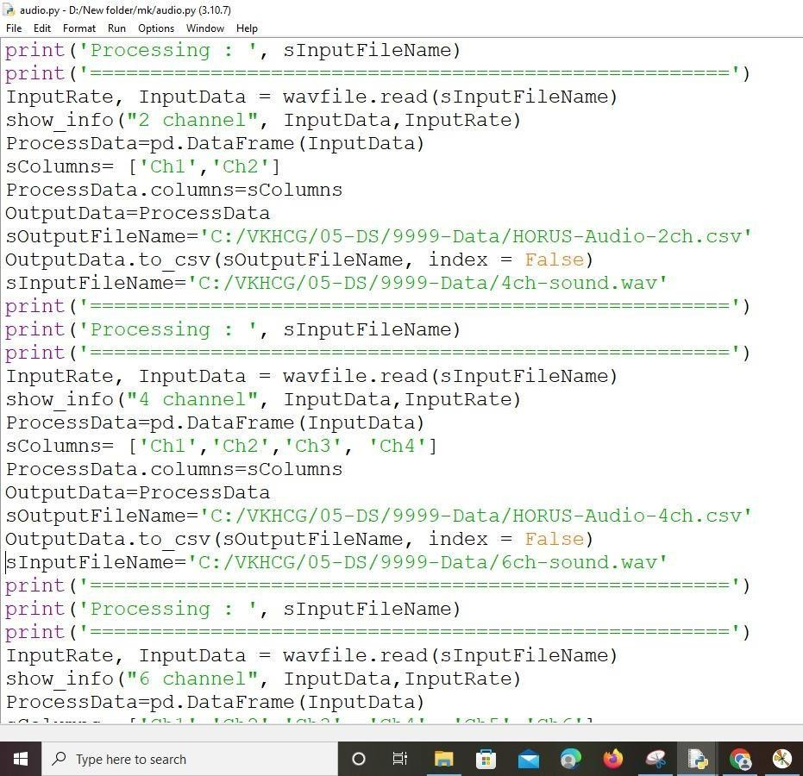

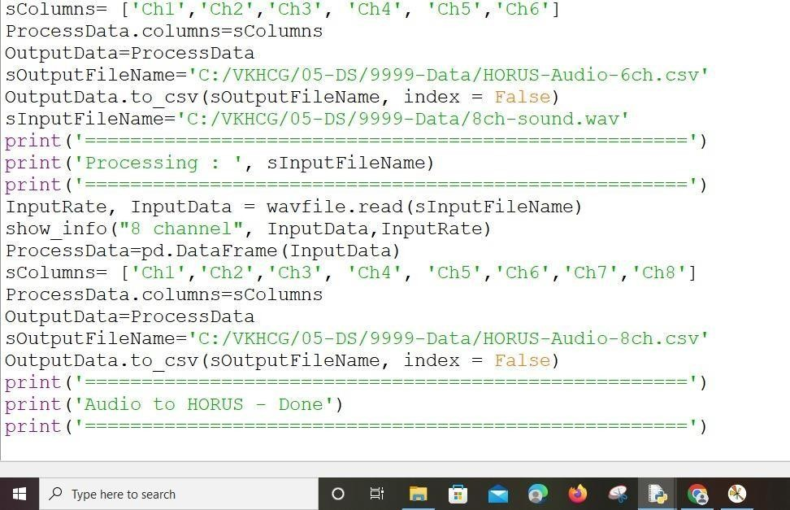

**Output:**

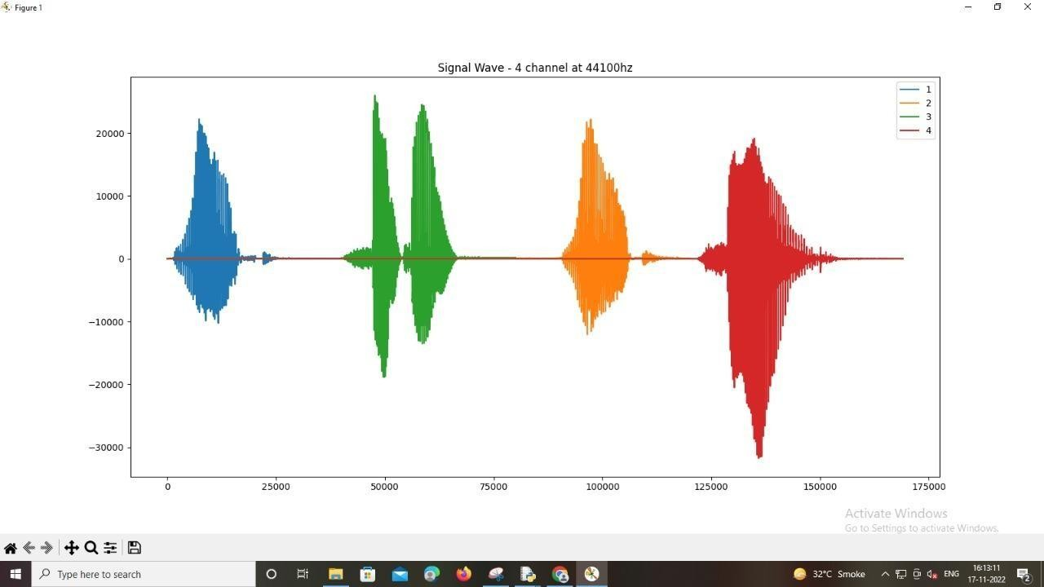

**Practical:3**

**Utilities and Auditing. A.Fixers Utilities.**

**Code:**

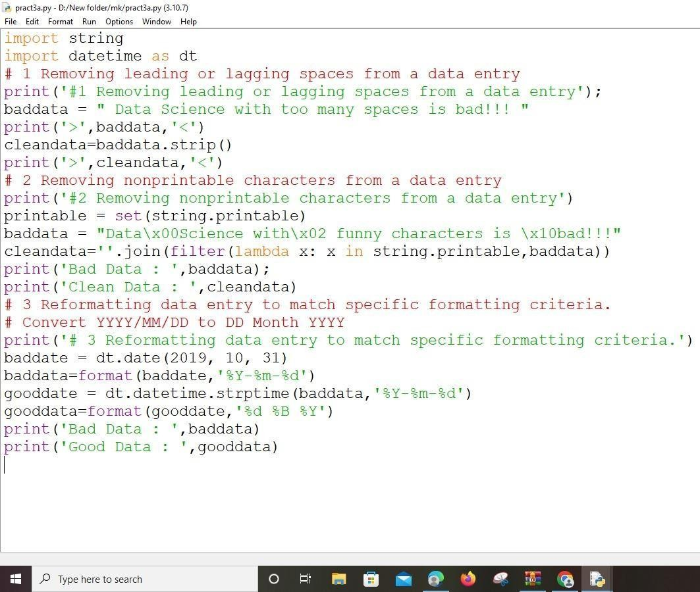

**Output:**

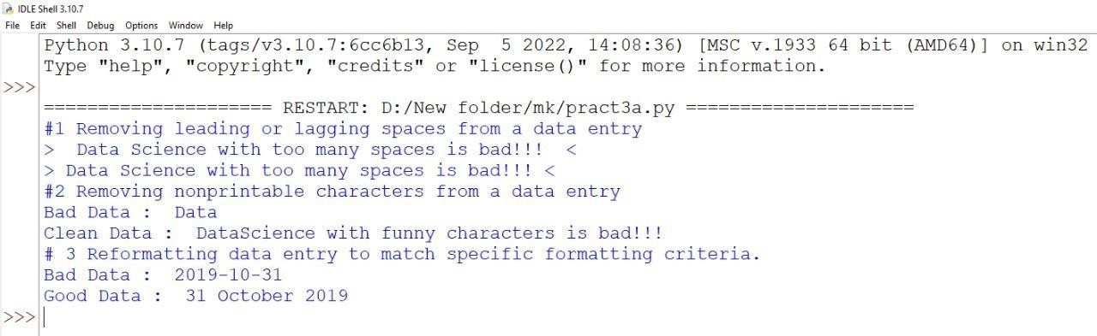

1. **Data Binning or Bucketing. Code:**

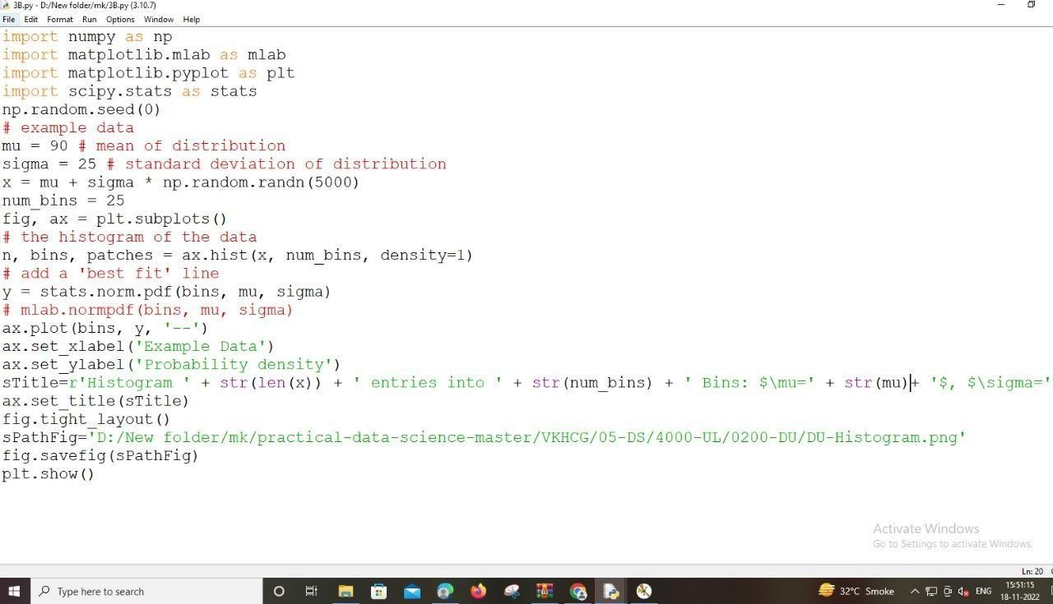

**Output:**

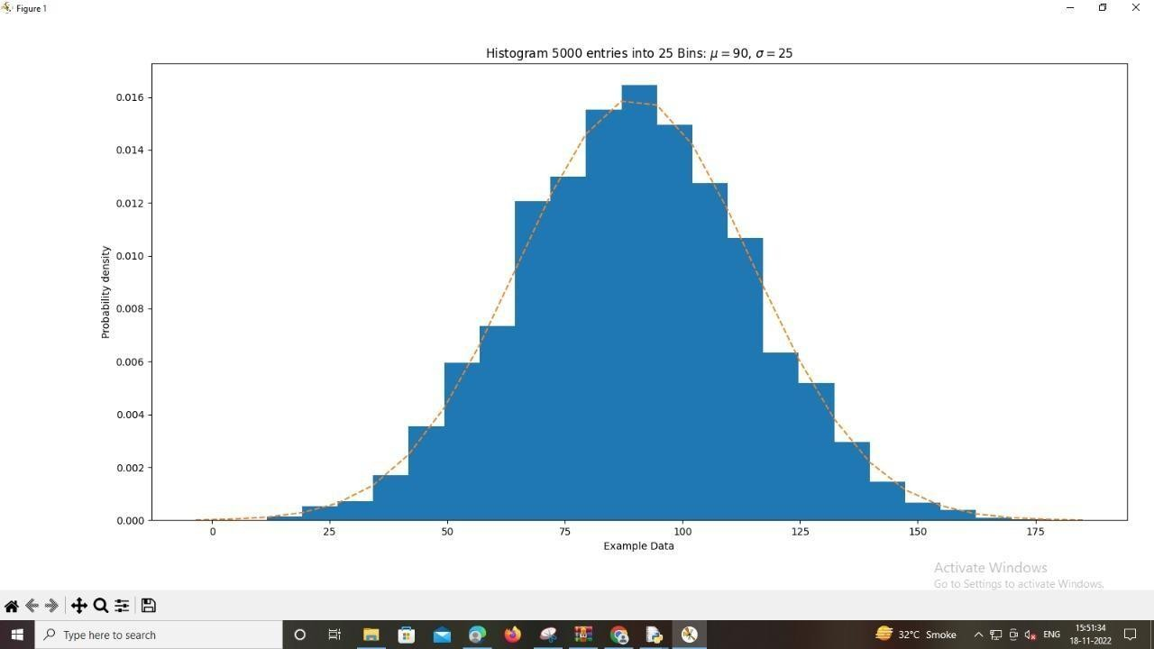

1. **Logging. Code:**

import sys import os import logging import uuid import shutil import time

Base='c:\ds\ds\practical-data-science-master\VKHCG'

sCompanies=['01-Vermeulen','02-Krennwallner','03-Hillman','04-Clark']

sLayers=['01-Retrieve','02-Assess','03-Process','04-Transform','05-Organise','06-Report'] sLevels=['debug','info','warning','error']

#You can now build the loops to perform a basic logging run. for sCompany in sCompanies:

sFileDir=Base + '/' + sCompany if not os.path.exists(sFileDir): os.makedirs(sFileDir)

for sLayer in sLayers:

log = logging.getLogger() # root logger

for hdlr in log.handlers[:]: # remove all old handlers log.removeHandler(hdlr)

sFileDir=Base + '/' + sCompany + '/' + sLayer + '/Logging' if os.path.exists(sFileDir):

shutil.rmtree(sFileDir) time.sleep(2)

if not os.path.exists(sFileDir): os.makedirs(sFileDir) skey=str(uuid.uuid4())

sLogFile=Base + '/' + sCompany + '/' + sLayer + '/Logging/Logging_'+skey+'.log' print('Set up:',sLogFile)

#You set up logging to file, as follows: logging.basicConfig(level=logging.DEBUG,

format='%(asctime)s %(name)-12s %(levelname)- 8s%(message)s',datefmt='%m-%d %H:%M',filename=sLogFile,filemode='w')

#You define a handler, which writes all messages to sys.stderr. console = logging.StreamHandler() console.setLevel(logging.INFO)

#You set a format for console use.

formatter = logging.Formatter('%(name)-12s: %(levelname)-8s%(message)s') #You activate the handler to use this format.

console.setFormatter(formatter)

#Now, add the handler to the root logger. logging.getLogger('').addHandler(console) #Test your root logging. logging.info('Practical Data Science is fun!.') #Test all the other levels.

for sLevel in sLevels:

sApp='Application-'+ sCompany + '-' + sLayer + '-' + sLevel logger = logging.getLogger(sApp)

if sLevel == 'debug':

logger.debug('Practical Data Science logged a debugging message.') if sLevel == 'info':

logger.info('Practical Data Science logged information message.') if sLevel == 'warning':

logger.warning('Practical Data Science logged a warning message.') if sLevel == 'error':

logger.error('Practical Data Science logged an error message.')

**Output:**

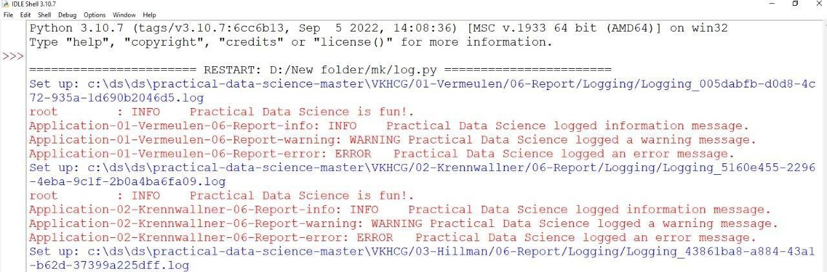

1. **Outter dedection**

**Code:**

InputFileName='IP_DATA_CORE.csv'

OutputFileName='Retrieve_Router_Location.csv' Base='C:/VKHCG' print('################################')

print('Working Base :',Base) print('################################')

sFileName=Base + '/01-Vermeulen/00-RawData/' + InputFileName print('Loading :',sFileName) IP_DATA_ALL=pd.read_csv(sFileName,header=0,low_memory=False,

usecols=['Country','Place Name','Latitude','Longitude'], encoding="latin-1") IP_DATA_ALL.rename(columns={'Place Name': 'Place_Name'}, inplace=True) LondonData=IP_DATA_ALL.loc[IP_DATA_ALL['Place_Name']=='London'] AllData=LondonData[['Country', 'Place_Name','Latitude']]

print('All Data') print(AllData)

MeanData=AllData.groupby(['Country', 'Place_Name'])['Latitude'].mean() StdData=AllData.groupby(['Country', 'Place_Name'])['Latitude'].std()

print('Outliers') UpperBound=float(MeanData+StdData) print('Higher than ', UpperBound)

OutliersHigher=AllData[AllData.Latitude>UpperBound] print(OutliersHigher)

LowerBound=float(MeanData-StdData) print('Lower than ', LowerBound)

OutliersLower=AllData[AllData.Latitude=LowerBound) & (AllData.Latitude<=UpperBound)] print(OutliersNot)

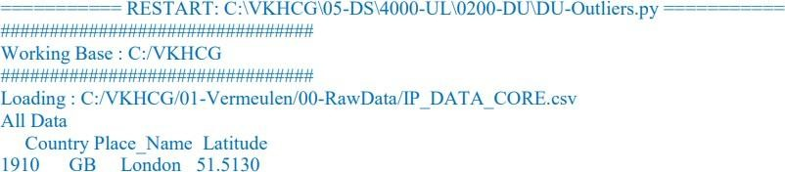**OUTPUT:**

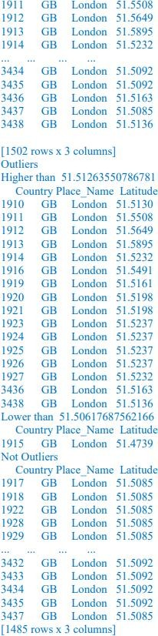

**E.Averaging of Data Code:**

import pandas as pd

InputFileName='IP_DATA_CORE.csv' OutputFileName='Retrieve_Router_Location.csv' Base='C:/VKHCG' print('################################')

print('Working Base :',Base, ' using ') print('################################')

sFileName=Base + '/01-Vermeulen/00-RawData/' + InputFileName print('Loading :',sFileName) IP_DATA_ALL=pd.read_csv(sFileName,header=0,low_memory=False,

usecols=['Country','Place Name','Latitude','Longitude'], encoding="latin-1") IP_DATA_ALL.rename(columns={'Place Name': 'Place_Name'}, inplace=True) AllData=IP_DATA_ALL[['Country', 'Place_Name','Latitude']]

print(AllData)

MeanData=AllData.groupby(['Country', 'Place_Name'])['Latitude'].mean()

print(MeanData)

**OUTPUT:**

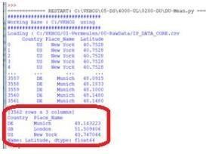

**Practical:4**

**Retrieving Data.**

1. **Loading IP_DATA_ALL: Code:**

library(readr)

IP_DATA_ALL <- read_csv('E:/M21005/DS/Practical 4/IP_DATA_ALL.csv') View(IP_DATA_ALL)

spec(IP_DATA_ALL) library(tibble)

set_tidy_names(IP_DATA_ALL,syntactic = TRUE,quiet = FALSE) IP_DATA_ALL_FIX = set_tidy_names(IP_DATA_ALL,syntactic = TRUE,quiet = TRUE)

sapply(IP_DATA_ALL_FIX,typeof) write.csv(IP_DATA_ALL_FIX,'E:/M21005/DS/Practical 4/IP_DATA_ALL_FIX.csv') setwd("E:/M21005/DS/Practical 4/")

library(data.table)

IP_DATA_ALL_with_ID = rowid_to_column(IP_DATA_ALL_FIX, var = "RowID") View(IP_DATA_ALL_with_ID) write.csv(IP_DATA_ALL_with_ID,'IP_DATA_ALL_with_ID.csv') sapply(IP_DATA_ALL_with_ID, typeof)

library(data.table)

hist_country = data.table(Country = unique(IP_DATA_ALL_with_ID[is.na(IP_DATA_ALL_with_ID['Country']) == 0,]$Country))

setorder(hist_country,'Country')

hist_country_with_id = rowid_to_column(hist_country, var = "RowIDCountry") View(hist_country_with_id)

IP_DATA_COUNTRY_FREQ = data.table(with(IP_DATA_ALL_with_ID, table(Country)))

View(IP_DATA_COUNTRY_FREQ) write.csv(IP_DATA_COUNTRY_FREQ,'IP_DATA_COUNTRY_FREQ.csv')

hist_latitude =data.table(Latitude=unique(IP_DATA_ALL_with_ID [is.na(IP_DATA_ALL_with_ID ['Latitude']) == 0, ]$Latitude)) setkeyv(hist_latitude, 'Latitude')

setorder(hist_latitude) hist_latitude_with_id=rowid_to_column(hist_latitude, var = "RowID") View(hist_latitude_with_id)

IP_DATA_Latitude_FREQ=data.table(with(IP_DATA_ALL_with_ID,table(Latitude)

))

View(IP_DATA_Latitude_FREQ) write.csv(IP_DATA_Latitude_FREQ,'IP_DATA_Latitude_FREQ.csv') hist_longitude =data.table(Longitude=unique(IP_DATA_ALL_with_ID [is.na(IP_DATA_ALL_with_ID ['Longitude']) == 0, ]$Longitude)) setkeyv(hist_longitude, 'Longitude') setorder(hist_longitude,'Longitude') hist_longitude_with_id=rowid_to_column(hist_longitude, var = "RowID") View(hist_longitude_with_id) IP_DATA_Longitude_FREQ=data.table(with(IP_DATA_ALL_with_ID,table(Longit ude)))

View(IP_DATA_Longitude_FREQ) write.csv(IP_DATA_Longitude_FREQ,'IP_DATA_Longitude_FREQ.csv') #minimum values

min(hist_country$Country) sapply(hist_country[,'Country'], min, na.rm=TRUE)

sapply(hist_latitude_with_id[,'Latitude'], min, na.rm=TRUE) sapply(hist_longitude_with_id[,'Longitude'], min, na.rm=TRUE) #maximum values

max(hist_country$Country) sapply(hist_country[,'Country'], max, na.rm=TRUE)

sapply(hist_latitude_with_id[,'Latitude'], max, na.rm=TRUE) sapply(hist_longitude_with_id[,'Longitude'], max, na.rm=TRUE) #Mean

sapply(hist_latitude_with_id[,'Latitude'], mean, na.rm=TRUE) sapply(hist_longitude_with_id[,'Longitude'], mean, na.rm=TRUE) #Median

sapply(hist_latitude_with_id[,'Latitude'], median, na.rm=TRUE) sapply(hist_longitude_with_id[,'Longitude'], median, na.rm=TRUE) #Mode

IP_DATA_COUNTRY_FREQ = data.table(with(IP_DATA_ALL_with_ID, table(Country)))

setorder(IP_DATA_COUNTRY_FREQ,-N) IP_DATA_COUNTRY_FREQ[1,'Country']

IP_DATA_Latitude_FREQ=data.table(with(IP_DATA_ALL_with_ID,table(Latitude)

))

setorder(IP_DATA_Latitude_FREQ,-N) IP_DATA_Latitude_FREQ[1,'Latitude']

IP_DATA_Longitude_FREQ=data.table(with(IP_DATA_ALL_with_ID,table(Longit ude)))

setorder(IP_DATA_Longitude_FREQ,-N) IP_DATA_Longitude_FREQ[1,'Longitude'] #Range

sapply(hist_latitude_with_id[,'Latitude'], range, na.rm=TRUE) sapply(hist_longitude_with_id[,'Longitude'], range, na.rm=TRUE)

sapply(hist_country_with_id[,'Country'], range, na.rm=TRUE) #Quartiles

sapply(hist_latitude_with_id[,'Latitude'], quantile, na.rm=TRUE) sapply(hist_longitude_with_id[,'Longitude'], quantile, na.rm=TRUE) #Standard Deviation

sapply(hist_latitude_with_id[,'Latitude'], sd, na.rm=TRUE) sapply(hist_longitude_with_id[,'Longitude'], sd, na.rm=TRUE) #Skewness

library(e1071)

skewness(hist_latitude_with_id$Latitude, na.rm = FALSE, type = 2) skewness(hist_longitude_with_id$Longitude,na.rm = FALSE, type = 2) #Missing or Unknown Values

missing_country=data.table(Country=unique(IP_DATA_ALL_with_ID[is.na(IP_DA TA_ALL_with_ID ['Country']) == 1, ]))

View(missing_country)

**Output:**

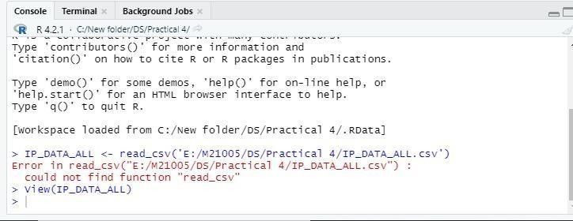

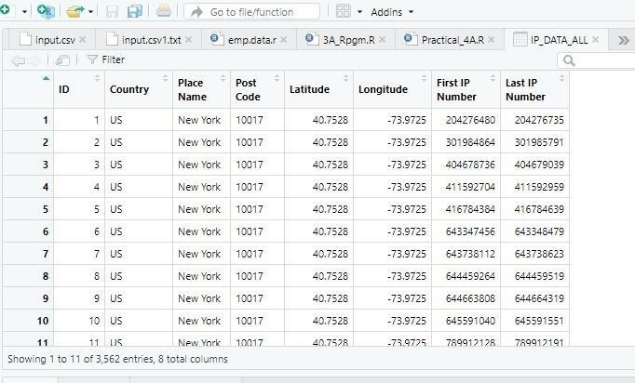

1. **Program to retrieve different attributes of data. Code:**

import sys import os

import pandas as pd

sFileName='C:/DS/DS/Practical 4/IP_DATA_ALL.csv' print('Loading :',sFileName)

IP_DATA_ALL=pd.read_csv(sFileName,header=1,low_memory=False,encoding="latin-1") print('Rows:', IP_DATA_ALL.shape[0])

print('Columns:', IP_DATA_ALL.shape[1])

print('Raw Data Set ')

for i in range(0,len(IP_DATA_ALL.columns)): print(IP_DATA_ALL.columns[i],type(IP_DATA_ALL.columns[i]))

print(' Fixed Data Set ')

IP_DATA_ALL_FIX=IP_DATA_ALL

for i in range(0,len(IP_DATA_ALL.columns)): cNameOld=IP_DATA_ALL_FIX.columns[i] + ' ' cNameNew = cNameOld.strip().replace(" ", ".")

IP_DATA_ALL_FIX.columns.values[i] = cNameNew print(IP_DATA_ALL.columns[i], type(IP_DATA_ALL.columns[i])

#print(IP_DATA_ALL_FIX.head()) print('Fixed Data Set with ID')

IP_DATA_ALL_with_ID=IP_DATA_ALL_FIX IP_DATA_ALL_with_ID.index.names = ['RowID'] #print(IP_DATA_ALL_with_ID.head() sFileName2='/Retrieve_IP_DATA.csv' IP_DATA_ALL_with_ID.to_csv(sFileName2, index = True)

print(' Done!! ')

**Output:**

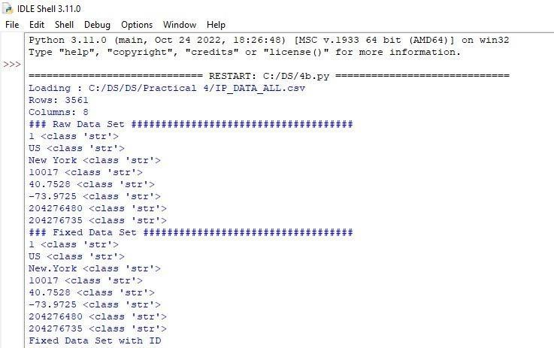

1. **Mysql. Code:**

import sqlite3

conn = sqlite3.connect('test1.db')

print ("Opened database successfully"); conn.execute('''CREATE TABLE COMPANY (ID INT PRIMARY KEY NOT NULL, NAME TEXT NOT NULL,

AGE INT NOT NULL,

ADDRESS CHAR(50) NOT NULL, SALARY REAL);''')

print("Table created successfully");

conn.execute("INSERT INTO COMPANY (ID,NAME,AGE,ADDRESS,SALARY) \ VALUES (1, 'Paul', 32, 'California', 20000.00 )");

conn.execute("INSERT INTO COMPANY (ID,NAME,AGE,ADDRESS,SALARY) \ VALUES (2, 'Allen', 25, 'Texas', 15000.00 )");

conn.execute("INSERT INTO COMPANY (ID,NAME,AGE,ADDRESS,SALARY) \ VALUES (3, 'Teddy', 23, 'Norway', 20000.00 )");

conn.execute("INSERT INTO COMPANY (ID,NAME,AGE,ADDRESS,SALARY) \ VALUES (4, 'Mark', 25, 'Rich-Mond', 65000.00 )");

conn.commit()

print("Records created successfully");

cursor = conn.execute("SELECT id, name, address, salary from COMPANY") for row in cursor:

print ("ID = ",row[0])

print ("NAME = ",row[1]) print ("ADDRESS = ",row[2])

print ("SALARY = ",row[3]) print("Operation done successfully");

**Output:**

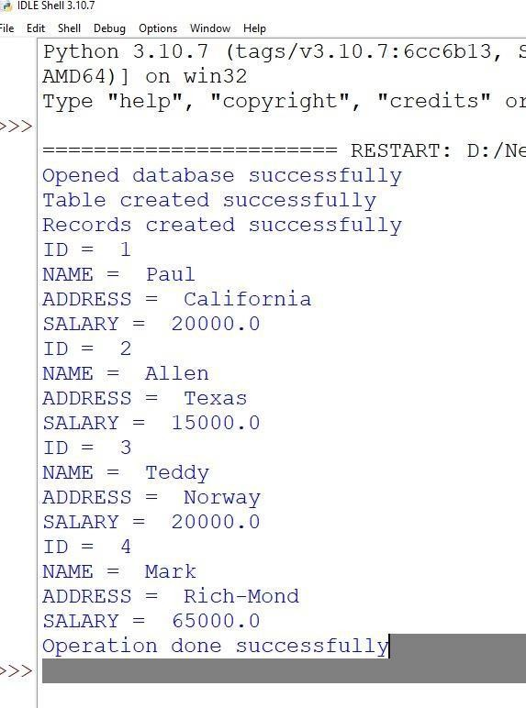

**D.Excel. Code:**

import os

import pandas as pd Base='C:/VKHCG'

sFileDir=Base + '/01-Vermeulen/01-Retrieve/01-EDS/02-Python' if not os.path.exists(sFileDir):

os.makedirs(sFileDir)

CurrencyRawData = pd.read_excel('C:/VKHCG/01-Vermeulen/00- RawData/Country_Currency.xlsx')

sColumns = ['Country or territory', 'Currency', 'ISO-4217'] CurrencyData = CurrencyRawData[sColumns] CurrencyData.rename(columns={'Country or territory': 'Country', 'ISO-4217':'CurrencyCode'}, inplace=True) CurrencyData.dropna(subset=['Currency'],inplace=True)

CurrencyData['Country'] = CurrencyData['Country'].map(lambda x:x.strip()) CurrencyData['Currency'] = CurrencyData['Currency'].map(lambda x:x.strip()) CurrencyData['CurrencyCode'] =CurrencyData['CurrencyCode'].map(lambda x:x.strip()) print(CurrencyData)

sFileName=sFileDir + '/Retrieve-Country-Currency.csv' CurrencyData.to_csv(sFileName, index = false)

**Output:**

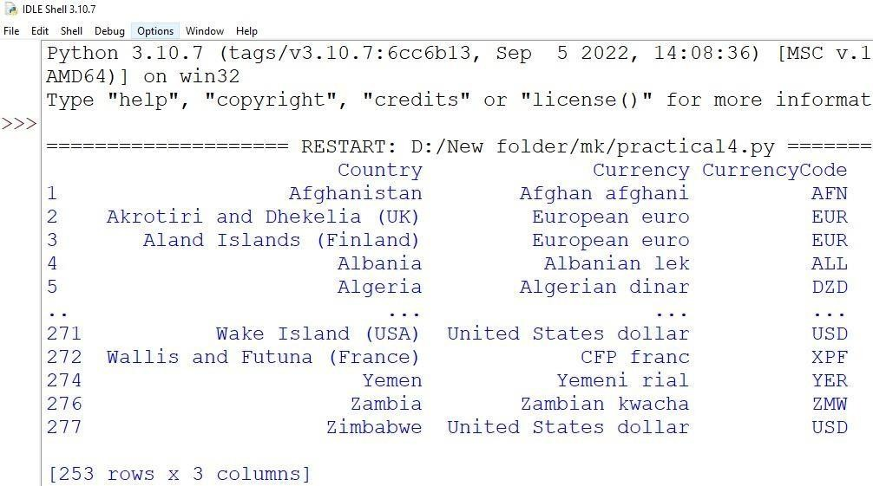

**Practical:5**

**Assessing Data.**

**A. Missing Values in Pandas:**

1. **Drop the Columns Where All Elements Are Missing Values. Code:**

import pandas as pd import numpy as np

d1 = {'Name': ['Pankaj', 'Meghna', 'David', 'Lisa'], 'ID': [1, 2, 3, 4], 'Salary': [100, 200, np.nan, pd.NaT],

'Role': ['CEO', None, pd.NaT, pd.NaT]} df = pd.DataFrame(d1)

print(df)

# drop all rows with any NaN and NaT values df1 = df.dropna()

print(df1)

**Output:**

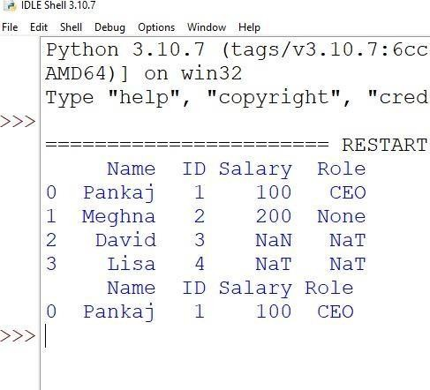

1. **Keep Only the Rows That Contain a Maximum of Two Missing Values. Code:**

import pandas as pd import numpy as np

pd.set_option('display.max_rows', None) #pd.set_option('display.max_columns', None) df = pd.DataFrame({

'ord_no':[np.nan,np.nan,70002,np.nan,np.nan,70005,np.nan,70010,70003,70012,np.nan,np.na n],

'purch_amt':[np.nan,270.65,65.26,np.nan,948.5,2400.6,5760,1983.43,2480.4,250.45,

75.29,np.nan],

'ord_date': [np.nan,'2012-09-10',np.nan,np.nan,'2012-09-10','2012-07-27','2012-09-10','2012- 10-10','2012-10-10','2012-06-27','2012-08-17',np.nan],

'customer_id':[np.nan,3001,3001,np.nan,3002,3001,3001,3004,3003,3002,3001,np.nan]}) print("Original Orders DataFrame:")

print(df)

print("\nKeep the rows with at least 2 NaN values of the said DataFrame:") result = df.dropna(thresh=2)

print(result)

**Output:**

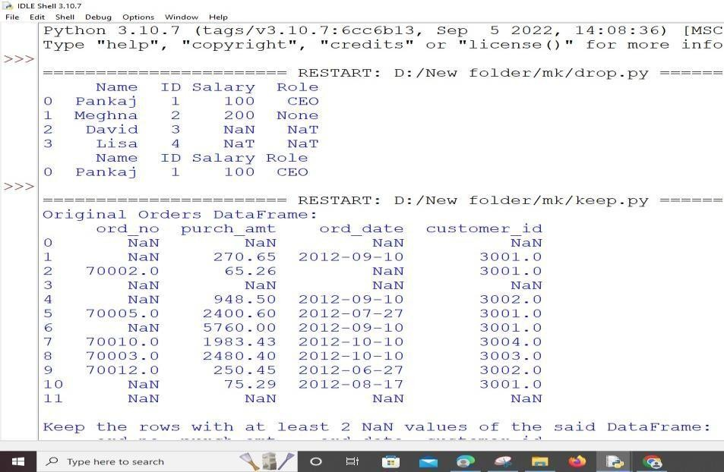

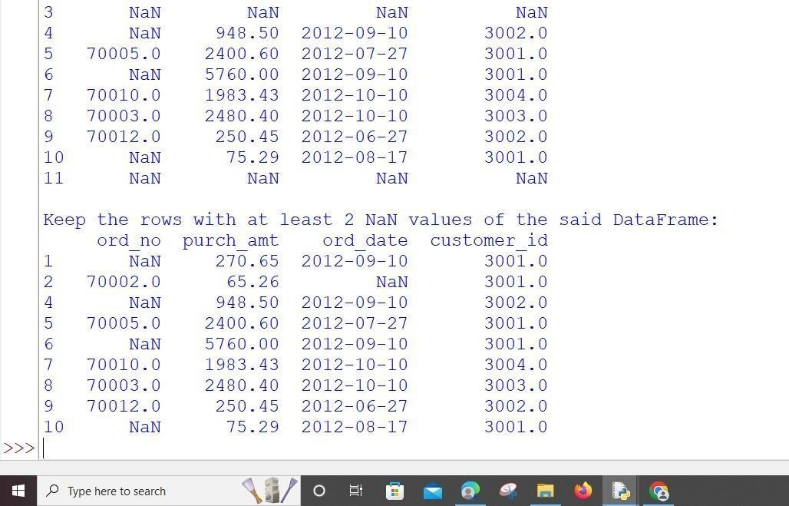

1. **Fill All Missing Values with the Mean, Median, Mode, Minimum, and Maximum of the Particular Numeric Column.**

**Code**:

import statistics

data = [220, 100, 190, 180, 250, 190, 240, 180, 140, 180, 190]

# Finding Mean

print("\nMean: ", statistics.mean(data)) # Finding Median

print("Median: ", statistics.median(data)) # Finding Single Mode

print("Single Mode: ", statistics.mode(data)) # Finding Multiple Modes

print("Mode: ", statistics.multimode(data)) print("max: ",max(data))

print("min: ",min(data))

**Output:**

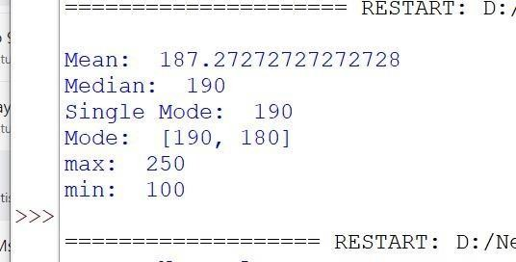

**5B.Write a Python / R program to build directed acyclic graph. Code:**

from collections import defaultdict class Graph:

def _init_(self,n): self.graph = defaultdict(list) self.N = n

def addEdge(self,m,n): self.graph[m].append

def sortUtil(self,n,visited,stack): visited[n] = True

for element in self.graph[n]:

if visited[element] == False: self.sortUtil(element,visited,stack) stack.insert(0,n)

def topologicalSort(self): visited = [False]*self.N stack =[]

for element in range(self.N):

if visited[element] == False: self.sortUtil(element,visited,stack)

print(stack) graph = Graph(5) graph.addEdge(0,1); graph.addEdge(0,3); graph.addEdge(1,2); graph.addEdge(2,3);

graph.addEdge(2,4); graph.addEdge(3,4);

print("The Topological Sort Of The Graph Is: ") graph.topologicalSort()

**Output:**

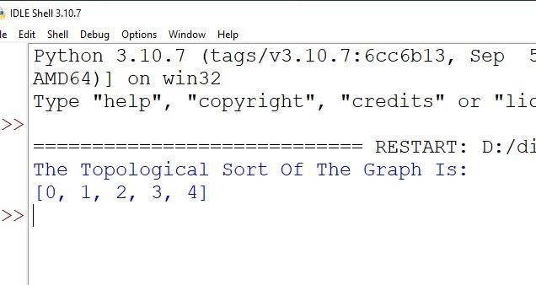

**5C.Write python/R program to create the network routing diagram from the given data on routers**

**Code:**

import sys import os import pandas as pd

Base='C:/VKHCG'

print('Working Base :',Base, ' using Windows')

sInputFileName1='01-Retrieve/01-EDS/01-R/Retrieve_Country_Code.csv'

sInputFileName2='01-Retrieve/01-EDS/02-Python/Retrieve_Router_Location.csv'

sInputFileName3='01-Retrieve/01-EDS/01-R/Retrieve_IP_DATA.csv'

sOutputFileName='Assess-Network-Routing-Company.csv'

Company='01-Vermeulen'

Import Country Data

sFileName=Base + '/' + Company + '/' + sInputFileName1

print('Loading :',sFileName)

CountryData=pd.read_csv(sFileName,header=0, low_memory=False, encoding="latin-1") print('Loaded Country:',CountryData.columns.values)

## Assess Country Data

print('Changed :',CountryData.columns.values)

CountryData.rename(columns={'Country': 'Country_Name'}, inplace=True) CountryData.rename(columns={'ISO-2-CODE': 'Country_Code'}, inplace=True) CountryData.drop('ISO-M49', axis=1, inplace=True)

CountryData.drop('ISO-3-Code', axis=1, inplace=True) CountryData.drop('RowID', axis=1, inplace=True) print('To :',CountryData.columns.values)

# Import Company Data

sFileName=Base + '/' + Company + '/' + sInputFileName2

print('Loading :',sFileName)

CompanyData=pd.read_csv(sFileName,header=0,low_memory=False, encoding="latin-1")

print('Loaded Company :',CompanyData.columns.values)

## Assess Company Data

print('Changed :',CompanyData.columns.values) CompanyData.rename(columns={'Country': 'Country_Code'}, inplace=True) print('To :',CompanyData.columns.values)

Import Customer Data

sFileName=Base + '/' + Company + '/' +sInputFileName3

print('Loading :',sFileName)

CustomerRawData=pd.read_csv(sFileName,header=0,low_memory=False, encoding="latin- 1")

print('Loaded Customer :',CustomerRawData.columns.values)

CustomerData=CustomerRawData.dropna(axis=0, how='any')

print('Remove Blank Country Code')

print('Reduce Rows from', CustomerRawData.shape[0],' to ', CustomerData.shape[0])

print('Changed :',CustomerData.columns.values) CustomerData.rename(columns={'Country': 'Country_Code'}, inplace=True) print('To :',CustomerData.columns.values)

print('Merge Company and Country Data')

CompanyNetworkData=pd.merge(CompanyData, CountryData, how='inner', on='Country_Code' )

print('Change ',CompanyNetworkData.columns.values) for i in

CompanyNetworkData.columns.values: j='Company_'+i CompanyNetworkData.rename(columns={i: j}, inplace=True) print('To ', CompanyNetworkData.columns.values)

sFileDir=Base + '/' + Company + '/02-Assess/01-EDS/02-Python' if not os.path.exists(sFileDir): os.makedirs(sFileDir)

sFileName=sFileDir + '/' + sOutputFileName

print('Storing :', sFileName)

CompanyNetworkData.to_csv(sFileName, index = False, encoding="latin-1")

print(' Done!! ')

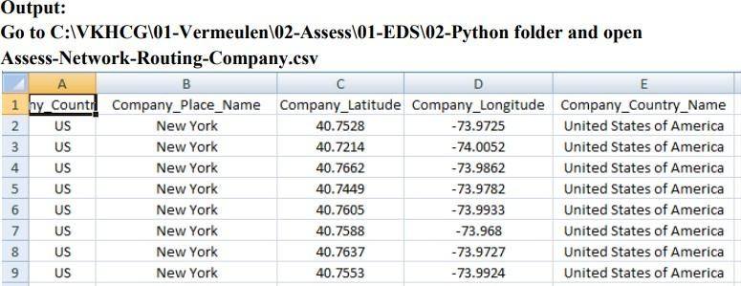

#################### Assess-Network-Routing-Customer.py ######################

import sys

import os

import pandas as pd

pd.options.mode.chained_assignment = None

Base='C:/VKHCG'

print('Working Base :',Base, ' using ', sys.platform)

sOutputFileName='Assess-Network-Routing-Customer.gml'

Company='01-Vermeulen'

Import Country Data

sFileName=sInputFileName

print('Loading :',sFileName)

CustomerData=pd.read_csv(sFileName,header=0,low_memory=False, encoding="latin-1") print('Loaded Country:',CustomerData.columns.values)

print(CustomerData.head())

print('Done!!’)

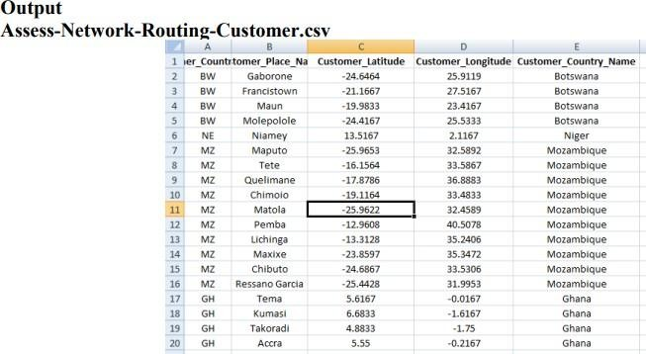

Assess-Network-Routing-Node.py

import sys

import os

import pandas as pd

pd.options.mode.chained_assignment = None

Base='C:/VKHCG'

print('Working Base :',Base, ' using ', sys.platform)

sInputFileName='01-Retrieve/01-EDS/02-Python/Retrieve_IP_DATA.csv'

sOutputFileName='Assess-Network-Routing-Node.csv' Company='01-Vermeulen'

Import IP Data

sFileName=Base + '/' + Company + '/' + sInputFileName

print('Loading :',sFileName)

IPData=pd.read_csv(sFileName,header=0,low_memory=False, encoding="latin-1")

print('Loaded IP :', IPData.columns.values)

print('Changed :',IPData.columns.values) IPData.drop('RowID', axis=1, inplace=True) IPData.drop('ID', axis=1, inplace=True)

IPData.rename(columns={'Country': 'Country_Code'}, inplace=True) IPData.rename(columns={'Place.Name': 'Place_Name'}, inplace=True) IPData.rename(columns={'Post.Code': 'Post_Code'}, inplace=True) IPData.rename(columns={'First.IP.Number': 'First_IP_Number'}, inplace=True) IPData.rename(columns={'Last.IP.Number': 'Last_IP_Number'}, inplace=True)

print('To :',IPData.columns.values)

print('Change ',IPData.columns.values) for i in

IPData.columns.values: j='Node_'+i IPData.rename(columns={i: j}, inplace=True) print('To ', IPData.columns.values)

sFileDir=Base + '/' + Company + '/02-Assess/01-EDS/02-Python' if not os.path.exists(sFileDir): os.makedirs(sFileDir)

sFileName=sFileDir + '/' + sOutputFileName

print('Storing :', sFileName)

IPData.to_csv(sFileName, index = False, encoding="latin-1")

print('Done!! ')

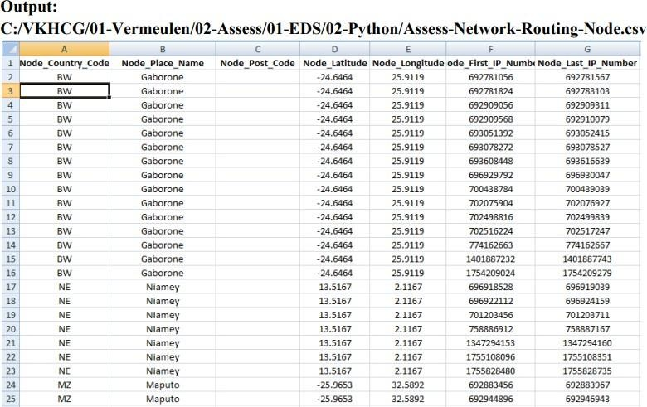

**5D. Write a Python / R program to pick the content for Bill Boards from the given data.**

**Code:**

################# Assess-DE-Billboard.py ######################

import sys import os import sqlite3 as sq import pandas as pd

Base='C:/VKHCG'

print('Working Base :',Base, ' using ', sys.platform)

sInputFileName1='01-Retrieve/01-EDS/02-Python/Retrieve_DE_Billboard_Locations.csv' sInputFileName2='01-Retrieve/01-EDS/02-Python/Retrieve_Online_Visitor.csv' sOutputFileName='Assess-DE-Billboard-Visitor.csv' Company='02-Krennwallner'

sDataBaseDir=Base + '/' + Company + '/02-Assess/SQLite' if not os.path.exists(sDataBaseDir):

sDatabaseName=sDataBaseDir + '/krennwallner.db'

conn = sq.connect(sDatabaseName)

Import Billboard Data

sFileName=Base + '/' + Company + '/' + sInputFileName1

print('Loading :',sFileName)

BillboardRawData=pd.read_csv(sFileName,header=0,low_memory=False, encoding="latin-

1")

BillboardRawData.drop_duplicates(subset=None, keep='first', inplace=True) BillboardData=BillboardRawData

print('Loaded Company :',BillboardData.columns.values)

sTable='Assess_BillboardData'

print('Storing :',sDatabaseName,' Table:',sTable)

BillboardData.to_sql(sTable, conn, if_exists="replace")

print(BillboardData.head())

print('Rows : ',BillboardData.shape[0])

Import Billboard Data

sFileName=Base + '/' + Company + '/' +sInputFileName2

print('Loading :',sFileName)

VisitorRawData=pd.read_csv(sFileName,header=0,low_memory=False, encoding="latin-1")

VisitorRawData.drop_duplicates(subset=None, keep='first', inplace=True) VisitorData=VisitorRawData[VisitorRawData.Country=='DE']

print('Loaded Company :',VisitorData.columns.values)

sTable='Assess_VisitorData'

print('Storing :',sDatabaseName,' Table:',sTable) VisitorData.to_sql(sTable, conn, if_exists="replace")

print(VisitorData.head())

print('Rows : ',VisitorData.shape[0])

sTable='Assess_BillboardVisitorData' print('Loading :',sDatabaseName,' Table:',sTable)

sSQL="select distinct" sSQL=sSQL+ " A.Country AS BillboardCountry," sSQL=sSQL+ " A.Place_Name AS BillboardPlaceName,"

sSQL=sSQL+ " A.Latitude AS BillboardLatitude, " sSQL=sSQL+ " A.Longitude AS BillboardLongitude," sSQL=sSQL+ " B.Country AS VisitorCountry," sSQL=sSQL+ " B.Place_Name AS VisitorPlaceName," sSQL=sSQL+ " B.Latitude AS VisitorLatitude, " sSQL=sSQL+ " B.Longitude AS VisitorLongitude,"

sSQL=sSQL+ " (B.Last_IP_Number - B.First_IP_Number) * 365.25 * 24 * 12 AS VisitorYearRate" sSQL=sSQL+ " from"

sSQL=sSQL+ " Assess_BillboardData as A" sSQL=sSQL+ " JOIN "

sSQL=sSQL+ " Assess_VisitorData as B" sSQL=sSQL+ " ON "

sSQL=sSQL+ " A.Country = B.Country" sSQL=sSQL+ " AND "

sSQL=sSQL+ " A.Place_Name = B.Place_Name;" BillboardVistorsData=pd.read_sql_query(sSQL, conn)

sTable='Assess_BillboardVistorsData' print('Storing :',sDatabaseName,' Table:',sTable)

BillboardVistorsData.to_sql(sTable, conn, if_exists="replace")

print(BillboardVistorsData.head())

print('Rows : ',BillboardVistorsData.shape[0])

sFileDir=Base + '/' + Company + '/02-Assess/01-EDS/02-Python' if not os.path.exists(sFileDir): os.makedirs(sFileDir)

print('Storing :', sFileName)

sFileName=sFileDir + '/' + sOutputFileName BillboardVistorsData.to_csv(sFileName, index

= False)

print('Done!! ')

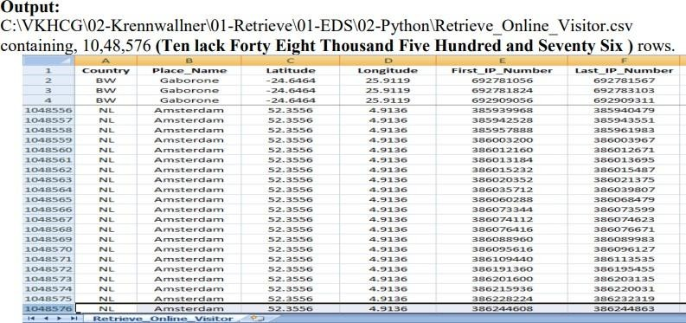

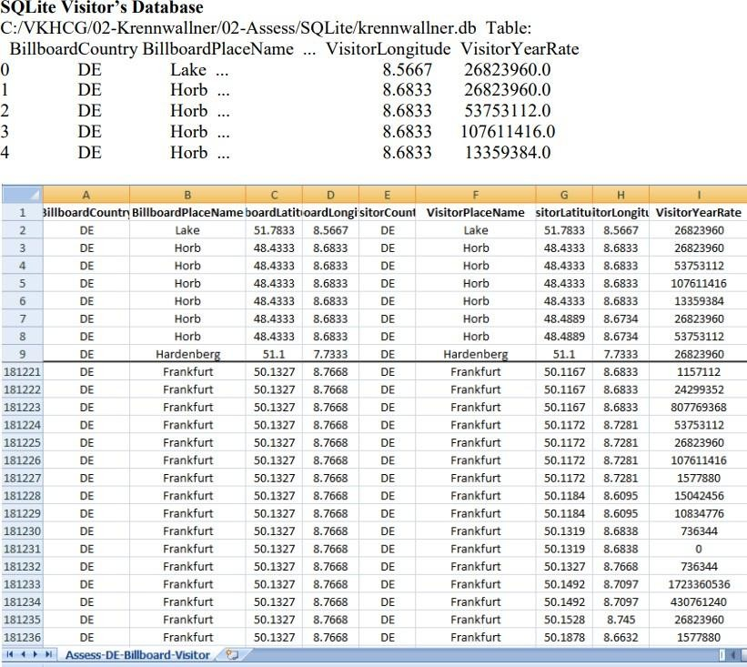

**E. Write a Python / R program to generate GML file from the given csv file. Understanding Your Online Visitor Data**

import sys import os

import sqlite3 as sq

import pandas as pd

from geopy.distance import vincenty

Base='C:/VKHCG'

print('Working Base :',Base, ' using ', sys.platform)

Company='02-Krennwallner' sTable='Assess_BillboardVisitorData'

sOutputFileName='Assess-DE-Billboard-Visitor.gml'

sDataBaseDir=Base + '/' + Company + '/02-Assess/SQLite' if not os.path.exists(sDataBaseDir): os.makedirs(sDataBaseDir)

sDatabaseName=sDataBaseDir + '/krennwallner.db' conn = sq.connect(sDatabaseName)

print('Loading :',sDatabaseName,' Table:',sTable) sSQL="select " sSQL=sSQL+ " A.BillboardCountry," sSQL=sSQL+ " A.BillboardPlaceName,"

sSQL=sSQL+ " ROUND(A.BillboardLatitude,3) AS BillboardLatitude, " sSQL=sSQL+ " ROUND(A.BillboardLongitude,3) AS BillboardLongitude," sSQL=sSQL+ " (CASE WHEN A.BillboardLatitude < 0 THEN " sSQL=sSQL+ " 'S' || ROUND(ABS(A.BillboardLatitude),3)"

sSQL=sSQL+ " ELSE " sSQL=sSQL+ " 'N' || ROUND(ABS(A.BillboardLatitude),3)" sSQL=sSQL+ " END ) AS sBillboardLatitude,"

sSQL=sSQL+ " (CASE WHEN A.BillboardLongitude < 0 THEN " sSQL=sSQL+ " 'W' || ROUND(ABS(A.BillboardLongitude),3)"

sSQL=sSQL+ " ELSE "

sSQL=sSQL+ " 'E' || ROUND(ABS(A.BillboardLongitude),3)" sSQL=sSQL+ " END ) AS sBillboardLongitude," sSQL=sSQL+ " A.VisitorCountry,"

sSQL=sSQL+ " A.VisitorPlaceName,"

sSQL=sSQL+ " ROUND(A.VisitorLatitude,3) AS VisitorLatitude, " sSQL=sSQL+ " ROUND(A.VisitorLongitude,3) AS VisitorLongitude," sSQL=sSQL+ " (CASE WHEN A.VisitorLatitude < 0 THEN " sSQL=sSQL+ " 'S' || ROUND(ABS(A.VisitorLatitude),3)" sSQL=sSQL+ " ELSE "

sSQL=sSQL+ " 'N' ||ROUND(ABS(A.VisitorLatitude),3)" sSQL=sSQL+ " END ) AS sVisitorLatitude,"

sSQL=sSQL+ " (CASE WHEN A.VisitorLongitude < 0 THEN " sSQL=sSQL+ " 'W' || ROUND(ABS(A.VisitorLongitude),3)" sSQL=sSQL+ " ELSE "

sSQL=sSQL+ " 'E' || ROUND(ABS(A.VisitorLongitude),3)" sSQL=sSQL+ " END ) AS sVisitorLongitude," sSQL=sSQL+ " A.VisitorYearRate"

sSQL=sSQL+ " from"

sSQL=sSQL+ " Assess_BillboardVistorsData AS A;" BillboardVistorsData=pd.read_sql_query(sSQL, conn)

BillboardVistorsData['Distance']=BillboardVistorsData.apply(lambda row: round(vincenty((row['BillboardLatitude'],row['BillboardLongitude']), (row['VisitorLatitude'],row['VisitorLongitude'])).miles ,4) ,axis=1)

G=nx.Graph()

For I in range(BillboardVistorsData.shape[0]):

sNode0='MediaHub-' + BillboardVistorsData['BillboardCountry'][i]

sNode1='B-'+ BillboardVistorsData['sBillboardLatitude'][i] + '-' sNode1=sNode1 + BillboardVistorsData['sBillboardLongitude'][i] G.add_node(sNode1, Nodetype='Billboard',

Country=BillboardVistorsData['BillboardCountry'][i], PlaceName=BillboardVistorsData['BillboardPlaceName'][i], Latitude=round(BillboardVistorsData['BillboardLatitude'][i],3), Longitude=round(BillboardVistorsData['BillboardLongitude'][i],3))

sNode2='M-'+ BillboardVistorsData['sVisitorLatitude'][i] + '-' sNode2=sNode2 + BillboardVistorsData['sVisitorLongitude'][i] G.add_node(sNode2, Nodetype='Mobile',

Country=BillboardVistorsData['VisitorCountry'][i], PlaceName=BillboardVistorsData['VisitorPlaceName'][i], Latitude=round(BillboardVistorsData['VisitorLatitude'][i],3), Longitude=round(BillboardVistorsData['VisitorLongitude'][i],3))

print('Link Media Hub :',sNode0,' to Billboard : ', sNode1) G.add_edge(sNode0,sNode1)

print('Link Post Code :',sNode1,' to GPS : ', sNode2) G.add_edge(sNode1,sNode2,distance=round(BillboardVistorsData['Distance'][i]))

print("Nodes of graph: ",nx.number_of_nodes(G)) print("Edges of graph: ",nx.number_of_edges(G))

sFileDir=Base + '/' + Company + '/02-Assess/01-EDS/02-Python' if not os.path.exists(sFileDir): os.makedirs(sFileDir)

sFileName=sFileDir + '/' + sOutputFileName

print('Storing :', sFileName)

nx.write_gml(G,sFileName)

sFileName=sFileName +'.gz' nx.write_gml(G,sFileName)

print('Done!! ')

#### Output:

Assess

import sys import os import sqlite3 as sq

import pandas as pd from pandas.io

import sql

Base='C:/VKHCG'

sSQL=sSQL+ " SELECT"

sSQL=sSQL+ " A.Country," sSQL=sSQL+ " A.Place_Name," sSQL=sSQL+ " A.Latitude," sSQL=sSQL+ " A.Longitude,"

sSQL=sSQL+ " (A.Last_IP_Number - A.First_IP_Number) AS UsesIt" sSQL=sSQL+ " FROM"

sSQL=sSQL+ " Assess_Visitor as A" sSQL=sSQL+ " WHERE"

sSQL=sSQL+ " Country is not null" sSQL=sSQL+ " AND"

sSQL=sSQL+ " Place_Name is not null;"

sql.execute(sSQL,conn)

sView='Assess_Total_Visitors_Location' print('Creating :',sDatabaseName,' View:',sView) sSQL="DROP VIEW IF EXISTS " + sView + ";"

sql.execute(sSQL,conn)

sSQL="CREATE VIEW " + sView + " AS" sSQL=sSQL+ " SELECT"

sSQL=sSQL+ " Country," sSQL=sSQL+ " Place_Name,"

sSQL=sSQL+ " SUM(UsesIt) AS TotalUsesIt" sSQL=sSQL+ " FROM"

sSQL=sSQL+ " Assess_Visitor_UseIt" sSQL=sSQL+ " GROUP BY"

sSQL=sSQL+ " Country," sSQL=sSQL+ " Place_Name" sSQL=sSQL+ " ORDER BY"

sSQL=sSQL+ " TotalUsesIt DESC" sSQL=sSQL+ " LIMIT 10;"

sql.execute(sSQL,conn)

sView='Assess_Total_Visitors_GPS' print('Creating :',sDatabaseName,' View:',sView)

sSQL="DROP VIEW IF EXISTS " + sView + ";" sql.execute(sSQL,conn) sSQL="CREATE VIEW " + sView + " AS"

sSQL=sSQL+ " SELECT"

sSQL=sSQL+ " Latitude," sSQL=sSQL+ " Longitude,"

sSQL=sSQL+ " SUM(UsesIt) AS TotalUsesIt" sSQL=sSQL+ " FROM"

sSQL=sSQL+ " Assess_Visitor_UseIt" sSQL=sSQL+ " GROUP BY"

sSQL=sSQL+ " Latitude," sSQL=sSQL+ " Longitude" sSQL=sSQL+ " ORDER BY"

sSQL=sSQL+ " TotalUsesIt DESC" sSQL=sSQL+ " LIMIT 10;"

sql.execute(sSQL,conn)

sTables=['Assess_Total_Visitors_Location', 'Assess_Total_Visitors_GPS'] for sTable in sTables:

print('Loading :',sDatabaseName,' Table:',sTable) sSQL=" SELECT "

sSQL=sSQL+ " *" sSQL=sSQL+ " FROM" sSQL=sSQL+ " " +

sTable + ";" TopData=pd.read_sql_query(sSQL, conn)

print(TopData)

print('Rows : ',TopData.shape[0])

print('### Done!! ############################################')

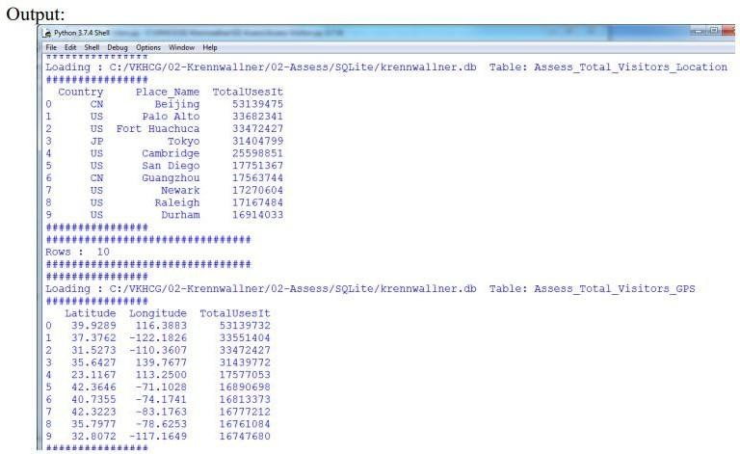

**5F. Write a Python / R program to plan the locations of the warehouses from the given data.**

import os

import pandas as pd from geopy.geocoders import Nominatim geolocator = Nominatim()

InputDir='01-Retrieve/01-EDS/01-R' InputFileName='Retrieve_GB_Postcode_Warehouse.csv' EDSDir='02-Assess/01-EDS'

OutputDir=EDSDir + '/02-Python'

OutputFileName='Assess_GB_Warehouse_Address.csv' Company='03-Hillman'

Base='C:/VKHCG'

print('Working Base :',Base, ' using Windows')

sFileDir=Base + '/' + Company + '/' + EDSDir if not os.path.exists(sFileDir):

os.makedirs(sFileDir)

sFileDir=Base + '/' + Company + '/' +

OutputDir if not os.path.exists(sFileDir): os.makedirs(sFileDir)

sFileName=Base + '/' + Company + '/' + InputDir + '/' + InputFileName

print('Loading :',sFileName)

Warehouse=pd.read_csv(sFileName,header=0,low_memory=False) Warehouse.sort_values(by='postcode', ascending=1) WarehouseGoodHead=Warehouse[Warehouse.latitude != 0].head(5) WarehouseGoodTail=Warehouse[Warehouse.latitude != 0].tail(5)

WarehouseGoodHead['Warehouse_Point']=WarehouseGoodHead.apply(lambda row:

(str(row['latitude'])+','+str(row['longitude'])) ,axis=1) WarehouseGoodHead['Warehouse_Address']=WarehouseGoodHead.apply(lambda row: geolocator.reverse(row['Warehouse_Point']).address,axis=1) WarehouseGoodHead.drop('Warehouse_Point', axis=1, inplace=True) WarehouseGoodHead.drop('id', axis=1, inplace=True)

WarehouseGoodHead.drop('postcode', axis=1, inplace=True)

WarehouseGoodTail['Warehouse_Point']=WarehouseGoodTail.apply(lambda row:(str(row['latitude'])+','+str(row['longitude'])) ,axis=1) WarehouseGoodTail['Warehouse_Address']=WarehouseGoodTail.apply(lambda row:geolocator.reverse(row['Warehouse_Point']).address ,axis=1) WarehouseGoodTail.drop('Warehouse_Point', axis=1, inplace=True)

WarehouseGoodTail.drop('id', axis=1, inplace=True)

WarehouseGoodTail.drop('postcode', axis=1, inplace=True)

WarehouseGood=WarehouseGoodHead.append(WarehouseGoodTail, ignore_index=True) print(WarehouseGood)

sFileName=sFileDir + '/' + OutputFileName

WarehouseGood.to_csv(sFileName, index = False)

print('### Done!! ############################################')

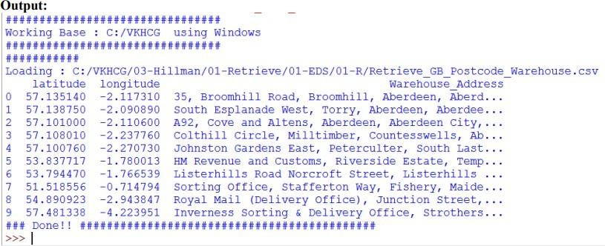

### 5G. Write a Python / R program using data science via clustering to determine new warehouses using the given data

import sys import os

import pandas as pd Base='C:/VKHCG'

print('Working Base :',Base, ' using ', sys.platform)

Company='03-Hillman' InputDir='01-Retrieve/01-EDS/01-R' InputFileName='Retrieve_All_Countries.csv'

EDSDir='02-Assess/01-EDS' OutputDir=EDSDir + '/02-Python'

OutputFileName='Assess_All_Warehouse.csv'

sFileDir=Base + '/' + Company + '/' +

EDSDir if not os.path.exists(sFileDir): os.makedirs(sFileDir)

sFileDir=Base + '/' + Company + '/' +

OutputDir if not os.path.exists(sFileDir): os.makedirs(sFileDir)

sFileName=Base + '/' + Company + '/' + InputDir + '/' +

InputFileName

print('Loading :',sFileName)

Warehouse=pd.read_csv(sFileName,header=0,low_memory=False, encoding="latin-1")

sColumns={'X1' : 'Country', 'X2' : 'PostCode',

'X3' : 'PlaceName',

'X4' : 'AreaName',

'X5' : 'AreaCode',

'X10' : 'Latitude'

'X11' : 'Longitude'}

Warehouse.rename(columns=sColumns,inplace=True)

WarehouseGood=Warehouse

sFileName=sFileDir + '/' +

OutputFileName WarehouseGood.to_csv(sFileName, index = False)

print('### Done!! ')

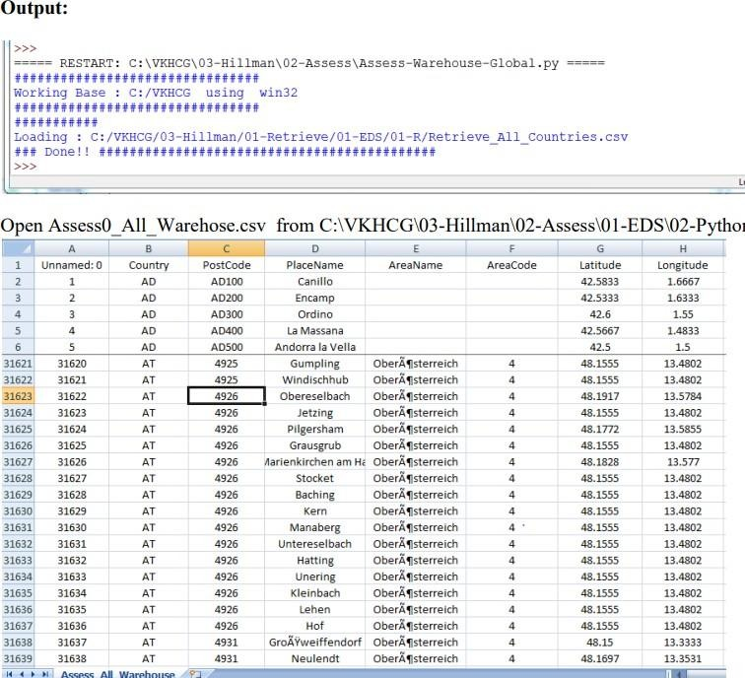

**5H. Using the given data, write a Python / R program to plan the shipping routes for best-fit international logistics**.

import sys import os

import pandas as pd

import networkx as nx from geopy.distance import vincenty

import sqlite3 as sq from pandas.io

import sql

if sys.platform == 'linux': Base=os.path.expanduser('~') + '/VKHCG' else: Base='C:/VKHCG'

print('Working Base :',Base, ' using ', sys.platform)

Company='03-Hillman'

InputDir='01-Retrieve/01-EDS/01-R' InputFileName='Retrieve_All_Countries.csv' EDSDir='02-Assess/01-EDS' OutputDir=EDSDir + '/02-Python'

OutputFileName='Assess_Best_Logistics.gml'

sFileDir=Base + '/' + Company + '/' +

EDSDir if not os.path.exists(sFileDir): os.makedirs(sFileDir)

sFileDir=Base + '/' + Company + '/' +

OutputDir if not os.path.exists(sFileDir): os.makedirs(sFileDir)

sDataBaseDir=Base + '/' + Company + '/02-Assess/SQLite' if not os.path.exists(sDataBaseDir):

os.makedirs(sDataBaseDir)

sDatabaseName=sDataBaseDir + '/Hillman.db' conn = sq.connect(sDatabaseName) sFileName=Base + '/' + Company + '/' + InputDir + '/' + InputFileName

print('Loading :',sFileName)

Warehouse=pd.read_csv(sFileName,header=0,low_memory=False, encoding="latin-1")

sColumns={'X1' : 'Country', 'X2' : 'PostCode',

'X3' : 'PlaceName',

'X4' : 'AreaName',

'X5' : 'AreaCode',

'X10' : 'Latitude',

'X11' : 'Longitude'} Warehouse.rename(columns=sColumns,inplace=True) WarehouseGood=Warehouse

#print(WarehouseGood.head())

RoutePointsCountry=pd.DataFrame(WarehouseGood.groupby(['Country'])[['Latitude','Longit ude' ]].mean())

#print(RoutePointsCountry.head())

sTable='Assess_RoutePointsCountry' print('Storing :',sDatabaseName,' Table:',sTable)

RoutePointsCountry.to_sql(sTable, conn, if_exists="replace")

RoutePointsPostCode=pd.DataFrame(WarehouseGood.groupby(['Country', 'PostCode'])[['Latitude','Longitude']].mean())

#print(RoutePointsPostCode.head())

sTable='Assess_RoutePointsPostCode' print('Storing :',sDatabaseName,' Table:',sTable)

RoutePointsPostCode.to_sql(sTable, conn, if_exists="replace")

RoutePointsPlaceName=pd.DataFrame(WarehouseGood.groupby(['Country', 'PostCode','PlaceName'])[['Latitude','Longitude']].mean())

#print(RoutePointsPlaceName.head())

sTable='Assess_RoutePointsPlaceName' print('Storing :',sDatabaseName,' Table:',sTable)

RoutePointsPlaceName.to_sql(sTable, conn, if_exists="replace")

### Fit Country to Country

sView='Assess_RouteCountries'

print('Creating :',sDatabaseName,' View:',sView)

sSQL="DROP VIEW IF EXISTS " + sView + ";"

sql.execute(sSQL,conn)

sSQL="CREATE VIEW " + sView + " AS" sSQL=sSQL+ " SELECT DISTINCT"

sSQL=sSQL+ " S.Country AS SourceCountry," sSQL=sSQL+ " S.Latitude AS SourceLatitude," sSQL=sSQL+ " S.Longitude AS SourceLongitude," sSQL=sSQL+ " T.Country AS TargetCountry," sSQL=sSQL+ " T.Latitude AS TargetLatitude," sSQL=sSQL+ " T.Longitude AS TargetLongitude" sSQL=sSQL+ " FROM"

sSQL=sSQL+ " Assess_RoutePointsCountry AS S" sSQL=sSQL+ " ,"

sSQL=sSQL+ " Assess_RoutePointsCountry AS T"

sSQL=sSQL+ " WHERE S.Country <> T.Country" sSQL=sSQL+ " AND"

sSQL=sSQL+ " S.Country in ('GB','DE','BE','AU','US','IN')" sSQL=sSQL+ " AND"

sSQL=sSQL+ " T.Country in ('GB','DE','BE','AU','US','IN');"

sql.execute(sSQL,conn)

print('Loading :',sDatabaseName,' Table:',sView) sSQL=" SELECT "

sSQL=sSQL+ " *" sSQL=sSQL+ " FROM" sSQL=sSQL+ " " + sView + ";"

RouteCountries=pd.read_sql_query(sSQL, conn) RouteCountries['Distance']=RouteCountries.apply(lambda row: round(vincenty((row['SourceLatitude'],row['SourceLongitude']), (row['TargetLatitude'],row['TargetLongitude'])).miles,4),axis=1)

print(RouteCountries.head(5))

### Fit Country to Post Code

sView='Assess_RoutePostCode'

print('Creating :',sDatabaseName,' View:',sView) sSQL="DROP VIEW IF EXISTS " + sView + ";"

sql.execute(sSQL,conn)

sSQL="CREATE VIEW " + sView + " AS" sSQL=sSQL+ " SELECT DISTINCT"

sSQL=sSQL+ " S.Country AS SourceCountry," sSQL=sSQL+ " S.Latitude AS SourceLatitude," sSQL=sSQL+ " S.Longitude AS SourceLongitude,

sSQL=sSQL+ " T.Country AS TargetCountry," sSQL=sSQL+ " T.PostCode AS TargetPostCode," sSQL=sSQL+ " T.Latitude AS TargetLatitude," sSQL=sSQL+ " T.Longitude AS TargetLongitude" sSQL=sSQL+ " FROM"

sSQL=sSQL+ " Assess_RoutePointsCountry AS S" sSQL=sSQL+ " ,"

sSQL=sSQL+ " Assess_RoutePointsPostCode AS T" sSQL=sSQL+ " WHERE S.Country = T.Country" sSQL=sSQL+ " AND"

sSQL=sSQL+ " S.Country in ('GB','DE','BE','AU','US','IN')" sSQL=sSQL+ " AND"

sSQL=sSQL+ " T.Country in ('GB','DE','BE','AU','US','IN');"

sql.execute(sSQL,conn)

print('Loading :',sDatabaseName,' Table:',sView) sSQL=" SELECT "

sSQL=sSQL+ " *" sSQL=sSQL+ " FROM" sSQL=sSQL+ " " + sView + ";"

RoutePostCode=pd.read_sql_query(sSQL, conn) RoutePostCode['Distance']=RoutePostCode.apply(lambda row: round(vincenty((row['SourceLatitude'],row['SourceLongitude']), (row['TargetLatitude'],row['TargetLongitude'])).miles ,4) ,axis=1)

print(RoutePostCode.head(5))

### Fit Post Code to Place Name

sView='Assess_RoutePlaceName' print('Creating :',sDatabaseName,' View:',sView)

sSQL="DROP VIEW IF EXISTS " + sView + ";"

sql.execute(sSQL,conn)

sSQL="CREATE VIEW " + sView + " AS" sSQL=sSQL+ " SELECT DISTINCT"

sSQL=sSQL+ " S.Country AS SourceCountry," sSQL=sSQL+ " S.PostCode AS SourcePostCode," sSQL=sSQL+ " S.Latitude AS SourceLatitude," sSQL=sSQL+ " S.Longitude AS SourceLongitude," sSQL=sSQL+ " T.Country AS TargetCountry," sSQL=sSQL+ " T.PostCode AS TargetPostCode," sSQL=sSQL+ " T.PlaceName AS TargetPlaceName," sSQL=sSQL+ " T.Latitude AS TargetLatitude," sSQL=sSQL+ " T.Longitude AS TargetLongitude" sSQL=sSQL+ " FROM"

sSQL=sSQL+ " Assess_RoutePointsPostCode AS S" sSQL=sSQL+ " ,"

sSQL=sSQL+ " Assess_RoutePointsPLaceName AS T" sSQL=sSQL+ " WHERE"

sSQL=sSQL+ " S.Country = T.Country" sSQL=sSQL+ " AND"

sSQL=sSQL+ " S.PostCode = T.PostCode" sSQL=sSQL+ " AND"

sSQL=sSQL+ " S.Country in ('GB','DE','BE','AU','US','IN')" sSQL=sSQL+ " AND"

sSQL=sSQL+ " T.Country in ('GB','DE','BE','AU','US','IN');"

sql.execute(sSQL,conn)

print('Loading :',sDatabaseName,' Table:',sView) sSQL=" SELECT "

sSQL=sSQL+ " *" sSQL=sSQL+ " FROM"

sSQL=sSQL+ " " + sView + ";"

RoutePlaceName=pd.read_sql_query(sSQL, conn) RoutePlaceName['Distance']=RoutePlaceName.apply(lambda row: round(vincenty((row['SourceLatitude'],row['SourceLongitude']), (row['TargetLatitude'],row['TargetLongitude'])).miles ,4) ,axis=1)

print(RoutePlaceName.head(5))

G=nx.Graph()

print('Countries:',RouteCountries.shape) for i in range(RouteCountries.shape[0]):

sNode0='C-' + RouteCountries['SourceCountry'][i] G.add_node(sNode0, Nodetype='Country', Country=RouteCountries['SourceCountry'][i],

Latitude=round(RouteCountries['SourceLatitude'][i],4), Longitude=round(RouteCountries['SourceLongitude'][i],4))

sNode1='C-' + RouteCountries['TargetCountry'][i] G.add_node(sNode1, Nodetype='Country', Country=RouteCountries['TargetCountry'][i],

Latitude=round(RouteCountries['TargetLatitude'][i],4), Longitude=round(RouteCountries['TargetLongitude'][i],4)) G.add_edge(sNode0,sNode1,distance=round(RouteCountries['Distance'][i],3)) #print(sNode0,sNode1)

print('PostCode:',RoutePostCode.shape)

for i in range(RoutePostCode.shape[0]):

sNode0='C-' + RoutePostCode['SourceCountry'][i] G.add_node(sNode0, Nodetype='Country', Country=RoutePostCode['SourceCountry'][i],

Latitude=round(RoutePostCode['SourceLatitude'][i],4), Longitude=round(RoutePostCode['SourceLongitude'][i],4))

sNode1='P-' + RoutePostCode['TargetPostCode'][i] + '-' + RoutePostCode['TargetCountry'][i] G.add_node(sNode1, Nodetype='PostCode', Country=RoutePostCode['TargetCountry'][i], PostCode=RoutePostCode['TargetPostCode'][i], Latitude=round(RoutePostCode['TargetLatitude'][i],4), Longitude=round(RoutePostCode['TargetLongitude'][i],4)) G.add_edge(sNode0,sNode1,distance=round(RoutePostCode['Distance'][i],3))

#print(sNode0,sNode1)

print('PlaceName:',RoutePlaceName.shape)

for i in range(RoutePlaceName.shape[0]):

sNode0='P-' + RoutePlaceName['TargetPostCode'][i] + '-' sNode0=sNode0 + RoutePlaceName['TargetCountry'][i]

G.add_node(sNode0, Nodetype='PostCode', Country=RoutePlaceName['SourceCountry'][i],

PostCode=RoutePlaceName['TargetPostCode'][i], Latitude=round(RoutePlaceName['SourceLatitude'][i],4), Longitude=round(RoutePlaceName['SourceLongitude'][i],4))

sNode1='L-' + RoutePlaceName['TargetPlaceName'][i] + '-' sNode1=sNode1 + RoutePlaceName['TargetPostCode'][i] + '-'

sNode1=sNode1 + RoutePlaceName['TargetCountry'][i] G.add_node(sNode1, Nodetype='PlaceName', Country=RoutePlaceName['TargetCountry'][i],

PostCode=RoutePlaceName['TargetPostCode'][i], PlaceName=RoutePlaceName['TargetPlaceName'][i], Latitude=round(RoutePlaceName['TargetLatitude'][i],4), Longitude=round(RoutePlaceName['TargetLongitude'][i],4))

G.add_edge(sNode0,sNode1,distance=round(RoutePlaceName['Distance'][i],3)) #print(sNode0,sNode1)

sFileName=sFileDir + '/' +

OutputFileName

print('Storing :', sFileName)

nx.write_gml(G,sFileName)

sFileName=sFileName +'.gz' nx.write_gml(G,sFileName)

print('Path:', nx.shortest_path(G,source='P-SW1-GB',target='P-01001-US',weight='distance')) print('Path length:', nx.shortest_path_length(G,source='P-SW1-GB',target='P-01001- US',weight='distance'))

print('Path length (1):', nx.shortest_path_length(G,source='P-SW1- GB',target='CGB',weight='distance'))

print('Path length (2):', nx.shortest_path_length(G,source='C- GB',target='CUS',weight='distance')) print('Path length (3):', nx.shortest_path_length(G,source='C-US',target='P-01001- US',weight='distance'))

print('Routes from P-SW1-GB < 2: ', nx.single_source_shortest_path(G,source='P-SW1-GB'

,cutoff=1)) print('Routes from P-01001-US < 2: ', nx.single_source_shortest_path(G,source='P-01001-US' ,cutoff=1))

print('Vacuum Database') sSQL="VACUUM;"

sql.execute(sSQL,conn)

**Output: You can now query features out of a graph, such as shortage paths between locations and paths from a given location, using Assess_Best_Logistics.gml with appropirate application**

**5I) Write a Python / R program to decide the best packing option to ship in container from the given data**

import sys import os

import pandas as pd

import sqlite3 as sq from pandas.io

import sql Base='C:/VKHCG'

print('Working Base :',Base, ' using ', sys.platform)

Company='03-Hillman'

InputDir='01-Retrieve/01-EDS/02-Python' InputFileName1='Retrieve_Product.csv' InputFileName2='Retrieve_Box.csv' InputFileName3='Retrieve_Container.csv' EDSDir='02-Assess/01-EDS' OutputDir=EDSDir + '/02-Python'

OutputFileName='Assess_Shipping_Containers.csv'

sFileDir=Base + '/' + Company + '/' +

EDSDir if not os.path.exists(sFileDir): os.makedirs(sFileDir)

sFileDir=Base + '/' + Company + '/' +

if not os.path.exists(sFileDir): os.makedirs(sFileDir)

sDataBaseDir=Base + '/' + Company + '/02-Assess/SQLite' if not os.path.exists(sDataBaseDir): os.makedirs(sDataBaseDir)

sDatabaseName=sDataBaseDir + '/hillman.db' conn = sq.connect(sDatabaseName)

Import Product Data

sFileName=Base + '/' + Company + '/' + InputDir + '/' + InputFileName1

print('Loading :',sFileName) ProductRawData=pd.read_csv(sFileName, header=0, low_memory=False, encoding="latin-1" )

ProductRawData.drop_duplicates(subset=None, keep='first', inplace=True) ProductRawData.index.name = 'IDNumber' ProductData=ProductRawData[ProductRawData.Length <= 0.5].head(10) print('Loaded Product :',ProductData.columns.values)

sTable='Assess_Product'

print('Storing :',sDatabaseName,' Table:',sTable) ProductData.to_sql(sTable, conn, if_exists="replace")

print(ProductData.head())

print('Rows : ',ProductData.shape[0])

Import Box Data

sFileName=Base + '/' + Company + '/' + InputDir + '/' + InputFileName2

print('Loading :',sFileName)

BoxRawData=pd.read_csv(sFileName, header=0, low_memory=False, encoding="latin-1" ) BoxRawData.drop_duplicates(subset=None, keep='first', inplace=True)

BoxRawData.index.name = 'IDNumber' BoxData=BoxRawData[BoxRawData.Length <= 1].head(1000) print('Loaded Product :',BoxData.columns.values)

sTable='Assess_Box'

print('Storing :',sDatabaseName,' Table:',sTable)

BoxData.to_sql(sTable, conn, if_exists="replace")

print(BoxData.head())

print('Rows : ',BoxData.shape[0])

Import Container Data

sFileName=Base + '/' + Company + '/' + InputDir + '/' + InputFileName3

print('Loading :',sFileName)

ContainerRawData=pd.read_csv(sFileName, header=0, low_memory=False, encoding="latin-1" ) ContainerRawData.drop_duplicates(subset=None, keep='first', inplace=True) ContainerRawData.index.name = 'IDNumber' ContainerData=ContainerRawData[ContainerRawData.Length <= 2].head(10)

print('Loaded Product :',ContainerData.columns.values)

sTable='Assess_Container'

print('Storing :',sDatabaseName,' Table:',sTable) BoxData.to_sql(sTable, conn, if_exists="replace")

print(ContainerData.head())

print('Rows : ',ContainerData.shape[0])

### Fit Product in Box

sView='Assess_Product_in_Box'

print('Creating :',sDatabaseName,' View:',sView) sSQL="DROP VIEW IF EXISTS " + sView + ";"

sql.execute(sSQL,conn)

sSQL="CREATE VIEW " + sView + " AS" sSQL=sSQL+ " SELECT"

sSQL=sSQL+ " P.UnitNumber AS ProductNumber," sSQL=sSQL+ " B.UnitNumber AS BoxNumber," sSQL=sSQL+ " (B.Thickness * 1000) AS PackSafeCode,"

sSQL=sSQL+ " (B.BoxVolume - P.ProductVolume) AS PackFoamVolume,"

sSQL=sSQL+ " ((B.Length*10) * (B.Width*10) * (B.Height*10)) * 167 AS Air_Dimensional_Weight," sSQL=sSQL+ " ((B.Length*10) * (B.Width*10) * (B.Height*10)) * 333 AS Road_Dimensional_Weight," sSQL=sSQL+ " ((B.Length*10) * (B.Width*10) * (B.Height*10)) * 1000 AS Sea_Dimensional_Weight," sSQL=sSQL+ " P.Length AS Product_Length,"

sSQL=sSQL+ " P.Width AS Product_Width," sSQL=sSQL+ " P.Height AS Product_Height,"

sSQL=sSQL+ " P.ProductVolume AS Product_cm_Volume,"

sSQL=sSQL+ " ((P.Length*10) * (P.Width*10) * (P.Height*10)) AS Product_ccm_Volume," sSQL=sSQL+ " (B.Thickness * 0.95) AS Minimum_Pack_Foam,"

sSQL=sSQL+ " (B.Thickness * 1.05) AS Maximum_Pack_Foam,"

sSQL=sSQL+ " B.Length - (B.Thickness * 1.10) AS Minimum_Product_Box_Length," sSQL=sSQL+ " B.Length - (B.Thickness * 0.95) AS Maximum_Product_Box_Length," sSQL=sSQL+ " B.Width - (B.Thickness * 1.10) AS Minimum_Product_Box_Width," sSQL=sSQL+ " B.Width - (B.Thickness * 0.95) AS Maximum_Product_Box_Width," sSQL=sSQL+ " B.Height - (B.Thickness * 1.10) AS Minimum_Product_Box_Height," sSQL=sSQL+ " B.Height - (B.Thickness * 0.95) AS Maximum_Product_Box_Height," sSQL=sSQL+ " B.Length AS Box_Length,"

sSQL=sSQL+ " B.Width AS Box_Width," sSQL=sSQL+ " B.Height AS Box_Height,"

sSQL=sSQL+ " B.BoxVolume AS Box_cm_Volume,"

sSQL=sSQL+ " ((B.Length*10) * (B.Width*10) * (B.Height*10)) AS Box_ccm_Volume,"

sSQL=sSQL+ " (2 * B.Length * B.Width) + (2 * B.Length * B.Height) + (2 * B.Width * B.Height) AS Box_sqm_Area,"

sSQL=sSQL+ " ((B.Length*10) * (B.Width*10) * (B.Height*10)) * 3.5 AS Box_A_Max_Kg_Weight," sSQL=sSQL+ " ((B.Length*10) * (B.Width*10) * (B.Height*10)) * 7.7 AS Box_B_Max_Kg_Weight," sSQL=sSQL+ " ((B.Length*10) * (B.Width*10) * (B.Height*10)) * 10.0 AS Box_C_Max_Kg_Weight" sSQL=sSQL+ " FROM"

sSQL=sSQL+ " Assess_Product as P" sSQL=sSQL+ " ,"

sSQL=sSQL+ " Assess_Box as B" sSQL=sSQL+ " WHERE"

sSQL=sSQL+ " P.Length >= (B.Length - (B.Thickness * 1.10))" sSQL=sSQL+ " AND"

sSQL=sSQL+ " P.Width >= (B.Width - (B.Thickness * 1.10))" sSQL=sSQL+ " AND"

sSQL=sSQL+ " P.Height >= (B.Height - (B.Thickness * 1.10))" sSQL=sSQL+ " AND"

sSQL=sSQL+ " P.Length <= (B.Length - (B.Thickness * 0.95))" sSQL=sSQL+ " AND"

sSQL=sSQL+ " P.Width <= (B.Width - (B.Thickness * 0.95))" sSQL=sSQL+ " AND"

sSQL=sSQL+ " P.Height <= (B.Height - (B.Thickness * 0.95))" sSQL=sSQL+ " AND"

sSQL=sSQL+ " (B.Height - B.Thickness) >= 0" sSQL=sSQL+ " AND"

sSQL=sSQL+ " (B.Width - B.Thickness) >= 0" sSQL=sSQL+ " AND"

sSQL=sSQL+ " (B.Height - B.Thickness) >= 0" sSQL=sSQL+ " AND"

sSQL=sSQL+ " B.BoxVolume >= P.ProductVolume;"

sql.execute(sSQL,conn)

### Fit Box in Pallet t=0 for l in range(2,8):

for w in range(2,8):

for h in range(4): t += 1 PalletLine=[('IDNumber',[t]), ('ShipType', ['Pallet']), ('UnitNumber',

('L-'+format(t,"06d"))), ('Box_per_Length',(format(2**l,"4d"))),

('Box_per_Width',(format(2**w,"4d"))), ('Box_per_Height',(format(2**h,"4d")))] if t==1: PalletFrame = pd.DataFrame.from_items(PalletLine)

else: PalletRow = pd.DataFrame.from_items(PalletLine) PalletFrame = PalletFrame.append(PalletRow)

PalletFrame.set_index(['IDNumber'],inplace=True)

PalletFrame.head()

print('Rows : ',PalletFrame.shape[0])

Fit Box on Pallet

sView='Assess_Box_on_Pallet'

print('Creating :',sDatabaseName,' View:',sView) sSQL="DROP VIEW IF EXISTS " + sView + ";"

sql.execute(sSQL,conn)

sSQL="CREATE VIEW " + sView + " AS" sSQL=sSQL+ " SELECT DISTINCT"

sSQL=sSQL+ " P.UnitNumber AS PalletNumber," sSQL=sSQL+ " B.UnitNumber AS BoxNumber,"

sSQL=sSQL+ " round(B.Length*P.Box_per_Length,3) AS Pallet_Length," sSQL=sSQL+ " round(B.Width*P.Box_per_Width,3) AS Pallet_Width," sSQL=sSQL+ " round(B.Height*P.Box_per_Height,3) AS Pallet_Height,"

sSQL=sSQL+ " P.Box_per_Length * P.Box_per_Width * P.Box_per_Height AS Pallet_Boxes" sSQL=sSQL+ " FROM"

sSQL=sSQL+ " Assess_Box as B" sSQL=sSQL+ " ,"

sSQL=sSQL+ " Assess_Pallet as P" sSQL=sSQL+ " WHERE"

sSQL=sSQL+ " round(B.Length*P.Box_per_Length,3) <= 20" sSQL=sSQL+ " AND"

sSQL=sSQL+ " round(B.Width*P.Box_per_Width,3) <= 9" sSQL=sSQL+ " AND"

sSQL=sSQL+ " round(B.Height*P.Box_per_Height,3) <= 5;"

sql.execute(sSQL,conn)

sTables=['Assess_Product_in_Box','Assess_Box_on_Pallet'] for sTable in sTables:

print('Loading :',sDatabaseName,' Table:',sTable) sSQL=" SELECT "

sSQL=sSQL+ " *" sSQL=sSQL+ " FROM"

sSQL=sSQL+ " " + sTable + ";" SnapShotData=pd.read_sql_query(sSQL, conn)

sTableOut=sTable + '_SnapShot'

print('Storing :',sDatabaseName,' Table:',sTable) SnapShotData.to_sql(sTableOut, conn, if_exists="replace")

### Fit Pallet in Container

sTables=['Length','Width','Height']

for sTable in sTables: sView='Assess_Pallet_in_Container_' + sTable

print('Creating :',sDatabaseName,' View:',sView) sSQL="DROP VIEW IF EXISTS " + sView + ";"

sql.execute(sSQL,conn)

sSQL="CREATE VIEW " + sView + " AS" sSQL=sSQL+ " SELECT DISTINCT"

sSQL=sSQL+ " C.UnitNumber AS ContainerNumber," sSQL=sSQL+ " P.PalletNumber,"

sSQL=sSQL+ " P.BoxNumber,"

sSQL=sSQL+ " round(C." + sTable + "/P.Pallet_" + sTable + ",0)" sSQL=sSQL+ " AS Pallet_per_" + sTable + ","

sSQL=sSQL+ " round(C." + sTable + "/P.Pallet_" + sTable + ",0)" sSQL=sSQL+ " * P.Pallet_Boxes AS Pallet_" + sTable + "_Boxes," sSQL=sSQL+ " P.Pallet_Boxes" sSQL=sSQL+ " FROM" sSQL=sSQL+ " Assess_Container as C"

sSQL=sSQL+ " ,"

sSQL=sSQL+ " Assess_Box_on_Pallet_SnapShot as P" sSQL=sSQL+ " WHERE"

sSQL=sSQL+ " round(C.Length/P.Pallet_Length,0) > 0" sSQL=sSQL+ " AND"

sSQL=sSQL+ " round(C.Width/P.Pallet_Width,0) > 0" sSQL=sSQL+ " AND"

sSQL=sSQL+ " round(C.Height/P.Pallet_Height,0) > 0;" sql.execute(sSQL,conn)

print('Loading :',sDatabaseName,' Table:',sView) sSQL=" SELECT "

sSQL=sSQL+ " *" sSQL=sSQL+ " FROM" sSQL=sSQL+ " " + sView + ";"

SnapShotData=pd.read_sql_query(sSQL, conn)

sTableOut= sView + '_SnapShot' print('Storing :',sDatabaseName,' Table:',sTableOut) SnapShotData.to_sql(sTableOut, conn, if_exists="replace")

sView='Assess_Pallet_in_Container' print('Creating :',sDatabaseName,' View:',sView) sSQL="DROP VIEW IF EXISTS " + sView + ";"

sql.execute(sSQL,conn)

sSQL="CREATE VIEW " + sView + " AS" sSQL=sSQL+ " SELECT"

sSQL=sSQL+ " CL.ContainerNumber," sSQL=sSQL+ " CL.PalletNumber," sSQL=sSQL+ " CL.BoxNumber,"

sSQL=sSQL+ " CL.Pallet_Boxes AS Boxes_per_Pallet," sSQL=sSQL+ " CL.Pallet_per_Length,"

sSQL=sSQL+ " CW.Pallet_per_Width," sSQL=sSQL+ " CH.Pallet_per_Height,"

sSQL=sSQL+ " CL.Pallet_Length_Boxes * CW.Pallet_Width_Boxes * CH.Pallet_Height_Boxes AS Container_Boxes"

sSQL=sSQL+ " FROM"

sSQL=sSQL+ " Assess_Pallet_in_Container_Length_SnapShot as CL" sSQL=sSQL+ " JOIN"

sSQL=sSQL+ " Assess_Pallet_in_Container_Width_SnapShot as CW" sSQL=sSQL+ " ON"

sSQL=sSQL+ " CL.ContainerNumber = CW.ContainerNumber" sSQL=sSQL+ " AND"

sSQL=sSQL+ " CL.PalletNumber = CW.PalletNumber" sSQL=sSQL+ " AND"

sSQL=sSQL+ " CL.BoxNumber = CW.BoxNumber"

sSQL=sSQL+ " JOIN"

sSQL=sSQL+ " Assess_Pallet_in_Container_Height_SnapShot as CH" sSQL=sSQL+ " ON"

sSQL=sSQL+ " CL.ContainerNumber = CH.ContainerNumber" sSQL=sSQL+ " AND"

sSQL=sSQL+ " CL.PalletNumber = CH.PalletNumber" sSQL=sSQL+ " AND"

sSQL=sSQL+ " CL.BoxNumber = CH.BoxNumber;"

sql.execute(sSQL,conn)

sTables=['Assess_Product_in_Box','Assess_Pallet_in_Container'] for sTable in sTables:

print('Loading :',sDatabaseName,' Table:',sTable) sSQL=" SELECT "

sSQL=sSQL+ " *" sSQL=sSQL+ " FROM"

sSQL=sSQL+ " " + sTable + ";" PackData=pd.read_sql_query(sSQL, conn)

print(PackData)

print('Rows : ',PackData.shape[0])

sFileName=sFileDir + '/' + sTable + '.csv' print(sFileName) PackData.to_csv(sFileName, index = False)

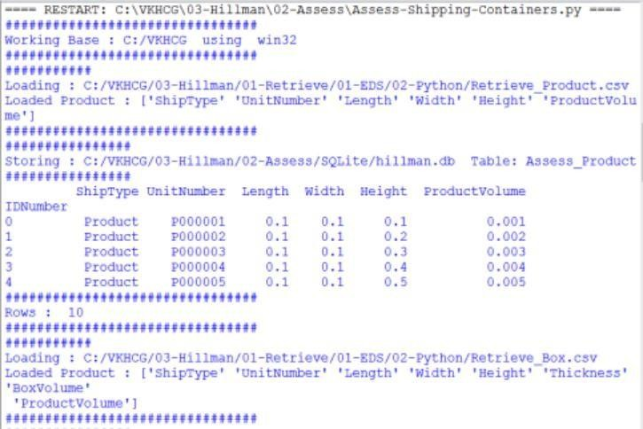

### J. Write a Python program to create a delivery route using the given data.

import sys import os

import pandas as pd

import sqlite3 as sq from pandas.io import sql

import networkx as nx from geopy.distance

import vincenty

nMax=3

nMaxPath=10 nSet=False nVSet=False

Base='C:/VKHCG'

print('Working Base :',Base, ' using ', sys.platform)

Company='03-Hillman' InputDir1='01-Retrieve/01-EDS/01-R'

InputDir2='01-Retrieve/01-EDS/02-Python' InputFileName1='Retrieve_GB_Postcode_Warehouse.csv' InputFileName2='Retrieve_GB_Postcodes_Shops.csv'

EDSDir='02-Assess/01-EDS' OutputDir=EDSDir + '/02-Python'

OutputFileName1='Assess_Shipping_Routes.gml'

OutputFileName2='Assess_Shipping_Routes.txt'

sFileDir=Base + '/' + Company + '/' +

EDSDir if not os.path.exists(sFileDir): os.makedirs(sFileDir)

sFileDir=Base + '/' + Company + '/' +

OutputDir if not os.path.exists(sFileDir): os.makedirs(sFileDir)

sDataBaseDir=Base + '/' + Company + '/02-Assess/SQLite' if not os.path.exists(sDataBaseDir):

os.makedirs(sDataBaseDir)

sDatabaseName=sDataBaseDir + '/hillman.db'

conn = sq.connect(sDatabaseName)

Import Warehouse Data

sFileName=Base + '/' + Company + '/' + InputDir1 + '/' +

InputFileName1 print('###########')

print('Loading :',sFileName)

WarehouseRawData=pd.read_csv(sFileName, header=0, low_memory=False, encoding="latin-1" ) WarehouseRawData.drop_duplicates(subset=None, keep='first', inplace=True) WarehouseRawData.index.name = 'IDNumber'

WarehouseData=WarehouseRawData.head(nMax) WarehouseData=WarehouseData.append(WarehouseRawData.tail(nMax))

WarehouseData=WarehouseData.append(WarehouseRawData[WarehouseRawData.postcode

=='KA13'])

if nSet==True: WarehouseData=WarehouseData.append(WarehouseRawData[WarehouseRawData.postcode

=='SW1W'])

WarehouseData.drop_duplicates(subset=None, keep='first', inplace=True) print('Loaded Warehouses :',WarehouseData.columns.values)

sTable='Assess_Warehouse_UK'

print('Storing :',sDatabaseName,' Table:',sTable) WarehouseData.to_sql(sTable, conn, if_exists="replace")

print(WarehouseData.head())

print('Rows : ',WarehouseData.shape[0])

Import Shop Data

sFileName=Base + '/' + Company + '/' + InputDir1 + '/' +

InputFileName2

print('Loading :',sFileName)

ShopRawData=pd.read_csv(sFileName, header=0, low_memory=False, encoding="latin-1" ) ShopRawData.drop_duplicates(subset=None, keep='first', inplace=True)

ShopRawData.index.name = 'IDNumber'

ShopData=ShopRawData

print('Loaded Shops :',ShopData.columns.values)

sTable='Assess_Shop_UK'

print('Storing :',sDatabaseName,' Table:',sTable) ShopData.to_sql(sTable, conn, if_exists="replace")

print(ShopData.head())

print('Rows : ',ShopData.shape[0])

Connect HQ

sView='Assess_HQ'

print('Creating :',sDatabaseName,' View:',sView) sSQL="DROP VIEW IF EXISTS " + sView + ";"

sql.execute(sSQL,conn)

sSQL="CREATE VIEW " + sView + " AS" sSQL=sSQL+ " SELECT"

sSQL=sSQL+ " W.postcode AS HQ_PostCode," sSQL=sSQL+ " 'HQ-' || W.postcode AS HQ_Name," sSQL=sSQL+ " round(W.latitude,6) AS HQ_Latitude," sSQL=sSQL+ " round(W.longitude,6) AS HQ_Longitude" sSQL=sSQL+ " FROM"

sSQL=sSQL+ " Assess_Warehouse_UK as W" sSQL=sSQL+ " WHERE"

sSQL=sSQL+ " TRIM(W.postcode) in ('KA13','SW1W');"

sql.execute(sSQL,conn)

### Connect Warehouses

sView='Assess_Warehouse'

print('Creating :',sDatabaseName,' View:',sView)

sSQL="DROP VIEW IF EXISTS " + sView + ";"

sql.execute(sSQL,conn)

sSQL="CREATE VIEW " + sView + " AS" sSQL=sSQL+ " SELECT"

sSQL=sSQL+ " W.postcode AS Warehouse_PostCode," sSQL=sSQL+ " 'WH-' || W.postcode AS Warehouse_Name," sSQL=sSQL+ " round(W.latitude,6) AS Warehouse_Latitude," sSQL=sSQL+ " round(W.longitude,6) AS Warehouse_Longitude"

sSQL=sSQL+ " FROM" sSQL=sSQL+ " Assess_Warehouse_UK as W;" sql.execute(sSQL,conn)

sView='Assess_Shop' print('Creating :',sDatabaseName,' View:',sView) sSQL="DROP VIEW IF EXISTS " +

sView + ";" sql.execute(sSQL,conn) sSQL="CREATE VIEW " + sView + " AS" sSQL=sSQL+ " SELECT"

sSQL=sSQL+ " TRIM(S.postcode) AS Shop_PostCode,"

sSQL=sSQL+ " 'SP-' || TRIM(S.FirstCode) || '-' || TRIM(S.SecondCode) AS Shop_Name," sSQL=sSQL+ " TRIM(S.FirstCode) AS Warehouse_PostCode,"

sSQL=sSQL+ " round(S.latitude,6) AS Shop_Latitude," sSQL=sSQL+ " round(S.longitude,6) AS Shop_Longitude" sSQL=sSQL+ " FROM"

sSQL=sSQL+ " Assess_Warehouse_UK as W" sSQL=sSQL+ " JOIN"

sSQL=sSQL+ " Assess_Shop_UK as S" sSQL=sSQL+ " ON"

sSQL=sSQL+ " TRIM(W.postcode) = TRIM(S.FirstCode);"

sql.execute(sSQL,conn)

G=nx.Graph()

sTable = 'Assess_HQ'

print('Loading :',sDatabaseName,' Table:',sTable) sSQL=" SELECT DISTINCT"

sSQL=sSQL+ " *" sSQL=sSQL+ " FROM"

sSQL=sSQL+ " " + sTable + ";"

RouteData=pd.read_sql_query(sSQL, conn)

print(RouteData.head())

print('HQ Rows : ',RouteData.shape[0])

for i in range(RouteData.shape[0]): sNode0=RouteData['HQ_Name'][i] G.add_node(sNode0, Nodetype='HQ', PostCode=RouteData['HQ_PostCode'][i], Latitude=round(RouteData['HQ_Latitude'][i],6),

Longitude=round(RouteData['HQ_Longitude'][i],6))

sTable = 'Assess_Warehouse'

print('Loading :',sDatabaseName,' Table:',sTable) sSQL=" SELECT DISTINCT"

sSQL=sSQL+ " *" sSQL=sSQL+ " FROM" sSQL=sSQL+ " " +

sTable + ";" RouteData=pd.read_sql_query(sSQL, conn)

print(RouteData.head())

print('Warehouse Rows : ',RouteData.shape[0])

for i in range(RouteData.shape[0]): sNode0=RouteData['Warehouse_Name'][i] G.add_node(sNode0, Nodetype='Warehouse',

PostCode=RouteData['Warehouse_PostCode'][i], Latitude=round(RouteData['Warehouse_Latitude'][i],6), Longitude=round(RouteData['Warehouse_Longitude'][i],6))

sTable = 'Assess_Shop'

print('Loading :',sDatabaseName,' Table:',sTable) sSQL=" SELECT DISTINCT"

sSQL=sSQL+ " *" sSQL=sSQL+ " FROM"

sSQL=sSQL+ " " + sTable + ";" RouteData=pd.read_sql_query(sSQL, conn)

print(RouteData.head())

print('Shop Rows : ',RouteData.shape[0])

for i in range(RouteData.shape[0]): sNode0=RouteData['Shop_Name'][i] G.add_node(sNode0, Nodetype='Shop',

PostCode=RouteData['Shop_PostCode'][i], WarehousePostCode=RouteData['Warehouse_PostCode'][i], Latitude=round(RouteData['Shop_Latitude'][i],6), Longitude=round(RouteData['Shop_Longitude'][i],6))

## Create Edges

print('Loading Edges')

for sNode0 in nx.nodes_iter(G):

for sNode1 in nx.nodes_iter(G):

if G.node[sNode0]['Nodetype']=='HQ' and \ G.node[sNode1]['Nodetype']=='HQ' and \ sNode0 != sNode1: distancemeters=round(\ vincenty(\ (\ G.node[sNode0]['Latitude'],\ G.node[sNode0]['Longitude']\

),\ (\ G.node[sNode1]['Latitude']\ ,\ G.node[sNode1]['Longitude']\ )\ ).meters\ ,0)

distancemiles=round(\ vincenty(\ (\ G.node[sNode0]['Latitude'],\ G.node[sNode0]['Longitude']\ ),\ (\ G.node[sNode1]['Latitude']\ ,\ G.node[sNode1]['Longitude']\ )\ ).miles\ ,3)

if distancemiles >= 0.05: cost = round(150+(distancemiles * 2.5),6) vehicle='V001' else: cost

= round(2+(distancemiles * 0.10),6) vehicle='ForkLift' G.add_edge(sNode0,sNode1,DistanceMeters=distancemeters, \ DistanceMiles=distancemiles,

\ Cost=cost,Vehicle=vehicle) if nVSet==True:

print('Edge-H-H:',sNode0,' to ', sNode1, \ ' Distance:',distancemeters,'meters',\ distancemiles,'miles','Cost', cost,'Vehicle',vehicle)

if G.node[sNode0]['Nodetype']=='HQ' and \ G.node[sNode1]['Nodetype']=='Warehouse' and \ sNode0 != sNode1: distancemeters=round(\ vincenty(\ (\ G.node[sNode0]['Latitude'],\ G.node[sNode0]['Longitude']\ ),\ (\ G.node[sNode1]['Latitude']\ ,\ G.node[sNode1]['Longitude']\ )\ ).meters\ ,0)

distancemiles=round(\ vincenty(\ (\ G.node[sNode0]['Latitude'],\ G.node[sNode0]['Longitude']\ ),\ (\ G.node[sNode1]['Latitude']\ ,\ G.node[sNode1]['Longitude']\ )\ ).miles\ ,3) if distancemiles >= 10: cost = round(50+(distancemiles * 2),6)

vehicle='V002' else: cost = round(5+(distancemiles * 1.5),6) vehicle='V003' if distancemiles <= 50:

G.add_edge(sNode0,sNode1,DistanceMeters=distancemeters, \ DistanceMiles=distancemiles,

\ Cost=cost,Vehicle=vehicle) if nVSet==True: print('Edge-H-W:',sNode0,' to ', sNode1, \ ' Distance:',distancemeters,'meters',\ distancemiles,'miles','Cost', cost,'Vehicle',vehicle)

if nSet==True

and \ G.node[sNode0]['Nodetype']=='Warehouse'

and \ G.node[sNode1]['Nodetype']=='Warehouse' and \ sNode0 != sNode1: distancemeters=round(\ vincenty(\ (\ G.node[sNode0]['Latitude'],\ G.node[sNode0]['Longitude']\ ),\ (\ G.node[sNode1]['Latitude']\ ,

\ G.node[sNode1]['Longitude']\ )\ ).meters\ ,0) distancemiles=round(\ vincenty(\ (\ G.node[sNode0]['Latitude'],\

G.node[sNode0]['Longitude']\ ),\ (\ G.node[sNode1]['Latitude']\

\ G.node[sNode1]['Longitude']\ )\ ).miles\ ,3)

if distancemiles >= 10: cost = round(50+(distancemiles * 1.10),6) vehicle='V004' else: cost = round(5+(distancemiles * 1.05),6)

vehicle='V005' if distancemiles <= 20:

G.add_edge(sNode0,sNode1,DistanceMeters=distancemeters, \ DistanceMiles=distancemiles, \ Cost=cost,Vehicle=vehicle)

if nVSet==True: print('Edge-W-W:',sNode0,' to ', sNode1, \ ' Distance:',distancemeters,'meters',\ distancemiles,'miles','Cost', cost,'Vehicle',vehicle)

if G.node[sNode0]['Nodetype']=='Warehouse' and \ G.node[sNode1]['Nodetype']=='Shop' and \ G.node[sNode0]['PostCode']==G.node[sNode1]['WarehousePostCode'] and \ sNode0 != sNode1: distancemeters=round(\ vincenty(\ (\ G.node[sNode0]['Latitude'],\

G.node[sNode0]['Longitude']\ ),\ (\ G.node[sNode1]['Latitude']\ ,\ G.node[sNode1]['Longitude']\ )\ ).meters\ ,0) distancemiles=round(\ vincenty(\

(\ G.node[sNode0]['Latitude'],\ G.node[sNode0]['Longitude']\ ),\ (\ G.node[sNode1]['Latitude']\ ,\

G.node[sNode1]['Longitude']\ )\ ).miles\ ,3) if distancemiles >= 10:

cost = round(50+(distancemiles * 1.50),6)

vehicle='V006' else: cost = round(5+(distancemiles * 0.75),6) vehicle='V007' if distancemiles <= 10:

G.add_edge(sNode0,sNode1,DistanceMeters=distancemeters, \ DistanceMiles=distancemiles,

\ Cost=cost,Vehicle=vehicle) if nVSet==True:

print('Edge-W-S:',sNode0,' to ', sNode1, \ ' Distance:',distancemeters,'meters',\ distancemiles,'miles','Cost', cost,'Vehicle',vehicle)

if nSet==True

and \ G.node[sNode0]['Nodetype']=='Shop' and \

G.node[sNode1]['Nodetype']=='Shop' and \ G.node[sNode0]['WarehousePostCode']==G.node[sNode1]['WarehousePostCode'] and \

sNode0 != sNode1: distancemeters=round(\ vincenty(\ (\ G.node[sNode0]['Latitude'],\ G.node[sNode0]['Longitude']\ ),\ (\ G.node[sNode1]['Latitude']\ ,\ G.node[sNode1]['Longitude']\ )\ ).meters\ ,0) distancemiles=round(\ vincenty(\ (\ G.node[sNode0]['Latitude'],\ G.node[sNode0]['Longitude']\ ),\ (\ G.node[sNode1]['Latitude']\

,\ G.node[sNode1]['Longitude']\ )\ ).miles\ ,3)

if distancemiles >= 0.05: cost = round(5+(distancemiles * 0.5),6) vehicle='V008' else: cost = round(1+(distancemiles * 0.1),6) vehicle='V009

if distancemiles <= 0.075: G.add_edge(sNode0,sNode1,DistanceMeters=distancemeters, \ DistanceMiles=distancemiles, \

Cost=cost,Vehicle=vehicle)

if nVSet==True: print('Edge-S-S:',sNode0,' to ', sNode1, \ ' Distance:',distancemeters,'meters',\ distancemiles,'miles','Cost', cost,'Vehicle',vehicle)

if nSet==True and \ G.node[sNode0]['Nodetype']=='Shop' and \

G.node[sNode1]['Nodetype']=='Shop' and \ G.node[sNode0]['WarehousePostCode']!=G.node[sNode1]['WarehousePostCode'] and \

sNode0 != sNode1: distancemeters=round(\ vincenty(\ (\ G.node[sNode0]['Latitude'],\ G.node[sNode0]['Longitude']\ ),\ (\ G.node[sNode1]['Latitude']\ ,\ G.node[sNode1]['Longitude']\ )\ ).meters\ ,0) distancemiles=round(\ vincenty(\ (\ G.node[sNode0]['Latitude'],\ G.node[sNode0]['Longitude']\ ),\ (\ G.node[sNode1]['Latitude']\

,\ G.node[sNode1]['Longitude']\ )\ ).miles\ ,3)

cost = round(1+(distancemiles * 0.1),6) vehicle='V010' if distancemiles <= 0.025:

G.add_edge(sNode0,sNode1,DistanceMeters=distancemeters, \ DistanceMiles=distancemiles,

\ Cost=cost,Vehicle=vehicle) if nVSet==True:

print('Edge-S-S:',sNode0,' to ', sNode1, \ ' Distance:',distancemeters,'meters',\ distancemiles,'miles','Cost', cost,'Vehicle',vehicle)

sFileName=sFileDir + '/' + OutputFileName1

print('Storing :', sFileName)

nx.write_gml(G,sFileName)

sFileName=sFileName +'.gz' nx.write_gml(G,sFileName) print('Nodes:',nx.number_of_nodes(G)) print('Edges:',nx.number_of_edges(G)) sFileName=sFileDir + '/' +

OutputFileName2

print('Storing :', sFileName)

## Create Paths

print('Loading Paths')

f = open(sFileName,'w') l=0

sline = 'ID|Cost|StartAt|EndAt|Path|Measure'

if nVSet==True: print ('0', sline) f.write(sline+ '\n') for sNode0 in nx.nodes_iter(G):

for sNode1 in nx.nodes_iter(G):

if sNode0 != sNode1 and \ nx.has_path(G, sNode0, sNode1)==True and \ nx.shortest_path_length(G, \ source=sNode0, \ target=sNode1, \ weight='DistanceMiles') < nMaxPath: l+=1 sID='{:.0f}'.format(l) spath = ','.join(nx.shortest_path(G, \ source=sNode0, \ target=sNode1, \ weight='DistanceMiles')) slength= '{:.6f}'.format(\ nx.shortest_path_length(G, \ source=sNode0, \ target=sNode1, \ weight='DistanceMiles'))

sline = sID + '|"DistanceMiles"|"' + sNode0 + '"|"' \ + sNode1 + '"|"' + spath + '"|' + slength if nVSet==True:

print (sline) f.write(sline + '\n') l+=1 sID='{:.0f}'.format(l) spath = ','.join(nx.shortest_path(G,

\ source=sNode0, \ target=sNode1, \ weight='DistanceMeters'))

slength= '{:.6f}'.format(\ nx.shortest_path_length(G, \ source=sNode0, \

target=sNode1, \ weight='DistanceMeters'))

sline = sID + '|"DistanceMeters"|"' + sNode0 + '"|"' \ + sNode1 + '"|"' + spath + '"|' + slength if nVSet==True:

print (sline) f.write(sline + '\n') l+=1 sID='{:.0f}'.format(l) spath = ','.join(nx.shortest_path(G, \

source=sNode0, \ target=sNode1, \ weight='Cost'))

slength= '{:.6f}'.format(\ nx.shortest_path_length(G, \ source=sNode0, \ target=sNode1, \ weight='Cost'))

sline = sID + '|"Cost"|"' + sNode0 + '"|"' \ + sNode1 + '"|"' + spath + '"|' + slength if nVSet==True: print (sline)

f.write(sline + '\n') f.close() print('Nodes:',nx.number_of_nodes(G)) print('Edges:',nx.number_of_edges(G)) print('Paths:',sID)

print('Vacuum Database') sSQL="VACUUM;"

sql.execute(sSQL,conn)

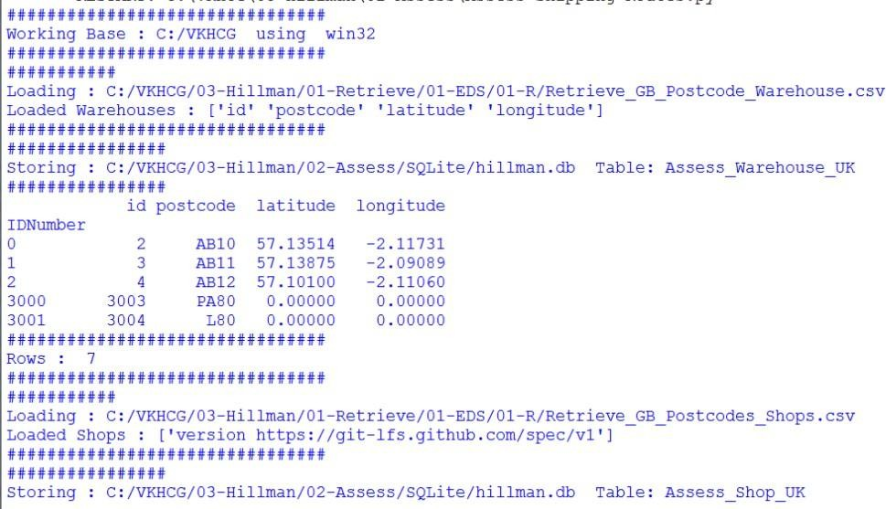

**5K. Write a Python program to create Simple forex trading planner from the given data.**

import sys import os

import sqlite3 as sq

import pandas as pd Base='C:/VKHCG'

print('Working Base :',Base, ' using ', sys.platform)

Company='04-Clark'

sInputFileName1='01-Vermeulen/01-Retrieve/01-EDS/02-Python/Retrieve-Country- Currency.csv'

sInputFileName2='04-Clark/01-Retrieve/01-EDS/01-R/Retrieve_Euro_EchangeRates.csv'

sDataBaseDir=Base + '/' + Company + '/02-Assess/SQLite'

if not os.path.exists(sDataBaseDir): os.makedirs(sDataBaseDir)

sDatabaseName=sDataBaseDir + '/clark.db'

conn = sq.connect(sDatabaseName)

Import Country Data

sFileName1=Base + '/' + sInputFileName1

print('Loading :',sFileName1) CountryRawData=pd.read_csv(sFileName1,header=0,low_memory=False, encoding="latin- 1") CountryRawData.drop_duplicates(subset=None, keep='first', inplace=True)

CountryData=CountryRawData print('Loaded Company :', CountryData.columns.values)

sTable='Assess_Country'

print('Storing :',sDatabaseName,' Table:',sTable) CountryData.to_sql(sTable, conn, if_exists="replace")

print(CountryData.head())

print('Rows : ',CountryData.shape[0])

Import Forex Data

sFileName2=Base + '/' + sInputFileName2

print('Loading :',sFileName2)

ForexRawData=pd.read_csv(sFileName2,header=0,low_memory=False, encoding="latin-1") ForexRawData.drop_duplicates(subset=None, keep='first', inplace=True) ForexData=ForexRawData.head(5)

print('Loaded Company :',ForexData.columns.values)

sTable='Assess_Forex'

print('Storing :',sDatabaseName,' Table:',sTable) ForexData.to_sql(sTable, conn, if_exists="replace")

print(ForexData.head())

print('Rows : ',ForexData.shape[0])

sTable='Assess_Forex' print('Loading :',sDatabaseName,' Table:',sTable) sSQL="select distinct"

sSQL=sSQL+ " A.CodeIn" sSQL=sSQL+ " from"

sSQL=sSQL+ " Assess_Forex as A;" CodeData=pd.read_sql_query(sSQL, conn)

for c in range(CodeData.shape[0]):

sTable='Assess_Forex & 2x Country > ' + CodeData['CodeIn'][c] print('Loading :',sDatabaseName,' Table:',sTable)

sSQL="select distinct" sSQL=sSQL+ " A.Date," sSQL=sSQL+ " A.CodeIn,"

sSQL=sSQL+ " B.Country as CountryIn," sSQL=sSQL+ " B.Currency as CurrencyNameIn," sSQL=sSQL+ " A.CodeOut,"

sSQL=sSQL+ " C.Country as CountryOut," sSQL=sSQL+ " C.Currency as CurrencyNameOut," sSQL=sSQL+ " A.Rate"

sSQL=sSQL+ " from" sSQL=sSQL+ " Assess_Forex as A" sSQL=sSQL+ " JOIN"

sSQL=sSQL+ " Assess_Country as B" sSQL=sSQL+ " ON A.CodeIn = B.CurrencyCode" sSQL=sSQL+ " JOIN"

sSQL=sSQL+ " Assess_Country as C" sSQL=sSQL+ " ON A.CodeOut = C.CurrencyCode" sSQL=sSQL+ " WHERE"

sSQL=sSQL+ " A.CodeIn ='" + CodeData['CodeIn'][c] + "';"

ForexData=pd.read_sql_query(sSQL, conn).head(1000)

print(ForexData)

sTable='Assess_Forex_' + CodeData['CodeIn'][c] print('Storing :',sDatabaseName,' Table:',sTable) ForexData.to_sql(sTable, conn, if_exists="replace")

print('Rows : ',ForexData.shape[0])

**Output: This will produce a set of demonstrated values onscreen by removing duplicate records and other related data processing.**

**5L. Write a Python program to process the balance sheet to ensure that only good data is processing.**

import sys import os

import sqlite3 as sq

import pandas as pd ################################################################ if

sys.platform == 'linux': Base=os.path.expanduser('~') + '/VKHCG' else: Base='C:/VKHCG' print('################################')

print('Working Base :',Base, ' using ', sys.platform)

print('################################') Company='04-Clark' sInputFileName='01- Retrieve/01-EDS/01-R/Retrieve_Profit_And_Loss.csv' ################################################################

sDataBaseDir=Base + '/' + Company + '/02-Assess/SQLite'

if not os.path.exists(sDataBaseDir): os.makedirs(sDataBaseDir)

sDatabaseName=sDataBaseDir + '/clark.db'

conn = sq.connect(sDatabaseName)

### Import Financial Data

sFileName=Base + '/' + Company + '/' + sInputFileName

print('Loading :',sFileName)

FinancialRawData=pd.read_csv(sFileName,header=0,low_memory=False, encoding="latin- 1") FinancialData=FinancialRawData

print('Loaded Company :',FinancialData.columns.values)

sTable='Assess-Financials'

print('Storing :',sDatabaseName,' Table:',sTable)

FinancialData.to_sql(sTable, conn, if_exists="replace")

print(FinancialData.head())

print('Rows : ',FinancialData.shape[0])

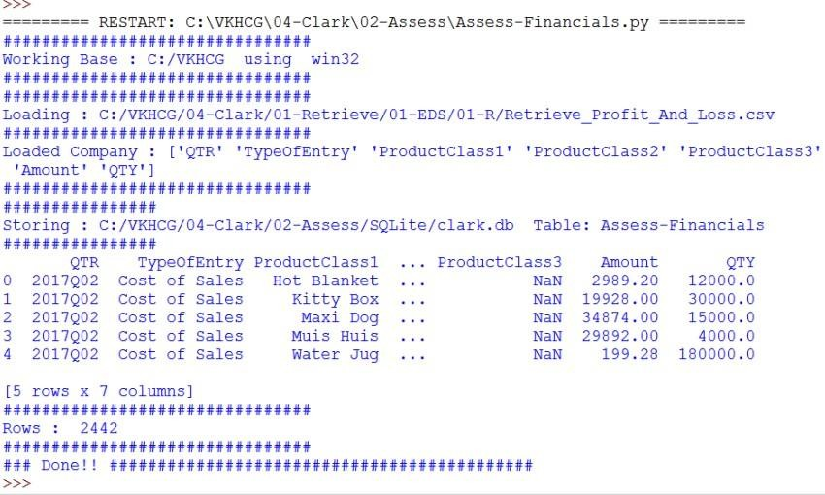

**5M. Write a Python program to generate payroll from the given data**

import sys import os

import sqlite3 as sq

import pandas as pd Base='C:/VKHCG'

print('Working Base :',Base, ' using ', sys.platform)

Company='04-Clark' sInputFileName1='01-Retrieve/01-EDS/02-Python/Retrieve- Data_female-names.csv' sInputFileName2='01-Retrieve/01-EDS/02-Python/Retrieve- Data_male-names.csv' sInputFileName3='01-Retrieve/01-EDS/02-Python/Retrieve- Data_last-names.csv' sOutputFileName1='Assess-Staff.csv' sOutputFileName2='Assess- Customers.csv'

sDataBaseDir=Base + '/' + Company + '/02-Assess/SQLite'

if not os.path.exists(sDataBaseDir): os.makedirs(sDataBaseDir)

sDatabaseName=sDataBaseDir + '/clark.db'

conn = sq.connect(sDatabaseName)

Import Female Data

sFileName=Base + '/' + Company + '/' +

sInputFileName1

print('Loading :',sFileName)

print(sFileName) FemaleRawData=pd.read_csv(sFileName,header=0,low_memory=False, encoding="latin-1")

FemaleRawData.rename(columns={'NameValues' : 'FirstName'},inplace=True) FemaleRawData.drop_duplicates(subset=None, keep='first', inplace=True) FemaleData=FemaleRawData.sample(100)

sTable='Assess_FemaleName'

print('Storing :',sDatabaseName,' Table:',sTable)

FemaleData.to_sql(sTable, conn, if_exists="replace")

print('Rows : ',FemaleData.shape[0], ' records')

Import Male Data sFileName=Base + '/' + Company + '/' + sInputFileName2

print('Loading :',sFileName)

MaleRawData=pd.read_csv(sFileName,header=0,low_memory=False, encoding="latin-1")

MaleRawData.rename(columns={'NameValues' : 'FirstName'},inplace=True)

MaleRawData.drop_duplicates(subset=None, keep='first', inplace=True)

MaleData=MaleRawData.sample(100)

sTable='Assess_MaleName'

print('Storing :',sDatabaseName,' Table:',sTable) MaleData.to_sql(sTable, conn, if_exists="replace")

print('Rows : ',MaleData.shape[0], ' records')

Import Surname Data sFileName=Base + '/' + Company + '/' + sInputFileName3

print('Loading :',sFileName)

SurnameRawData=pd.read_csv(sFileName,header=0, low_memory=False, encoding="latin-1")

SurnameRawData.rename(columns={'NameValues' : 'LastName'},inplace=True) SurnameRawData.drop_duplicates(subset=None, keep='first', inplace=True) SurnameData=SurnameRawData.sample(200)

sTable='Assess_Surname'

print('Storing :',sDatabaseName,' Table:',sTable) SurnameData.to_sql(sTable, conn, if_exists="replace")

print('Rows : ',SurnameData.shape[0], ' records')

sTable='Assess_FemaleName & Assess_MaleName' print('Loading :',sDatabaseName,' Table:',sTable) sSQL="select distinct"

sSQL=sSQL+ " A.FirstName," sSQL=sSQL+ " 'Female' as Gender" sSQL=sSQL+ " from"

sSQL=sSQL+ " Assess_FemaleName as A" sSQL=sSQL+ " UNION"

sSQL=sSQL+ " select distinct" sSQL=sSQL+ " A.FirstName," sSQL=sSQL+ " 'Male' as Gender" sSQL=sSQL+ " from"

sSQL=sSQL+ " Assess_MaleName as A;"

FirstNameData=pd.read_sql_query(sSQL, conn)

sTable='Assess_FirstName'

print('Storing :',sDatabaseName,' Table:',sTable) FirstNameData.to_sql(sTable, conn, if_exists="replace")

sTable='Assess_FirstName x2 & Assess_Surname'

print('Loading :',sDatabaseName,' Table:',sTable) sSQL="select distinct"

sSQL=sSQL+ " A.FirstName,"

sSQL=sSQL+ " B.FirstName AS SecondName," sSQL=sSQL+ " C.LastName,"

sSQL=sSQL+ " A.Gender" sSQL=sSQL+ " from"

sSQL=sSQL+ " Assess_FirstName as A" sSQL=sSQL+ " ,"

sSQL=sSQL+ " Assess_FirstName as B" sSQL=sSQL+ " ,"

sSQL=sSQL+ " Assess_Surname as C" sSQL=sSQL+ " WHERE"

sSQL=sSQL+ " A.Gender = B.Gender" sSQL=sSQL+ " AND"

sSQL=sSQL+ " A.FirstName <> B.FirstName;" PeopleRawData=pd.read_sql_query(sSQL, conn) People1Data=PeopleRawData.sample(10000) sTable='Assess_FirstName & Assess_Surname' print('Loading :',sDatabaseName,' Table:',sTable) sSQL="select distinct" sSQL=sSQL+ " A.FirstName," sSQL=sSQL+ " '' AS SecondName,"

sSQL=sSQL+ " B.LastName," sSQL=sSQL+ " A.Gender" sSQL=sSQL+ " from"

sSQL=sSQL+ " Assess_FirstName as A" sSQL=sSQL+ " ,"

sSQL=sSQL+ " Assess_Surname as B;" PeopleRawData=pd.read_sql_query(sSQL, conn) People2Data=PeopleRawData.sample(10000)

PeopleData=People1Data.append(People2Data) print(PeopleData)

sTable='Assess_People'

print('Storing :',sDatabaseName,' Table:',sTable) PeopleData.to_sql(sTable, conn, if_exists="replace")

sFileDir=Base + '/' + Company + '/02-Assess/01-EDS/02-Python' if not os.path.exists(sFileDir): os.makedirs(sFileDir)

sOutputFileName = sTable+'.csv' sFileName=sFileDir + '/' + sOutputFileName

print('Storing :', sFileName)

PeopleData.to_csv(sFileName, index = False)

**OUTPUT:**

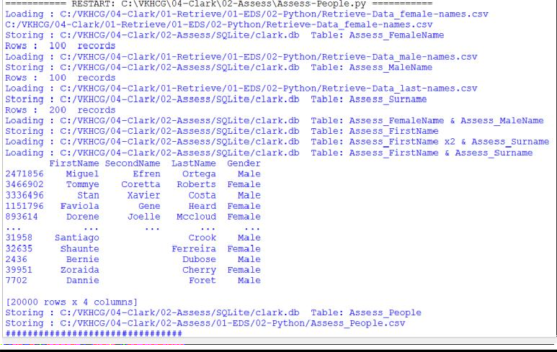

**Practical:6**

**Clustering.**

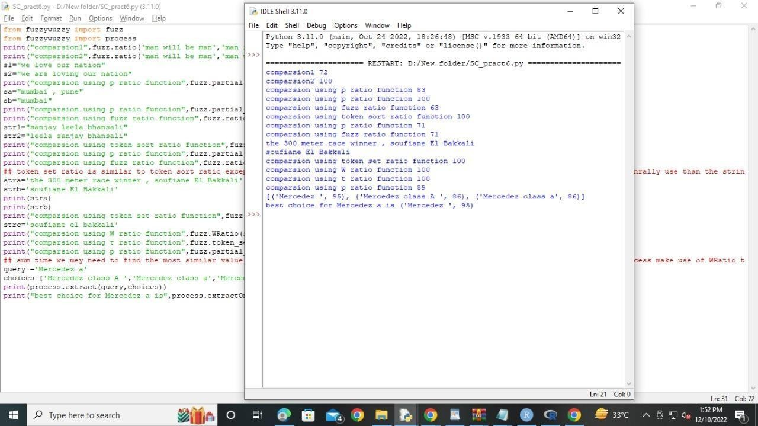

import sys

import os from datetime import datetime from datetime import timedelta from pytz

import timezone, all_timezones import pandas as pd

import sqlite3 as sq from pandas.io import sql

import uuid pd.options.mode.chained_assignment = None

if sys.platform == 'linux': Base=os.path.expanduser('~') + '/VKHCG' else: Base='C:/VKHCG'

print('Working Base :',Base, ' using ', sys.platform)

Company='03-Hillman' InputDir='00-RawData'

InputFileName='VehicleData.csv'

sDataBaseDir=Base + '/' + Company + '/03-Process/SQLite' if not os.path.exists(sDataBaseDir): os.makedirs(sDataBaseDir)

sDatabaseName=sDataBaseDir + '/Hillman.db'

conn1 = sq.connect(sDatabaseName)

sDataVaultDir=Base + '/88-DV' if not os.path.exists(sDataBaseDir): os.makedirs(sDataBaseDir)

sDatabaseName=sDataVaultDir + '/datavault.db'

conn2 = sq.connect(sDatabaseName)

base = datetime(2018,1,1,0,0,0) numUnits=10*365*24

date_list = [base - timedelta(hours=x) for x in range(0, numUnits)]

t=0 for i in date_list: now_utc=i.replace(tzinfo=timezone('UTC')) sDateTime=now_utc.strftime("%Y-%m-%d %H:%M:%S") sDateTimeKey=sDateTime.replace(' ','-').replace(':','-')

t+=1 IDNumber=str(uuid.uuid4())

TimeLine=[('ZoneBaseKey', ['UTC']), ('IDNumber', [IDNumber]), ('nDateTimeValue', [now_utc]), ('DateTimeValue', [sDateTime]), ('DateTimeKey', [sDateTimeKey])]

if t==1: TimeFrame = pd.DataFrame.from_items(TimeLine)

else: TimeRow = pd.DataFrame.from_items(TimeLine) TimeFrame = TimeFrame.append(TimeRow)

TimeHub=TimeFrame[['IDNumber','ZoneBaseKey','DateTimeKey','DateTimeValue']] TimeHubIndex=TimeHub.set_index(['IDNumber'],inplace=False)

TimeFrame.set_index(['IDNumber'],inplace=True)

sTable = 'Process-Time' print('Storing :',sDatabaseName,' Table:',sTable) TimeHubIndex.to_sql(sTable, conn1, if_exists="replace")

sTable ='Hub-Time' print('Storing :',sDatabaseName,' Table:',sTable)

TimeHubIndex.to_sql(sTable, conn2, if_exists="replace")

active_timezones=all_timezones z=0 for zone in active_timezones:

t=0

for j in range(TimeFrame.shape[0]): now_date=TimeFrame['nDateTimeValue'][j] DateTimeKey=TimeFrame['DateTimeKey'][j] now_utc=now_date.replace(tzinfo=timezone('UTC')) sDateTime=now_utc.strftime("%Y-%m-%d %H:%M:%S") now_zone = now_utc.astimezone(timezone(zone

sZoneDateTime=now_zone.strftime("%Y-%m-%d %H:%M:%S") t+=1 z+=1 IDZoneNumber=str(uuid.uuid4())

TimeZoneLine=[('ZoneBaseKey', ['UTC']),

('IDZoneNumber', [IDZoneNumber]), ('DateTimeKey', [DateTimeKey]),

('UTCDateTimeValue', [sDateTime]), ('Zone', [zone]), ('DateTimeValue', [sZoneDateTime])] if t==1: TimeZoneFrame = pd.DataFrame.from_items(TimeZoneLine)

else: TimeZoneRow = pd.DataFrame.from_items(TimeZoneLine) TimeZoneFrame = TimeZoneFrame.append(TimeZoneRow) TimeZoneFrameIndex=TimeZoneFrame.set_index(['IDZoneNumber'], inplace=False) sZone=zone.replace('/','-').replace(' ','')

sTable = 'Process-Time-'+sZone

print('Storing :',sDatabaseName,' Table:',sTable)

TimeZoneFrameIndex.to_sql(sTable, conn1, if_exists="replace")

sTable = 'Satellite-Time-'+sZone print('Storing :',sDatabaseName,' Table:',sTable) TimeZoneFrameIndex.to_sql(sTable, conn2, if_exists="replace")

print('################')

print('Vacuum Databases') sSQL="VACUUM;"

sql.execute(sSQL,conn1) sql.execute(sSQL,conn2)

print('################') #################################################################

print('### Done!! ############################################')

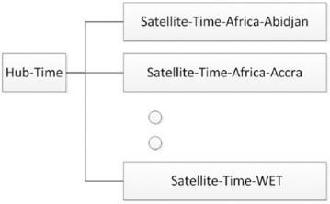

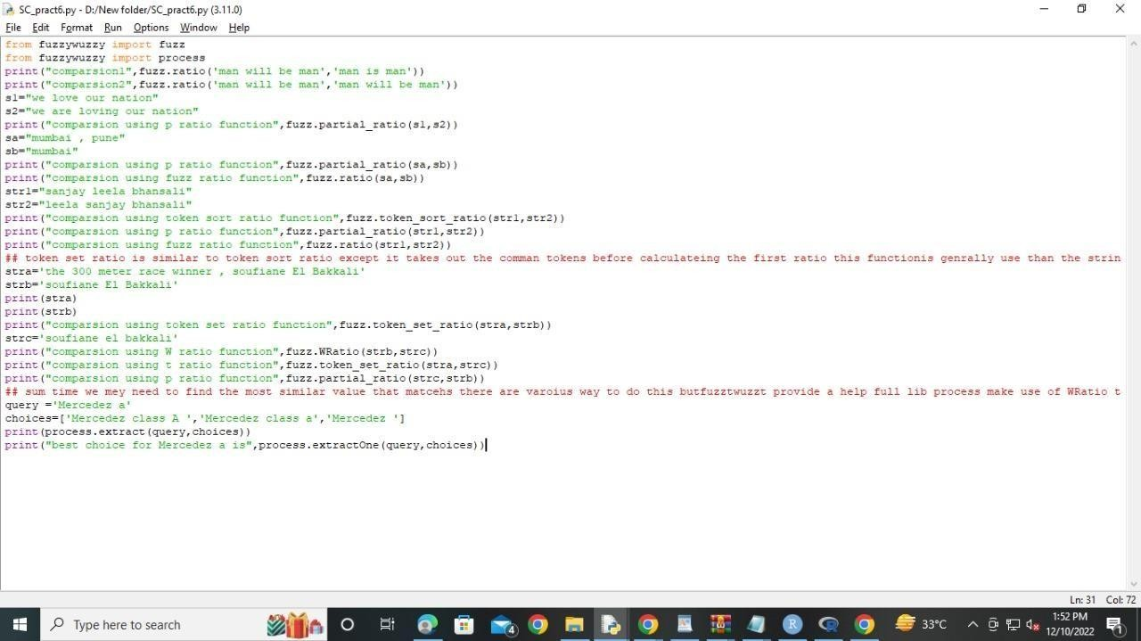

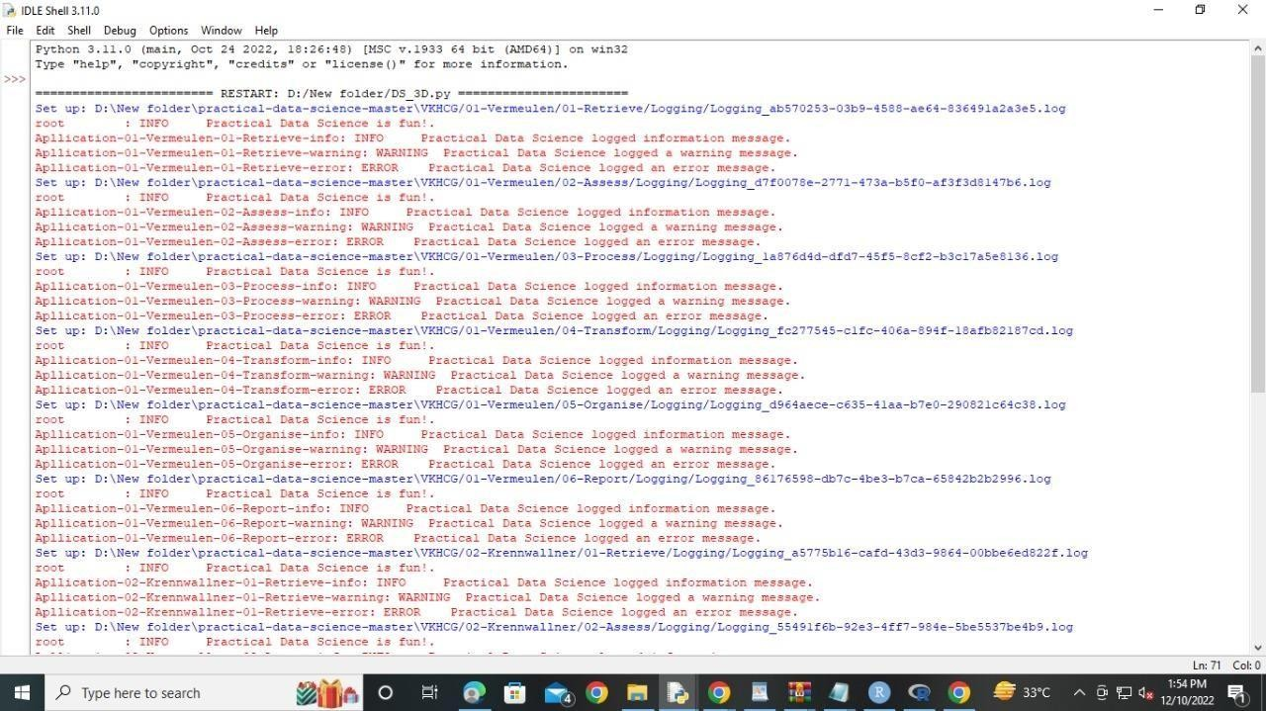

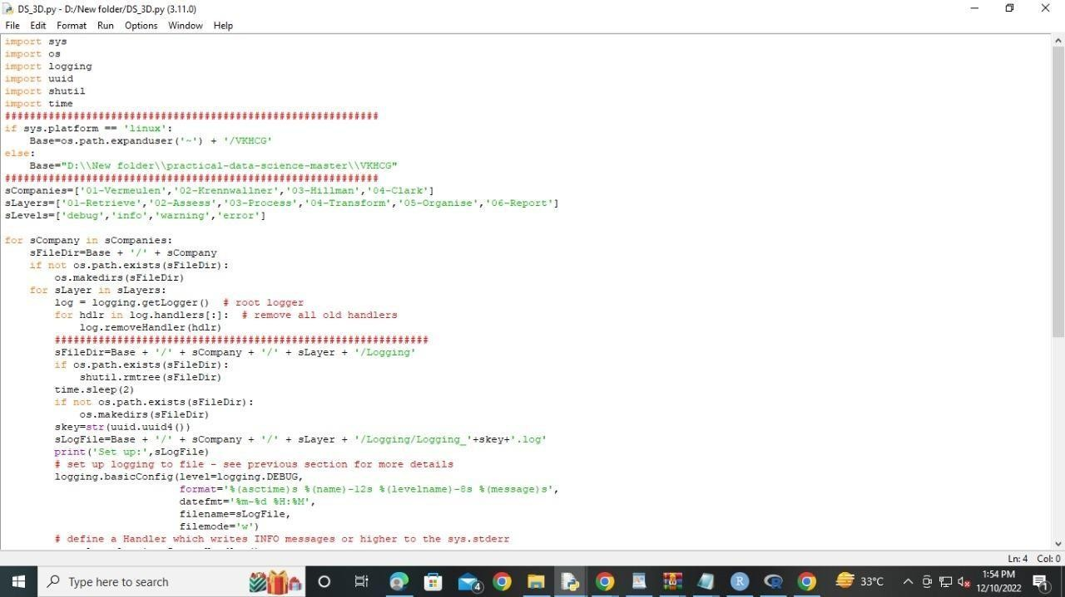

import sys import os

import sqlite3 as sq

import pandas as pd from pandas.io

import sql from datetime import datetime, timedelta from pytz import timezone, all_timezones from random

import randint i

mport uuid ################################################################

if sys.platform == 'linux': Base=os.path.expanduser('~') + '/VKHCG' else: Base='C:/VKHCG' print('################################')

print('Working Base :',Base, ' using ', sys.platform)

print('################################') ################################################################

Company='04-Clark'

sInputFileName='02-Assess/01-EDS/02-Python/Assess_People.csv' ################################################################

sDataBaseDir=Base + '/' + Company + '/03-Process/SQLite'

if not os.path.exists(sDataBaseDir): os.makedirs(sDataBaseDir) ################################################################

sDatabaseName=sDataBaseDir + '/clark.db'

conn1 = sq.connect(sDatabaseName) ################################################################

sDataVaultDir=Base + '/88-DV' if not os.path.exists(sDataBaseDir): os.makedirs(sDataBaseDir) ################################################################

sDatabaseName=sDataVaultDir + '/datavault.db'

conn2 = sq.connect(sDatabaseName) ################################################################ ###

Import Female Data ################################################################

sFileName=Base + '/' + Company + '/' + sInputFileName print('################################')

print('Loading :',sFileName) print('################################')

print(sFileName) RawData=pd.read_csv(sFileName,header=0,low_memory=False, encoding="latin-1")

RawData.drop_duplicates(subset=None, keep='first', inplace=True) start_date = datetime(1900,1,1,0,0,0) start_date_utc=start_date.replace(tzinfo=timezone('UTC'))

HoursBirth=100*365*24 RawData['BirthDateUTC']=RawData.apply(lambda row: (start_date_utc + timedelta(hours=randint(0, HoursBirth))) ,axis=1)

zonemax=len(all_timezones)-1

RawData['TimeZone']=RawData.apply(lambda row: (all_timezones[randint(0, zonemax)])

,axis=1) RawData['BirthDateISO']=RawData.apply(lambda row: row["BirthDateUTC"].astimezone(timezone(row['TimeZone'])) ,axis=1) RawData['BirthDateKey']=RawData.apply(lambda row: row["BirthDateUTC"].strftime("%Y-%m-%d %H:%M:%S") ,axis=1)

RawData['BirthDate']=RawData.apply(lambda row: row["BirthDateISO"].strftime("%Y-%m-

%d %H:%M:%S") ,axis=1)

RawData['PersonID']=RawData.apply(lambda row: str(uuid.uuid4()) ,axis=1) ################################################################

Data=RawData.copy() Data.drop('BirthDateUTC', axis=1,inplace=True) Data.drop('BirthDateISO', axis=1,inplace=True)

indexed_data = Data.set_index(['PersonID'])

print('################################') ################################################################# print('################')

sTable='Process_Person'

print('Storing :',sDatabaseName,' Table:',sTable)

indexed_data.to_sql(sTable, conn1, if_exists="replace")

print('################') ################################################################

PersonHubRaw=Data[['PersonID','FirstName','SecondName','LastName','BirthDateKey']] PersonHubRaw['PersonHubID']=RawData.apply(lambda row: str(uuid.uuid4()) ,axis=1) PersonHub=PersonHubRaw.drop_duplicates(subset=None, \ keep='first',\ inplace=False) indexed_PersonHub = PersonHub.set_index(['PersonHubID'])

sTable = 'Hub-Person' print('Storing :',sDatabaseName,' Table:',sTable) indexed_PersonHub.to_sql(sTable, conn2, if_exists="replace")

PersonSatelliteGenderRaw=Data[['PersonID','FirstName','SecondName','LastName'\

,'BirthDateKey','Gender']] PersonSatelliteGenderRaw['PersonSatelliteID']=RawData.apply(lambda row: str(uuid.uuid4()) ,axis=1) PersonSatelliteGender=PersonSatelliteGenderRaw.drop_duplicates(subset=None, \ keep='first', \ inplace=False) indexed_PersonSatelliteGender = PersonSatelliteGender.set_index(['PersonSatelliteID']) sTable = 'Satellite-Person-Gender' print('Storing :',sDatabaseName,' Table:',sTable)

indexed_PersonSatelliteGender.to_sql(sTable, conn2, if_exists="replace") ################################################################

PersonSatelliteBirthdayRaw=Data[['PersonID','FirstName','SecondName','LastName',\ 'BirthDateKey','TimeZone','BirthDate']] PersonSatelliteBirthdayRaw['PersonSatelliteID']=RawData.apply(lambda row: str(uuid.uuid4()) ,axis=1)

PersonSatelliteBirthday=PersonSatelliteBirthdayRaw.drop_duplicates(subset=None, \ keep='first',\ inplace=False) indexed_PersonSatelliteBirthday = PersonSatelliteBirthday.set_index(['PersonSatelliteID'])

sTable = 'Satellite-Person-Names'

print('Storing :',sDatabaseName,' Table:',sTable) indexed_PersonSatelliteBirthday.to_sql(sTable, conn2,

if_exists="replace") ################################################################

sFileDir=Base + '/' + Company + '/03-Process/01-EDS/02-Python' if not os.path.exists(sFileDir): os.makedirs(sFileDir)

################################################################

sOutputFileName = sTable + '.csv' sFileName=sFileDir + '/' + sOutputFileName print('################################')

print('Storing :', sFileName) print('################################')

RawData.to_csv(sFileName, index = False)

print('################################') ################################################################# print('################')

print('Vacuum Databases') sSQL="VACUUM;"

sql.execute(sSQL,conn1)

sql.execute(sSQL,conn2) print('################')

################################################################# print('### Done!! ############################################')

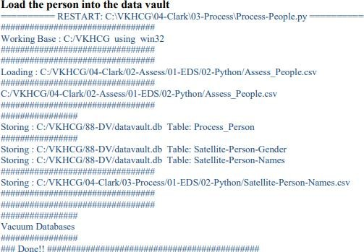

import sys import os

import pandas as pd

import sqlite3 as sq from pandas.io import sql

import uuid pd.options.mode.chained_assignment = None ################################################################

if sys.platform == 'linux': Base=os.path.expanduser('~') + '/VKHCG' else: Base='C:/VKHCG' print('################################')

print('Working Base :',Base, ' using ', sys.platform)

print('################################') ################################################################

Company='03-Hillman' InputDir='00-RawData' InputFileName='VehicleData.csv' ################################################################

sDataBaseDir=Base + '/' + Company + '/03-Process/SQLite' if not os.path.exists(sDataBaseDir): os.makedirs(sDataBaseDir)

################################################################

sDatabaseName=sDataBaseDir + '/Hillman.db'

conn1 = sq.connect(sDatabaseName) ################################################################

sDataVaultDir=Base + '/88-DV'

if not os.path.exists(sDataBaseDir): os.makedirs(sDataBaseDir) ################################################################

sDatabaseName=sDataVaultDir + '/datavault.db'

conn2 = sq.connect(sDatabaseName) ################################################################

sFileName=Base + '/' + Company + '/' + InputDir + '/' +

InputFileName print('###########')

print('Loading :',sFileName)

VehicleRaw=pd.read_csv(sFileName,header=0,low_memory=False, encoding="latin-1") ################################################################

sTable='Process_Vehicles'

print('Storing :',sDatabaseName,' Table:',sTable) VehicleRaw.to_sql(sTable, conn1, if_exists="replace")

################################################################

VehicleRawKey=VehicleRaw[['Make','Model']].copy()

VehicleKey=VehicleRawKey.drop_duplicates() ################################################################

VehicleKey['ObjectKey']=VehicleKey.apply(lambda row: str('('+ str(row['Make']).strip().replace(' ', '-').replace('/', '-').lower() + ')-(' +

(str(row['Model']).strip().replace(' ', '-').replace(' ', '-').lower()) +')') ,axis=1) ################################################################

VehicleKey['ObjectType']=VehicleKey.apply(lambda row: 'vehicle' ,axis=1) ################################################################

VehicleKey['ObjectUUID']=VehicleKey.apply(lambda row: str(uuid.uuid4()) ,axis=1)

VehicleHub=VehicleKey[['ObjectType','ObjectKey','ObjectUUID']].copy() VehicleHub.index.name='ObjectHubID' sTable = 'Hub-Object-Vehicle' print('Storing

:',sDatabaseName,' Table:',sTable)

VehicleHub.to_sql(sTable, conn2, if_exists="replace") ################################################################ ### Vehicle Satellite ################################################################ #

VehicleSatellite=VehicleKey[['ObjectType','ObjectKey','ObjectUUID','Make','Model']].copy(

) VehicleSatellite.index.name='ObjectSatelliteID' sTable = 'Satellite-Object-Make-Model' print('Storing :',sDatabaseName,' Table:',sTable)

VehicleSatellite.to_sql(sTable, conn2, if_exists="replace") ################################################################

### Vehicle Dimension ################################################################

sView='Dim-Object' print('Storing :',sDatabaseName,' View:',sView) sSQL="CREATE VIEW IF NOT EXISTS [" + sView + "] AS" sSQL=sSQL+ " SELECT DISTINCT"

sSQL=sSQL+ " H.ObjectType,"

sSQL=sSQL+ " H.ObjectKey AS VehicleKey," sSQL=sSQL+ " TRIM(S.Make) AS VehicleMake," sSQL=sSQL+ " TRIM(S.Model) AS VehicleModel" sSQL=sSQL+ " FROM"

sSQL=sSQL+ " [Hub-Object-Vehicle] AS H" sSQL=sSQL+ " JOIN"

sSQL=sSQL+ " [Satellite-Object-Make-Model] AS S" sSQL=sSQL+ " ON"

sSQL=sSQL+ " H.ObjectType=S.ObjectType" sSQL=sSQL+ " AND"

sSQL=sSQL+ " H.ObjectUUID=S.ObjectUUID;" sql.execute(sSQL,conn2) print('################')

print('Loading :',sDatabaseName,' Table:',sView) sSQL=" SELECT DISTINCT"

sSQL=sSQL+ " VehicleMake," sSQL=sSQL+ " VehicleModel" sSQL=sSQL+ " FROM" sSQL=sSQL+ " [" + sView + "]" sSQL=sSQL+ " ORDER BY"

sSQL=sSQL+ " VehicleMake" sSQL=sSQL+ " AND"

sSQL=sSQL+ " VehicleMake;"

DimObjectData=pd.read_sql_query(sSQL, conn2)

DimObjectData.index.name='ObjectDimID' DimObjectData.sort_values(['VehicleMake','VehicleModel'],inplace=True, ascending=True) print('################')

print(DimObjectData) ################################################################# print('################')

print('Vacuum Databases') sSQL="VACUUM;"

sql.execute(sSQL,conn1)

sql.execute(sSQL,conn2) print('################')

#################################################################

conn1.close() conn2.close()

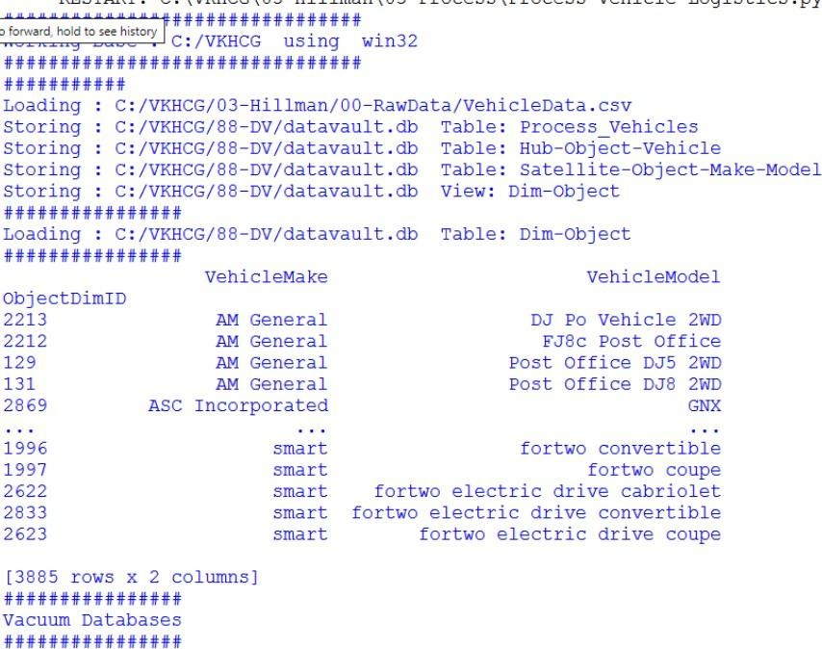################################################################# print('### Done!! ############################################')

import sys import os

import pandas as pd

import sqlite3 as sq from pandas.io import sql

import uuid ################################################################ Base='C:/VKHCG'

print('################################')

print('Working Base :',Base, ' using ', sys.platform)

print('################################') ################################################################

Company='01-Vermeulen' InputAssessGraphName='Assess_All_Animals.gml'

EDSAssessDir='02-Assess/01-EDS' InputAssessDir=EDSAssessDir + '/02-Python' ################################################################ sFileAssessDir=Base +

'/' + Company + '/' + InputAssessDir if not os.path.exists(sFileAssessDir): os.makedirs(sFileAssessDir) ################################################################ sDataBaseDir=Base +

'/' + Company + '/03-Process/SQLite' if not os.path.exists(sDataBaseDir): os.makedirs(sDataBaseDir) ################################################################

sDatabaseName=sDataBaseDir + '/Vermeulen.db'

conn1 = sq.connect(sDatabaseName) ################################################################

sDataVaultDir=Base + '/88-DV' if not os.path.exists(sDataBaseDir): os.makedirs(sDataBaseDir) ################################################################

sDatabaseName=sDataVaultDir + '/datavault.db' conn2 = sq.connect(sDatabaseName)

t=0 tMax=360*180

for Longitude in range(-180,180,10): for Latitude in range(-90,90,10):

t+=1

IDNumber=str(uuid.uuid4())

LocationName='L'+format(round(Longitude,3)*1000, '+07d') +\ '-'+format(round(Latitude,3)*1000, '+07d') print('Create:',t,' of ',tMax,':',LocationName)

LocationLine=[('ObjectBaseKey', ['GPS']), ('IDNumber', [IDNumber]), ('LocationNumber', [str(t)]), ('LocationName', [LocationName]), ('Longitude', [Longitude]), ('Latitude', [Latitude])] if t==1: LocationFrame = pd.DataFrame.from_items(LocationLine)

else: LocationRow = pd.DataFrame.from_items(LocationLine) LocationFrame = LocationFrame.append(LocationRow) ################################################################

LocationHubIndex=LocationFrame.set_index(['IDNumber'],inplace=False) ################################################################

sTable = 'Process-Location'

print('Storing :',sDatabaseName,' Table:',sTable)

LocationHubIndex.to_sql(sTable, conn1, if_exists="replace") #################################################################

sTable = 'Hub-Location'

print('Storing :',sDatabaseName,' Table:',sTable) LocationHubIndex.to_sql(sTable, conn2, if_exists="replace")

################################################################# print('################')

print('Vacuum Databases') sSQL="VACUUM;"

sql.execute(sSQL,conn1)

sql.execute(sSQL,conn2) print('################')

################################################################ print('### Done!! ############################################')

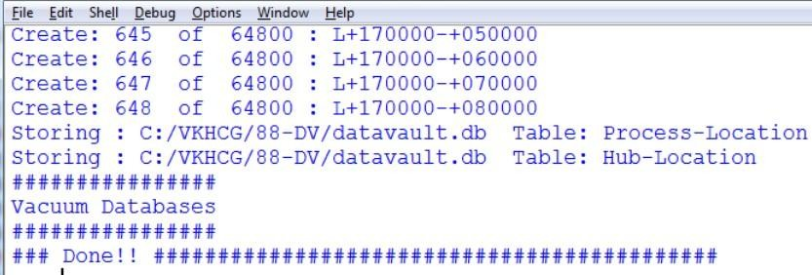

import sys import os

import sqlite3 as sq import quandl

import pandas as pd ################################################################ Base='C:/VKHCG'

print('################################')

print('Working Base :',Base, ' using ', sys.platform)

print('################################') ################################################################

Company='04-Clark' sInputFileName='00-RawData/VKHCG_Shares.csv' sOutputFileName='Shares.csv' ################################################################

sDataBaseDir=Base + '/' + Company + '/03-Process/SQLite' if not os.path.exists(sDataBaseDir): os.makedirs(sDataBaseDir) ################################################################

sFileDir1=Base + '/' + Company + '/01-Retrieve/01-EDS/02-Python' if not os.path.exists(sFileDir1): os.makedirs(sFileDir1) ################################################################

sFileDir2=Base + '/' + Company + '/02-Assess/01-EDS/02-Python' if not os.path.exists(sFileDir2): os.makedirs(sFileDir2) ################################################################

sFileDir3=Base + '/' + Company + '/03-Process/01-EDS/02-Python' if not os.path.exists(sFileDir3): os.makedirs(sFileDir3) ################################################################

sDatabaseName=sDataBaseDir + '/clark.db' conn = sq.connect(sDatabaseName) ################################################################ ###

Import Share Names Data sFileName=Base + '/' + Company + '/' + sInputFileName

print('################################')

print('Loading :',sFileName) print('################################')

RawData=pd.read_csv(sFileName,header=0,low_memory=False, encoding="latin-1") RawData.drop_duplicates(subset=None, keep='first', inplace=True)

print('Rows :',RawData.shape[0]) print('Columns:',RawData.shape[1])

print('################') ################################################################

sFileName=sFileDir1 + '/Retrieve_' + sOutputFileName print('################################')

print('Storing :', sFileName) print('################################')

RawData.to_csv(sFileName, index = False)

print('################################') ################################################################

sFileName=sFileDir2 + '/Assess_' + sOutputFileName print('################################')

print('Storing :', sFileName) print('################################')

RawData.to_csv(sFileName, index = False)

print('################################') ################################################################

sFileName=sFileDir3 + '/Process_' + sOutputFileName print('################################')

print('Storing :', sFileName) print('################################')

RawData.to_csv(sFileName, index = False)

print('################################') ################################################################ ###

Import Shares Data Details nShares=RawData.shape[0] #nShares=6

for sShare in range(nShares): sShareName=str(RawData['Shares'][sShare]) ShareData = quandl.get(sShareName)

UnitsOwn=RawData['Units'][sShare] ShareData['UnitsOwn']=ShareData.apply(lambda row:(UnitsOwn),axis=1)

ShareData['ShareCode']=ShareData.apply(lambda row:(sShareName),axis=1) print('################')

print('Share :',sShareName)

print('Rows :',ShareData.shape[0]) print('Columns:',ShareData.shape[1])

print('################') ################################################################# print('################')

sTable=str(RawData['sTable'][sShare]) print('Storing :',sDatabaseName,' Table:',sTable) ShareData.to_sql(sTable, conn, if_exists="replace")

print('################') ################################################################

sOutputFileName = sTable.replace("/","-") + '.csv'

sFileName=sFileDir1 + '/Retrieve_' + sOutputFileName print('################################')

print('Storing :', sFileName) print('################################')

ShareData.to_csv(sFileName, index = False)

print('################################') ################################################################

sOutputFileName = sTable.replace("/","-") + '.csv' sFileName=sFileDir2 + '/Assess_' + sOutputFileName print('################################')

print('Storing :', sFileName) print('################################')

ShareData.to_csv(sFileName, index = False)

print('################################') ################################################################

sOutputFileName = sTable.replace("/","-") + '.csv' sFileName=sFileDir3 + '/Process_' + sOutputFileName print('################################')

print('Storing :', sFileName) print('################################')

ShareData.to_csv(sFileName, index = False) print('################################')

print('### Done!! ############################################')

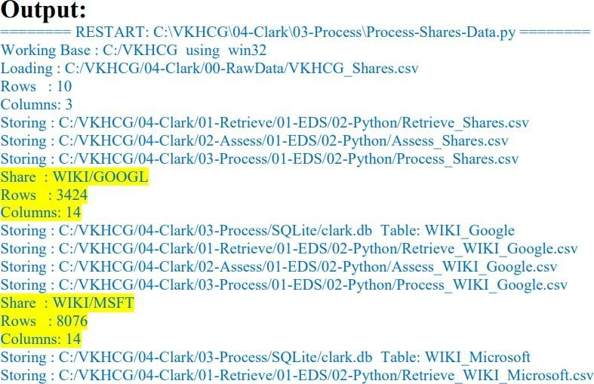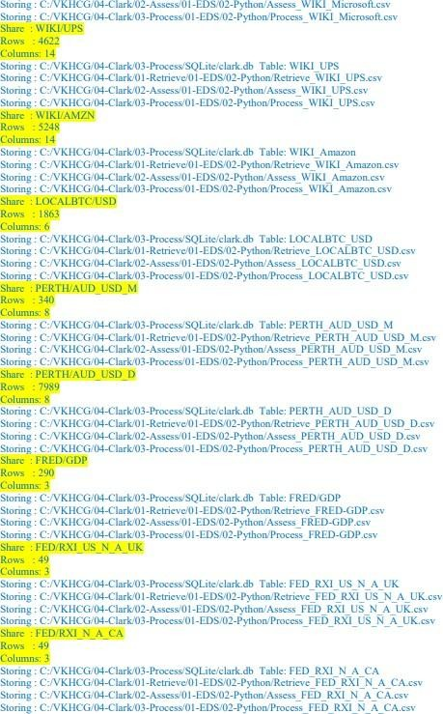

### Practical 7: Transforming Data

import sys

import os from datetime

import datetime from pytz import timezone

import pandas as pd import sqlite3 as sq

import uuid pd.options.mode.chained_assignment = None

Base='C:/VKHCG' print('################################')

print('Working Base :',Base, ' using ', sys.platform)

print('################################') ################################################################

Company='01-Vermeulen'

InputDir='00-RawData' InputFileName='VehicleData.csv'

################################################################

sDataBaseDir=Base + '/' + Company + '/04-Transform/SQLite' if not os.path.exists(sDataBaseDir): os.makedirs(sDataBaseDir) ################################################################

sDatabaseName=sDataBaseDir + '/Vermeulen.db'

conn1 = sq.connect(sDatabaseName) ################################################################

sDataVaultDir=Base + '/88-DV' if not os.path.exists(sDataVaultDir): os.makedirs(sDataVaultDir) ################################################################

sDatabaseName=sDataVaultDir + '/datavault.db' conn2 = sq.connect(sDatabaseName)

sDataWarehouseDir=Base + '/99-DW' if not os.path.exists(sDataWarehouseDir): os.makedirs(sDataWarehouseDir) ################################################################

sDatabaseName=sDataWarehouseDir + '/datawarehouse.db' conn3 = sq.connect(sDatabaseName) ################################################################

print('\n#################################') print('Time Category') print('UTC Time') BirthDateUTC = datetime(1960,12,20,10,15,0)

BirthDateZoneUTC=BirthDateUTC.replace(tzinfo=timezone('UTC')) BirthDateZoneStr=BirthDateZoneUTC.strftime("%Y-%m-%d %H:%M:%S") BirthDateZoneUTCStr=BirthDateZoneUTC.strftime("%Y-%m-%d %H:%M:%S (%Z) (%z)") print(BirthDateZoneUTCStr)

print('#################################')

print('Birth Date in Reykjavik :') BirthZone = 'Atlantic/Reykjavik'

BirthDate = BirthDateZoneUTC.astimezone(timezone(BirthZone)) BirthDateStr=BirthDate.strftime("%Y-%m-%d %H:%M:%S (%Z) (%z)") BirthDateLocal=BirthDate.strftime("%Y-%m-%d %H:%M:%S")

print(BirthDateStr) print('#################################')

################################################################

IDZoneNumber=str(uuid.uuid4()) sDateTimeKey=BirthDateZoneStr.replace(' ','-').replace(':','-')

TimeLine=[('ZoneBaseKey', ['UTC']), ('IDNumber', [IDZoneNumber]), ('DateTimeKey', [sDateTimeKey]), ('UTCDateTimeValue', [BirthDateZoneUTC]), ('Zone', [BirthZone]), ('DateTimeValue', [BirthDateStr])] TimeFrame = pd.DataFrame.from_items(TimeLine) ################################################################

TimeHub=TimeFrame[['IDNumber','ZoneBaseKey','DateTimeKey','DateTimeValue']] TimeHubIndex=TimeHub.set_index(['IDNumber'],inplace=False) ################################################################

sTable = 'Hub-Time-Gunnarsson' print('\n#################################')

print('Storing :',sDatabaseName,'\n Table:',sTable) print('\n#################################')

TimeHubIndex.to_sql(sTable, conn2, if_exists="replace") sTable = 'Dim-Time-Gunnarsson'

TimeHubIndex.to_sql(sTable, conn3, if_exists="replace") ################################################################

TimeSatellite=TimeFrame[['IDNumber','DateTimeKey','Zone','DateTimeValue']] TimeSatelliteIndex=TimeSatellite.set_index(['IDNumber'],inplace=False) ################################################################

BirthZoneFix=BirthZone.replace(' ','-').replace('/','-')

sTable = 'Satellite-Time-' + BirthZoneFix + '-Gunnarsson' print('\n#################################')

print('Storing :',sDatabaseName,'\n Table:',sTable) print('\n#################################')

TimeSatelliteIndex.to_sql(sTable, conn2, if_exists="replace")

sTable = 'Dim-Time-' + BirthZoneFix + '-Gunnarsson'

TimeSatelliteIndex.to_sql(sTable, conn3, if_exists="replace") ################################################################ print('\n#################################')

print('Person Category') FirstName = 'Guðmundur' LastName = 'Gunnarsson'

print('Name:',FirstName,LastName) print('Birth Date:',BirthDateLocal) print('Birth Zone:',BirthZone)

print('UTC Birth Date:',BirthDateZoneStr)

print('#################################') ###############################################################

IDPersonNumber=str(uuid.uuid4())

PersonLine=[('IDNumber', [IDPersonNumber]), ('FirstName', [FirstName]), ('LastName', [LastName]), ('Zone', ['UTC']), ('DateTimeValue', [BirthDateZoneStr])]

PersonFrame = pd.DataFrame.from_items(PersonLine) ################################################################

TimeHub=PersonFrame

TimeHubIndex=TimeHub.set_index(['IDNumber'],inplace=False) ################################################################

sTable = 'Hub-Person-Gunnarsson' print('\n#################################')

print('Storing :',sDatabaseName,'\n Table:',sTable) print('\n#################################')

TimeHubIndex.to_sql(sTable, conn2, if_exists="replace") sTable = 'Dim-Person-Gunnarsson' TimeHubIndex.to_sql(sTable, conn3, if_exists="replace")

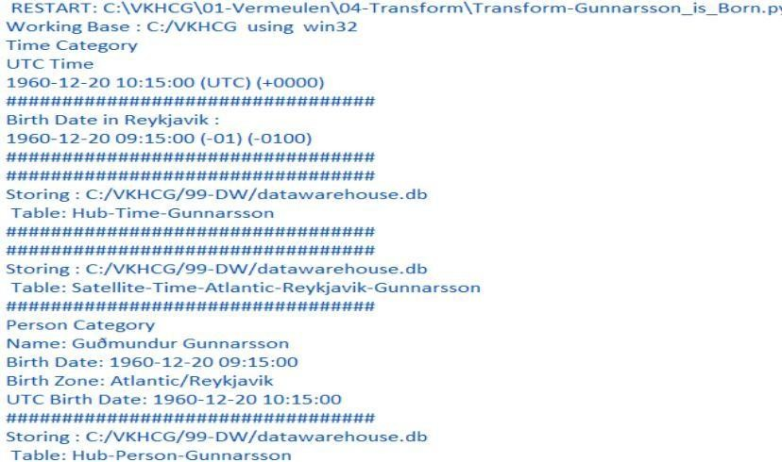

import sys

import os from datetime import datetime from pytz import timezone

import pandas as pd import sqlite3 as sq

import uuid pd.options.mode.chained_assignment = None ################################################################

if sys.platform == 'linux': Base=os.path.expanduser('~') + '/VKHCG' else: Base='C:/VKHCG'

print('################################')

print('Working Base :',Base, ' using ', sys.platform)

print('################################') ################################################################

Company='01-Vermeulen' ################################################################

sDataBaseDir=Base + '/' + Company + '/04-Transform/SQLite' if not os.path.exists(sDataBaseDir): os.makedirs(sDataBaseDir) ################################################################

sDatabaseName=sDataBaseDir + '/Vermeulen.db' conn1 = sq.connect(sDatabaseName) sDataWarehousetDir=Base + '/99-DW'

if not os.path.exists(sDataWarehousetDir): os.makedirs(sDataWarehousetDir) ################################################################

sDatabaseName=sDataWarehousetDir + '/datawarehouse.db'

conn2 = sq.connect(sDatabaseName) ################################################################ print('\n#################################')

print('Time Dimension') BirthZone = 'Atlantic/Reykjavik'

BirthDateUTC = datetime(1960,12,20,10,15,0) BirthDateZoneUTC=BirthDateUTC.replace(tzinfo=timezone('UTC')) BirthDateZoneStr=BirthDateZoneUTC.strftime("%Y-%m-%d %H:%M:%S") BirthDateZoneUTCStr=BirthDateZoneUTC.strftime("%Y-%m-%d %H:%M:%S (%Z) (%z)")

BirthDate = BirthDateZoneUTC.astimezone(timezone(BirthZone)) BirthDateStr=BirthDate.strftime("%Y-%m-%d %H:%M:%S (%Z) (%z)") BirthDateLocal=BirthDate.strftime("%Y-%m-%d %H:%M:%S")

################################################################

IDTimeNumber=str(uuid.uuid4())

TimeLine=[('TimeID', [IDTimeNumber]), ('UTCDate', [BirthDateZoneStr]), ('LocalTime', [BirthDateLocal]), ('TimeZone', [BirthZone])]

TimeFrame = pd.DataFrame.from_items(TimeLine) ################################################################

DimTime=TimeFrame DimTimeIndex=DimTime.set_index(['TimeID'],inplace=False) ################################################################

sTable = 'Dim-Time' print('\n#################################')

print('Storing :',sDatabaseName,'\n Table:',sTable) print('\n#################################')

DimTimeIndex.to_sql(sTable, conn1, if_exists="replace")

DimTimeIndex.to_sql(sTable, conn2, if_exists="replace") ################################################################ print('\n#################################')

print('Dimension Person') print('\n#################################')

FirstName = 'Guðmundur' LastName = 'Gunnarsson' ###############################################################

IDPersonNumber=str(uuid.uuid4())

PersonLine=[('PersonID', [IDPersonNumber]), ('FirstName', [FirstName]), ('LastName', [LastName]), ('Zone', ['UTC']), ('DateTimeValue', [BirthDateZoneStr])]

PersonFrame = pd.DataFrame.from_items(PersonLine) DimPerson=PersonFrame

DimPersonIndex=DimPerson.set_index(['PersonID'],inplace=False) ################################################################

sTable = 'Dim-Person' print('\n#################################')

print('Storing :',sDatabaseName,'\n Table:',sTable) print('\n#################################')

DimPersonIndex.to_sql(sTable, conn1, if_exists="replace")

DimPersonIndex.to_sql(sTable, conn2, if_exists="replace") ################################################################ print('\n#################################')

print('Fact - Person - time') print('\n#################################')

IDFactNumber=str(uuid.uuid4())

PersonTimeLine=[('IDNumber', [IDFactNumber]), ('IDPersonNumber', [IDPersonNumber]), ('IDTimeNumber', [IDTimeNumber])] PersonTimeFrame = pd.DataFrame.from_items(PersonTimeLine) ################################################################

FctPersonTime=PersonTimeFrame FctPersonTimeIndex=FctPersonTime.set_index(['IDNumber'],inplace=False) ################################################################

sTable = 'Fact-Person-Time' print('\n#################################') print('Storing :',sDatabaseName,'\n Table:',sTable) print('\n#################################')

FctPersonTimeIndex.to_sql(sTable, conn1, if_exists="replace") FctPersonTimeIndex.to_sql(sTable, conn2, if_exists="replace")

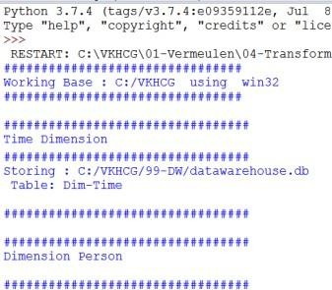

import sys

import os from datetime import datetime from pytz import timezone

import pandas as pd import sqlite3 as sq import uuid

pd.options.mode.chained_assignment = None ################################################################

if sys.platform == 'linux':

Base=os.path.expanduser('~') + '/VKHCG' else: Base='C:/VKHCG' print('################################')

print('Working Base :',Base, ' using ', sys.platform)

print('################################') ################################################################

Company='01-Vermeulen' ################################################################

sDataBaseDir=Base + '/' + Company + '/04-Transform/SQLite' if not os.path.exists(sDataBaseDir): os.makedirs(sDataBaseDir) ################################################################

sDatabaseName=sDataBaseDir + '/Vermeulen.db'

conn1 = sq.connect(sDatabaseName) ################################################################

sDataVaultDir=Base + '/88-DV' if not os.path.exists(sDataVaultDir): os.makedirs(sDataVaultDir) ################################################################

sDatabaseName=sDataVaultDir + '/datavault.db'

conn2 = sq.connect(sDatabaseName) ################################################################

sDataWarehouseDir=Base + '/99-DW' if not os.path.exists(sDataWarehouseDir): os.makedirs(sDataWarehouseDir) ################################################################

sDatabaseName=sDataWarehouseDir + '/datawarehouse.db'

conn3 = sq.connect(sDatabaseName) ################################################################

sSQL=" SELECT DateTimeValue FROM [Hub-Time];" DateDataRaw=pd.read_sql_query(sSQL, conn2) DateData=DateDataRaw.head(1000) print(DateData)

print('\n#################################')

print('Time Dimension') print('\n#################################')

t=0 mt=DateData.shape[0] for i in range(mt):

BirthZone = ('Atlantic/Reykjavik','Europe/London','UCT') for j in range(len(BirthZone)):

t+=1 print(t,mt*3)

BirthDateUTC = datetime.strptime(DateData['DateTimeValue'][i],"%Y-%m-%d

%H:%M:%S") BirthDateZoneUTC=BirthDateUTC.replace(tzinfo=timezone('UTC')) BirthDateZoneStr=BirthDateZoneUTC.strftime("%Y-%m-%d %H:%M:%S") BirthDateZoneUTCStr=BirthDateZoneUTC.strftime("%Y-%m-%d %H:%M:%S (%Z) (%z)")

BirthDate = BirthDateZoneUTC.astimezone(timezone(BirthZone[j])) BirthDateStr=BirthDate.strftime("%Y-%m-%d %H:%M:%S (%Z) (%z)") BirthDateLocal=BirthDate.strftime("%Y-%m-%d %H:%M:%S") ################################################################

IDTimeNumber=str(uuid.uuid4())

TimeLine=[('TimeID', [str(IDTimeNumber)]), ('UTCDate', [str(BirthDateZoneStr)]), ('LocalTime', [str(BirthDateLocal)]), ('TimeZone', [str(BirthZone)])]

if t==1: TimeFrame = pd.DataFrame.from_items(TimeLine)

else: TimeRow = pd.DataFrame.from_items(TimeLine)

TimeFrame=TimeFrame.append(TimeRow) ################################################################

DimTime=TimeFrame

DimTimeIndex=DimTime.set_index(['TimeID'],inplace=False) ################################################################

sTable = 'Dim-Time' print('\n#################################')

print('Storing :',sDatabaseName,'\n Table:',sTable) print('\n#################################')

DimTimeIndex.to_sql(sTable, conn1, if_exists="replace")

DimTimeIndex.to_sql(sTable, conn3, if_exists="replace") ################################################################

sSQL=" SELECT " + \ " FirstName," + \ " SecondName," + \ " LastName," + \ " BirthDateKey " + \ " FROM [Hub-Person];"

PersonDataRaw=pd.read_sql_query(sSQL, conn2) PersonData=PersonDataRaw.head(1000) print('\n#################################')

print('Dimension Person') print('\n#################################')

t=0 mt=DateData.shape[0] for i in range(mt): t+=1 print(t,mt)

FirstName = str(PersonData["FirstName"]) SecondName = str(PersonData["SecondName"])

if len(SecondName) > 0: SecondName="" LastName = str(PersonData["LastName"])

BirthDateKey = str(PersonData["BirthDateKey"]) ###############################################################

IDPersonNumber=str(uuid.uuid4())

PersonLine=[('PersonID', [str(IDPersonNumber)]), ('FirstName', [FirstName]), ('SecondName', [SecondName]), ('LastName', [LastName]), ('Zone', [str('UTC')]), ('BirthDate', [BirthDateKey])] if t==1: PersonFrame = pd.DataFrame.from_items(PersonLine)

else: PersonRow = pd.DataFrame.from_items(PersonLine) PersonFrame = PersonFrame.append(PersonRow)

################################################################

DimPerson=PersonFrame print(DimPerson) DimPersonIndex=DimPerson.set_index(['PersonID'],inplace=False) ################################################################

sTable = 'Dim-Person' print('\n#################################')

print('Storing :',sDatabaseName,'\n Table:',sTable) print('\n#################################')

DimPersonIndex.to_sql(sTable, conn1, if_exists="replace") DimPersonIndex.to_sql(sTable, conn3, if_exists="replace") import sys

import os

import pandas as pd

import sqlite3 as sq

import matplotlib.pyplot as plt import numpy as np from sklearn

import datasets, linear_model from sklearn.metrics

import mean_squared_error, r2_score ################################################################

Base='C:/VKHCG' print('################################')

print('Working Base :',Base, ' using ', sys.platform)

print('################################') ################################################################ ################################################################

Company='01-Vermeulen' ################################################################

sDataBaseDir=Base + '/' + Company + '/04-Transform/SQLite' if not os.path.exists(sDataBaseDir): os.makedirs(sDataBaseDir) ################################################################

sDatabaseName=sDataBaseDir + '/Vermeulen.db'

conn1 = sq.connect(sDatabaseName) ################################################################

sDataVaultDir=Base + '/88-DV' if not os.path.exists(sDataVaultDir): os.makedirs(sDataVaultDir) ################################################################

sDatabaseName=sDataVaultDir + '/datavault.db'

conn2 = sq.connect(sDatabaseName) ################################################################

sDataWarehouseDir=Base + '/99-DW'

if not os.path.exists(sDataWarehouseDir): os.makedirs(sDataWarehouseDir) ################################################################

sDatabaseName=sDataWarehouseDir + '/datawarehouse.db'

conn3 = sq.connect(sDatabaseName) ################################################################

t=0

tMax=((300-100)/10)*((300-30)/5)

for heightSelect in range(100,300,10): for weightSelect in range(30,300,5): height = round(heightSelect/100,3) weight = int(weightSelect)

bmi = weight/(height*height) if bmi <= 18.5: BMI_Result=1

elif bmi > 18.5 and bmi < 25: BMI_Result=2 elif bmi > 25 and bmi < 30:

BMI_Result=3 elif bmi > 30:

BMI_Result=4 else:

BMI_Result=0

PersonLine=[('PersonID', [str(t)]), ('Height', [height]), ('Weight', [weight]), ('bmi', [bmi]), ('Indicator', [BMI_Result])]

t+=1

print('Row:',t,'of',tMax) if t==1:

PersonFrame = pd.DataFrame.from_items(PersonLine) else: PersonRow = pd.DataFrame.from_items(PersonLine)

PersonFrame = PersonFrame.append(PersonRow) ################################################################

DimPerson=PersonFrame

DimPersonIndex=DimPerson.set_index(['PersonID'],inplace=False) ################################################################

sTable = 'Transform-BMI' print('\n#################################')

print('Storing :',sDatabaseName,'\n Table:',sTable) print('\n#################################')

DimPersonIndex.to_sql(sTable, conn1, if_exists="replace") ################################################################ ################################################################

sTable = 'Person-Satellite-BMI' print('\n#################################')

print('Storing :',sDatabaseName,'\n Table:',sTable) print('\n#################################')

DimPersonIndex.to_sql(sTable, conn2, if_exists="replace") ################################################################ ################################################################

sTable = 'Dim-BMI' print('\n#################################')

print('Storing :',sDatabaseName,'\n Table:',sTable)

print('\n#################################')

DimPersonIndex.to_sql(sTable, conn3, if_exists="replace") ################################################################

fig = plt.figure() PlotPerson=DimPerson[DimPerson['Indicator']==1] x=PlotPerson['Height']

y=PlotPerson['Weight'] plt.plot(x, y, ".") PlotPerson=DimPerson[DimPerson['Indicator']==2] x=PlotPerson['Height']

y=PlotPerson['Weight'] plt.plot(x, y, "o") PlotPerson=DimPerson[DimPerson['Indicator']==3] x=PlotPerson['Height']

y=PlotPerson['Weight'] plt.plot(x, y, "+")

PlotPerson=DimPerson[DimPerson['Indicator']==4] x=PlotPerson['Height']

y=PlotPerson['Weight'] plt.plot(x, y, "^") plt.axis('tight') plt.title("BMI Curve") plt.xlabel("Height(meters)") plt.ylabel("Weight(kg)") plt.plot()

diabetes = datasets.load_diabetes()

_X = diabetes.data[:, np.newaxis, 2]

diabetes_X_train = diabetes_X[:-30] diabetes_X_test = diabetes_X[-50:] diabetes_y_train = diabetes.target[:-30] diabetes_y_test = diabetes.target[-50:] regr = linear_model.LinearRegression()

regr.fit(diabetes_X_train, diabetes_y_train) diabetes_y_pred = regr.predict(diabetes_X_test) print('Coefficients: \n', regr.coef_)

print("Mean squared error: %.2f" % mean_squared_error(diabetes_y_test, diabetes_y_pred)) print('Variance score: %.2f' % r2_score(diabetes_y_test, diabetes_y_pred)) plt.scatter(diabetes_X_test, diabetes_y_test, color='black')

plt.plot(diabetes_X_test, diabetes_y_pred, color='blue', linewidth=3) plt.xticks(())

plt.yticks(()) plt.axis('tight') plt.title("Diabetes") plt.xlabel("BMI") plt.ylabel("Age") plt.show()

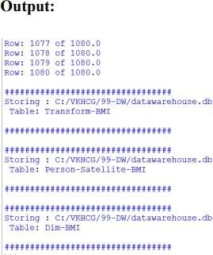

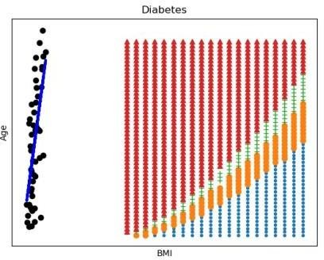

### Practical 8: Organizing Data

import sys import os

import pandas as pd import sqlite3 as sq

################################################################ Base='C:/VKHCG'

print('################################')

print('Working Base :',Base, ' using ', sys.platform)

print('################################') ################################################################ ################################################################

Company='01-Vermeulen' ################################################################

sDataWarehouseDir=Base + '/99-DW' if not os.path.exists(sDataWarehouseDir): os.makedirs(sDataWarehouseDir) ################################################################

sDatabaseName=sDataWarehouseDir + '/datawarehouse.db'

conn1 = sq.connect(sDatabaseName) ################################################################

sDatabaseName=sDataWarehouseDir + '/datamart.db'

conn2 = sq.connect(sDatabaseName) ################################################################ print('################')

sTable = 'Dim-BMI'

print('Loading :',sDatabaseName,' Table:',sTable) sSQL="SELECT * FROM [Dim-BMI];"

PersonFrame0=pd.read_sql_query(sSQL, conn1) print('################')

sTable = 'Dim-BMI'

print('Loading :',sDatabaseName,' Table:',sTable) sSQL="SELECT PersonID,\

Height,\ Weight,\ bmi,\ Indicator\ FROM [Dim-BMI]\ WHERE \ Height > 1.5 \ and

Indicator = 1\ ORDER BY \ Height,\ Weight;"

PersonFrame1=pd.read_sql_query(sSQL, conn1) ################################################################

DimPerson=PersonFrame1

DimPersonIndex=DimPerson.set_index(['PersonID'],inplace=False) ################################################################

sTable = 'Dim-BMI' print('\n#################################')

print('Storing :',sDatabaseName,'\n Table:',sTable) print('\n#################################')

#DimPersonIndex.to_sql(sTable, conn2, if_exists="replace") ################################################################ print('################')

sTable = 'Dim-BMI'

print('Loading :',sDatabaseName,' Table:',sTable) sSQL="SELECT * FROM [Dim-BMI];"

PersonFrame2=pd.read_sql_query(sSQL, conn2) print('Full Data Set (Rows):', PersonFrame0.shape[0])

print('Full Data Set (Columns):', PersonFrame0.shape[1]) print('Horizontal Data Set (Rows):', PersonFrame2.shape[0]) print('Horizontal Data Set (Columns):', PersonFrame2.shape[1])

### Output:

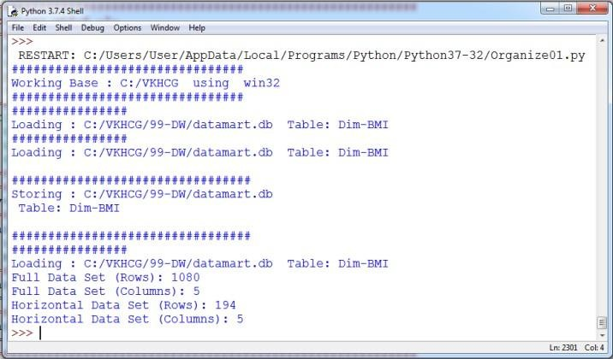

import sys import os

import pandas as pd

import sqlite3 as sq ################################################################ Base='C:/VKHCG'

print('################################')

print('Working Base :',Base, ' using ', sys.platform)

print('################################') ################################################################ ################################################################

Company='01-Vermeulen' ################################################################

sDataWarehouseDir=Base + '/99-DW' if not os.path.exists(sDataWarehouseDir): os.makedirs(sDataWarehouseDir) ################################################################

sDatabaseName=sDataWarehouseDir + '/datawarehouse.db'

conn1 = sq.connect(sDatabaseName) ################################################################

sDatabaseName=sDataWarehouseDir + '/datamart.db'

conn2 = sq.connect(sDatabaseName) ################################################################ print('################################')

sTable = 'Dim-BMI'

print('Loading :',sDatabaseName,' Table:',sTable) sSQL="SELECT * FROM [Dim-BMI];"

PersonFrame0=pd.read_sql_query(sSQL, conn1) ################################################################ print('################################')

sTable = 'Dim-BMI' print('Loading :',sDatabaseName,' Table:',sTable) print('################################')

sSQL="SELECT \ Height,\ Weight,\ Indicator\ FROM [Dim-BMI];" PersonFrame1=pd.read_sql_query(sSQL, conn1) ################################################################

DimPerson=PersonFrame1 DimPersonIndex=DimPerson.set_index(['Indicator'],inplace=False) sTable = 'Dim-BMI-Vertical' print('\n#################################')

print('Storing :',sDatabaseName,'\n Table:',sTable)

print('\n#################################')

DimPersonIndex.to_sql(sTable, conn2, if_exists="replace") ################################################################ print('################')

sTable = 'Dim-BMI-Vertical'

print('Loading :',sDatabaseName,' Table:',sTable) sSQL="SELECT * FROM [Dim-BMI-Vertical];"

PersonFrame2=pd.read_sql_query(sSQL, conn2) ################################################################ print('################################')

print('Full Data Set (Rows):', PersonFrame0.shape[0]) print('Full Data Set (Columns):', PersonFrame0.shape[1])

print('################################')

print('Horizontal Data Set (Rows):', PersonFrame2.shape[0]) print('Horizontal Data Set (Columns):', PersonFrame2.shape[1])

print('################################')

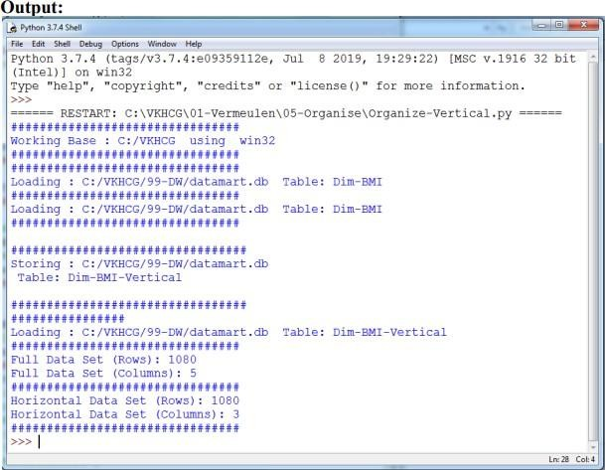

import sys import os

import pandas as pd

import sqlite3 as sq ################################################################ Base='C:/VKHCG'

print('################################')

print('Working Base :',Base, ' using ', sys.platform)

print('################################') ################################################################ ################################################################

Company='01-Vermeulen' ################################################################

sDataWarehouseDir=Base + '/99-DW' if not os.path.exists(sDataWarehouseDir): os.makedirs(sDataWarehouseDir) ################################################################

sDatabaseName=sDataWarehouseDir + '/datawarehouse.db'

conn1 = sq.connect(sDatabaseName) ################################################################

sDatabaseName=sDataWarehouseDir + '/datamart.db'

conn2 = sq.connect(sDatabaseName) ################################################################ print('################')

sTable = 'Dim-BMI'

print('Loading :',sDatabaseName,' Table:', sTable) sSQL="SELECT * FROM [Dim-BMI];"

PersonFrame0=pd.read_sql_query(sSQL, conn1) ################################################################ print('################')

sTable = 'Dim-BMI'

print('Loading :',sDatabaseName,' Table:',sTable)

sSQL="SELECT \ Height,\ Weight,\ Indicator\ FROM [Dim-BMI]\ WHERE Indicator > 2\ ORDER BY \ Height,\ Weight;"

PersonFrame1=pd.read_sql_query(sSQL, conn1) ################################################################

DimPerson=PersonFrame1

DimPersonIndex=DimPerson.set_index(['Indicator'],inplace=False) ################################################################

sTable = 'Dim-BMI-Vertical'

print('\n#################################')

print('Storing :',sDatabaseName,'\n Table:',sTable) print('\n#################################')

DimPersonIndex.to_sql(sTable, conn2, if_exists="replace") ################################################################ print('################################')

sTable = 'Dim-BMI-Vertical'

print('Loading :',sDatabaseName,' Table:',sTable) print('################################') sSQL="SELECT * FROM [Dim-BMI-Vertical];"

PersonFrame2=pd.read_sql_query(sSQL, conn2) ################################################################ print('################################')

print('Full Data Set (Rows):', PersonFrame0.shape[0]) print('Full Data Set (Columns):', PersonFrame0.shape[1])

print('################################')

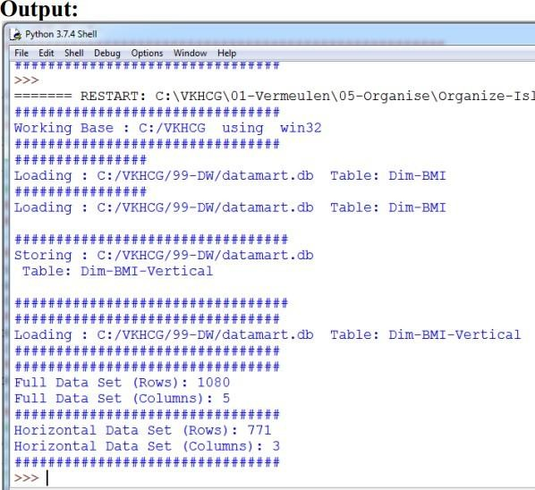print('Horizontal Data Set (Rows):', PersonFrame2.shape[0]) print('Horizontal Data Set (Columns):', PersonFrame2.shape[1]) print('################################')

import sys import os

import pandas as pd

import sqlite3 as sq ################################################################ Base='C:/VKHCG'

print('################################')

print('Working Base :',Base, ' using ', sys.platform)

print('################################') ################################################################ ################################################################

Company='01-Vermeulen' ################################################################

sDataWarehouseDir=Base + '/99-DW' if not os.path.exists(sDataWarehouseDir): os.makedirs(sDataWarehouseDir) ################################################################

sDatabaseName=sDataWarehouseDir + '/datawarehouse.db'

conn1 = sq.connect(sDatabaseName) ################################################################

sDatabaseName=sDataWarehouseDir + '/datamart.db'

conn2 = sq.connect(sDatabaseName) ################################################################ print('################')

sTable = 'Dim-BMI' print('Loading :', sDatabaseName,' Table:',sTable)

sSQL="SELECT * FROM [Dim-BMI];"

PersonFrame0=pd.read_sql_query(sSQL, conn1) ################################################################ print('################')

sTable = 'Dim-BMI'

print('Loading :',sDatabaseName,' Table:',sTable)

sSQL="SELECT \ Height,\ Weight,\ Indicator,\ CASE Indicator\ WHEN 1 THEN 'Pip'\ WHEN 2 THEN 'Norman'\ WHEN 3 THEN 'Grant'\ ELSE 'Sam'\ END AS Name\ FROM [Dim-BMI]\ WHERE Indicator > 2\ ORDER BY \ Height,\ Weight;"

PersonFrame1=pd.read_sql_query(sSQL, conn1)

DimPerson=PersonFrame1

DimPersonIndex=DimPerson.set_index(['Indicator'],inplace=False) ################################################################

sTable = 'Dim-BMI-Secure' print('\n#################################')

print('Storing :',sDatabaseName,'\n Table:',sTable) print('\n#################################')

DimPersonIndex.to_sql(sTable, conn2, if_exists="replace") ################################################################ print('################################')

sTable = 'Dim-BMI-Secure'

print('Loading :',sDatabaseName,' Table:',sTable) print('################################') sSQL="SELECT * FROM [Dim-BMI-Secure] WHERE Name = 'Sam';"

PersonFrame2=pd.read_sql_query(sSQL, conn2) ################################################################ print('################################')

print('Full Data Set (Rows):', PersonFrame0.shape[0]) print('Full Data Set (Columns):', PersonFrame0.shape[1])

print('################################')

print('Horizontal Data Set (Rows):', PersonFrame2.shape[0]) print('Horizontal Data Set (Columns):', PersonFrame2.shape[1])

print('Only Sam Data') print(PersonFrame2.head()) print('################################')

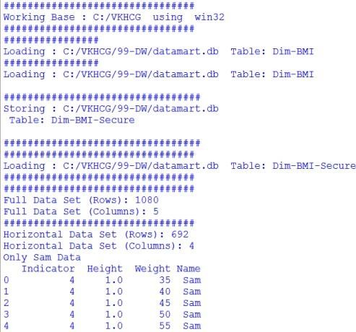

import sys import os

import pandas as pd from mlxtend.frequent_patterns import apriori from mlxtend.frequent_patterns

import association_rules ################################################################

Base='C:/VKHCG' print('################################')

print('Working Base :',Base, ' using ', sys.platform)

print('################################') ################################################################

Company='01-Vermeulen' InputFileName='Online-Retail-Billboard.xlsx' EDSAssessDir='02- Assess/01-EDS' InputAssessDir=EDSAssessDir + '/02-Python' ################################################################

sFileAssessDir=Base + '/' + Company + '/' +

InputAssessDir if not os.path.exists(sFileAssessDir): os.makedirs(sFileAssessDir) ################################################################

sFileName=Base+'/'+ Company + '/00-RawData/' +

InputFileName ################################################################ df =

pd.read_excel(sFileName)

print(df.shape) ################################################################

df['Description'] = df['Description'].str.strip() df.dropna(axis=0, subset=['InvoiceNo'], inplace=True) df['InvoiceNo'] = df['InvoiceNo'].astype('str') df = df[~df['InvoiceNo'].str.contains('C')] basket = (df[df['Country'] =="France"]

.groupby(['InvoiceNo', 'Description'])['Quantity'] .sum().unstack().reset_index().fillna(0)

.set_index('InvoiceNo')) ################################################################

def encode_units(x): if x <= 0: return 0 if x >= 1: return 1

################################################################

basket_sets = basket.applymap(encode_units) basket_sets.drop('POSTAGE', inplace=True, axis=1)

frequent_itemsets = apriori(basket_sets, min_support=0.07, use_colnames=True) rules = association_rules(frequent_itemsets, metric="lift", min_threshold=1) print(rules.head())

rules[ (rules['lift'] >= 6) & (rules['confidence'] >= 0.8) ] ################################################################

sProduct1='ALARM CLOCK BAKELIKE GREEN'

print(sProduct1) print(basket[sProduct1].sum())

sProduct2='ALARM CLOCK BAKELIKE RED'

print(sProduct2) print(basket[sProduct2].sum())

################################################################

basket2 = (df[df['Country'] =="Germany"] .groupby(['InvoiceNo', 'Description'])['Quantity']

.sum().unstack().reset_index().fillna(0) .set_index('InvoiceNo')) basket_sets2 = basket2.applymap(encode_units) basket_sets2.drop('POSTAGE', inplace=True, axis=1) frequent_itemsets2 = apriori(basket_sets2,

min_support=0.05, use_colnames=True)

rules2 = association_rules(frequent_itemsets2, metric="lift", min_threshold=1)

print(rules2[ (rules2['lift'] >= 4) & (rules2['confidence'] >= 0.5)]) ################################################################

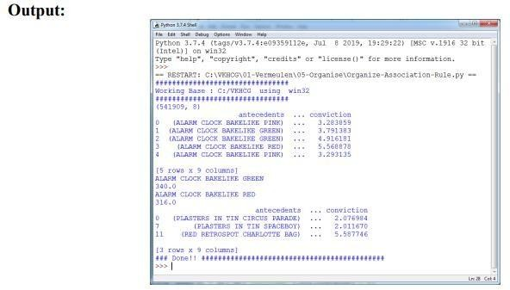print('### Done!! ############################################')

import sys import os

import pandas as pd import networkx as nx

import matplotlib.pyplot as plt ################################################################

pd.options.mode.chained_assignment = None ################################################################

Base='C:/VKHCG' ################################################################ print('################################')

print('Working Base :',Base, ' using ', sys.platform)

print('################################') ################################################################

sInputFileName='02-Assess/01-EDS/02-Python/Assess-Network-Routing-Company.csv' ################################################################

sOutputFileName1='05-Organise/01-EDS/02-Python/Organise-Network-Routing- Company.gml' sOutputFileName2='05-Organise/01-EDS/02-Python/Organise-Network- Routing-Company.png' Company='01-Vermeulen' ################################################################ ################################################################ ###

Import Country Data ################################################################

sFileName=Base + '/' + Company + '/' + sInputFileName print('################################')

print('Loading :',sFileName)

print('################################')

CompanyData=pd.read_csv(sFileName,header=0,low_memory=False, encoding="latin-1") print('################################') ################################################################

print(CompanyData.head())

print(CompanyData.shape) ################################################################

G=nx.Graph() for i in range(CompanyData.shape[0]):

for j in range(CompanyData.shape[0]):

Node0=CompanyData['Company_Country_Name'][i] Node1=CompanyData['Company_Country_Name'][j] if

Node0 != Node1: G.add_edge(Node0,Node1)

for i in range(CompanyData.shape[0]):

Node0=CompanyData['Company_Country_Name'][i] Node1=CompanyData['Company_Place_Name'][i] + '('+ CompanyData['Company_Country_Name'][i] + ')'

if Node0 != Node1:

G.add_edge(Node0,Node1) print('Nodes:', G.number_of_nodes())

print('Edges:', G.number_of_edges()) ################################################################

sFileName=Base + '/' + Company + '/' +

sOutputFileName1 print('################################')

print('Storing :',sFileName) print('################################')

nx.write_gml(G, sFileName) ################################################################

sFileName=Base + '/' + Company + '/' + sOutputFileName2 print('################################')

print('Storing Graph Image:',sFileName) print('################################')

plt.figure(figsize=(15, 15)) pos=nx.spectral_layout(G,dim=2)

nx.draw_networkx_nodes(G,pos, node_color='k', node_size=10, alpha=0.8) nx.draw_networkx_edges(G, pos,edge_color='r', arrows=False, style='dashed') nx.draw_networkx_labels(G,pos,font_size=12,font_family='sans-serif',font_color='b')

plt.axis('off') plt.savefig(sFileName,dpi=600) plt.show()

################################################################ print('################################')

print('### Done!! #####################') print('################################')

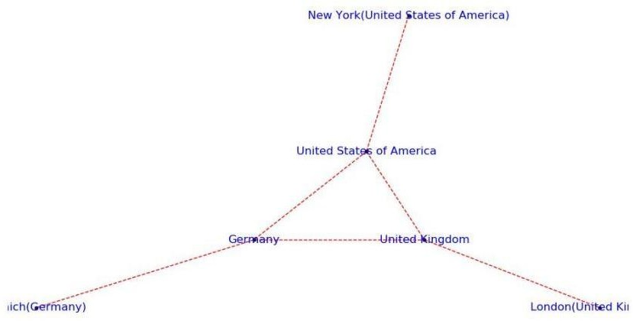

import sys import os

import pandas as pd import networkx as nx

import matplotlib.pyplot as plt

import numpy as np ################################################################

pd.options.mode.chained_assignment = None ################################################################

Base='C:/VKHCG' ################################################################ print('################################')

print('Working Base :',Base, ' using ', sys.platform)

print('################################') ################################################################

sInputFileName='02-Assess/01-EDS/02-Python/Assess-DE-Billboard-Visitor.csv' ################################################################

sOutputFileName1='05-Organise/01-EDS/02-Python/Organise-Billboards.gml' sOutputFileName2='05-Organise/01-EDS/02-Python/Organise-Billboards.png'

Company='02-Krennwallner' ################################################################ ################################################################ ###

Import Company Data ################################################################

sFileName=Base + '/' + Company + '/' +

sInputFileName print('################################')

print('Loading :',sFileName)

print('################################')

BillboardDataRaw=pd.read_csv(sFileName,header=0,low_memory=False, encoding="latin- 1") print('################################') ################################################################

print(BillboardDataRaw.head()) print(BillboardDataRaw.shape) BillboardData=BillboardDataRaw

sSample=list(np.random.choice(BillboardData.shape[0],20)) ############################################################### G=nx.Graph()

for i in sSample:

for j in sSample:

Node0=BillboardData['BillboardPlaceName'][i] + '('+ BillboardData['BillboardCountry'][i] + ')' Node1=BillboardData['BillboardPlaceName'][j] + '('+ BillboardData['BillboardCountry'][i]

+ ')' if Node0 != Node1: G.add_edge(Node0,Node1) for i in sSample:

Node0=BillboardData['BillboardPlaceName'][i] + '('+ BillboardData['VisitorPlaceName'][i] + ')' Node1=BillboardData['BillboardPlaceName'][i] + '('+ BillboardData['VisitorCountry'][i] + ')'

if Node0 != Node1: G.add_edge(Node0,Node1)

print('Nodes:', G.number_of_nodes()) print('Edges:', G.number_of_edges())

################################################################

sFileName=Base + '/02-Krennwallner/' + sOutputFileName1 print('################################')

print('Storing :',sFileName) print('################################')

nx.write_gml(G, sFileName) ################################################################

sFileName=Base + '/02-Krennwallner/' + sOutputFileName2 print('################################')

print('Storing Graph Image:',sFileName) print('################################')

plt.figure(figsize=(15, 15)) pos=nx.circular_layout(G,dim=2)

nx.draw_networkx_nodes(G,pos, node_color='k', node_size=150, alpha=0.8) nx.draw_networkx_edges(G, pos,edge_color='r', arrows=False, style='solid') nx.draw_networkx_labels(G,pos,font_size=12,font_family='sans-serif',font_color='b')

plt.axis('off') plt.savefig(sFileName,dpi=600) plt.show() ################################################################ print('################################')

print('### Done!! #####################') print('################################')

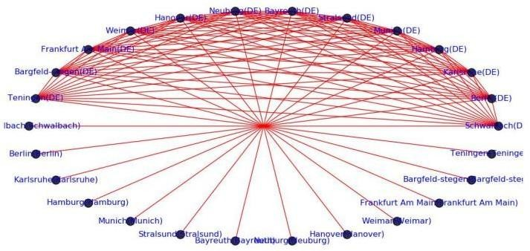

import sys import os

import pandas as pd ################################################################ Base='C:/VKHCG' ################################################################ print('################################')

print('Working Base :',Base, ' using ', sys.platform)

print('################################') ################################################################

sInputFileName='02-Assess/01-EDS/02-Python/Assess_Shipping_Routes.txt' ################################################################

sOutputFileName='05-Organise/01-EDS/02-Python/Organise-Routes.csv' Company='03-Hillman'

sFileName=Base + '/' + Company + '/' + sInputFileName

print('################################')

print('Loading :',sFileName) print('################################')

RouteDataRaw=pd.read_csv(sFileName,header=0,low_memory=False, sep='|', encoding="latin-1") print('################################') ################################################################

RouteStart=RouteDataRaw[RouteDataRaw['StartAt']=='WH-KA13'] ################################################################

RouteDistance=RouteStart[RouteStart['Cost']=='DistanceMiles'] RouteDistance=RouteDistance.sort_values(by=['Measure'], ascending=False) ################################################################

RouteMax=RouteStart["Measure"].max()

RouteMaxCost=round((((RouteMax/1000)*1.5*2)),2) print('################################') print('Maximum (£) per day:') print(RouteMaxCost)

print('################################') ################################################################

RouteMean=RouteStart["Measure"].mean() RouteMeanMonth=round((((RouteMean/1000)*2*30)),6) print('################################')

print('Mean per Month (Miles):')

print(RouteMeanMonth) print('################################')

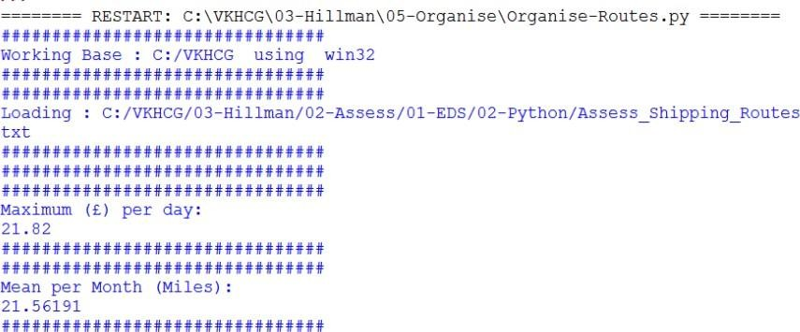

import sys import os

import pandas as pd import sqlite3 as sq

import re ################################################################ Base='C:/VKHCG' ################################################################ print('################################')

print('Working Base :',Base, ' using ', sys.platform)

print('################################') ################################################################

sInputFileName='03-Process/01-EDS/02-Python/Process_ExchangeRates.csv' ################################################################

sOutputFileName='05-Organise/01-EDS/02-Python/Organise-Forex.csv'

Company='04-Clark' ################################################################

sDatabaseName=Base + '/' + Company + '/05-Organise/SQLite/clark.db' conn = sq.connect(sDatabaseName)

#conn = sq.connect(':memory:') ################################################################ ################################################################ ###

Import Forex Data ################################################################

sFileName=Base + '/' + Company + '/' + sInputFileName print('################################')

print('Loading :',sFileName)

print('################################')

ForexDataRaw=pd.read_csv(sFileName,header=0,low_memory=False, encoding="latin-1") print('################################') ################################################################

ForexDataRaw.index.names = ['RowID']

sTable='Forex_All' print('Storing :',sDatabaseName,' Table:',sTable)

ForexDataRaw.to_sql(sTable, conn, if_exists="replace") ################################################################

sSQL="SELECT 1 as Bag\ , CAST(min(Date) AS VARCHAR(10)) as Date \

,CAST(1000000.0000000 as NUMERIC(12,4)) as Money \ ,'USD' as Currency \ FROM

Forex_All \ ;" sSQL=re.sub("\s\s+", " ", sSQL) nMoney=pd.read_sql_query(sSQL, conn) ################################################################

nMoney.index.names = ['RowID'] sTable='MoneyData'

print('Storing :',sDatabaseName,' Table:',sTable)

nMoney.to_sql(sTable, conn, if_exists="replace") ################################################################

sTable='TransactionData' print('Storing :',sDatabaseName,' Table:',sTable)

nMoney.to_sql(sTable, conn, if_exists="replace") ################################################################

ForexDay=pd.read_sql_query("SELECT Date FROM Forex_All GROUP BY Date;", conn) ################################################################

t=0

for i in range(ForexDay.shape[0]):

sDay1=ForexDay['Date'][i] sDay=str(sDay1)

sSQL='\ SELECT M.Bag as Bag, \ F.Date as Date,

\ round(M.Money * F.Rate,6) AS Money,

\ F.CodeIn AS PCurrency,

\ F.CodeOut AS Currency

\ FROM MoneyData AS M

\ JOIN \ ( \ SELECT \ CodeIn, CodeOut, Date, Rate

\ FROM \ Forex_All \ WHERE\ CodeIn = "USD" AND CodeOut = "GBP"

\ UNION \ SELECT \ CodeOut AS CodeIn, CodeIn AS CodeOut, Date, (1/Rate) AS Rate

\ FROM \ Forex_All \ WHERE\ CodeIn = "USD" AND CodeOut = "GBP" \ ) AS F

\ ON \ M.Currency=F.CodeIn \ AND \ F.Date ="' +sDay + '";' sSQL=re.sub("\s\s+", " ", sSQL) ForexDayRate=pd.read_sql_query(sSQL, conn)

for j in range(ForexDayRate.shape[0]): sBag=str(ForexDayRate['Bag'][j]) nMoney=str(round(ForexDayRate['Money'][j],2)) sCodeIn=ForexDayRate['PCurrency'][j] sCodeOut=ForexDayRate['Currency'][j]

sSQL='UPDATE MoneyData SET Date= "' + sDay + '", ' sSQL= sSQL + ' Money = ' + nMoney + ', Currency="' + sCodeOut + '"'

sSQL= sSQL + ' WHERE Bag=' + sBag + ' AND Currency="' + sCodeIn + '";' sSQL=re.sub("\s\s+", " ", sSQL) cur = conn.cursor()

cur.execute(sSQL) conn.commit() t+=1

print('Trade :', t, sDay, sCodeOut, nMoney)

sSQL=' \ INSERT INTO TransactionData ( \ RowID, \ Bag, \ Date, \ Money, \ Currency \ ) \

SELECT ' + str(t) + ' AS RowID, \ Bag, \ Date, \ Money, \ Currency \ FROM MoneyData \ ;' sSQL=re.sub("\s\s+", " ", sSQL)

cur = conn.cursor() cur.execute(sSQL) conn.commit()

################################################################

sSQL="SELECT RowID, Bag, Date, Money, Currency FROM TransactionData ORDER BY RowID;" sSQL=re.sub("\s\s+", " ", sSQL)

TransactionData=pd.read_sql_query(sSQL, conn) OutputFile=Base + '/' + Company + '/' +

sOutputFileName TransactionData.to_csv(OutputFile, index = False)

### Practical 9: Generating Data

import sys import os

import pandas as pd import networkx as nx

import matplotlib.pyplot as plt ################################################################

pd.options.mode.chained_assignment = None ################################################################

if sys.platform == 'linux':

Base=os.path.expanduser('~') + 'VKHCG' else:

Base='C:/VKHCG' ################################################################ print('################################')

print('Working Base :',Base, ' using ', sys.platform)

print('################################') ################################################################

sInputFileName='02-Assess/01-EDS/02-Python/Assess-Network-Routing-Customer.csv' ################################################################

sOutputFileName1='06-Report/01-EDS/02-Python/Report-Network-Routing-Customer.gml' sOutputFileName2='06-Report/01-EDS/02-Python/Report-Network-Routing-Customer.png' Company='01-Vermeulen' ################################################################ ################################################################ ###

Import Country Data ################################################################

sFileName=Base + '/' + Company + '/' + sInputFileName print('################################')

print('Loading :',sFileName) print('################################')

CustomerDataRaw=pd.read_csv(sFileName,header=0,low_memory=False, encoding="latin- 1") CustomerData=CustomerDataRaw.head(100)

print('Loaded Country:',CustomerData.columns.values) print('################################') ################################################################

print(CustomerData.head())

print(CustomerData.shape) ################################################################

G=nx.Graph() for i in range(CustomerData.shape[0]):

for j in range(CustomerData.shape[0]):

Node0=CustomerData['Customer_Country_Name'][i] Node1=CustomerData['Customer_Country_Name'][j]

if Node0 != Node1: G.add_edge(Node0,Node1) for i in range(CustomerData.shape[0]):

Node0=CustomerData['Customer_Country_Name'][i] Node1=CustomerData['Customer_Place_Name'][i] + '('+ CustomerData['Customer_Country_Name'][i] + ')'

Node2='('+ "{:.9f}".format(CustomerData['Customer_Latitude'][i]) + ')\ ('+

"{:.9f}".format(CustomerData['Customer_Longitude'][i]) + ')' if Node0 != Node1: G.add_edge(Node0,Node1)

if Node1 != Node2: G.add_edge(Node1,Node2) print('Nodes:', G.number_of_nodes())

print('Edges:', G.number_of_edges()) ################################################################

sFileName=Base + '/' + Company + '/' + sOutputFileName1 print('################################')

print('Storing :',sFileName) print('################################')

nx.write_gml(G, sFileName) ################################################################

sFileName=Base + '/' + Company + '/' + sOutputFileName2 print('################################')

print('Storing Graph Image:',sFileName) print('################################')

plt.figure(figsize=(25, 25)) pos=nx.spectral_layout(G,dim=2) nx.draw_networkx_nodes(G,pos, node_color='k', node_size=10, alpha=0.8) nx.draw_networkx_edges(G,

pos,edge_color='r', arrows=False, style='dashed') nx.draw_networkx_labels(G,pos,font_size=12,font_family='sans-serif',font_color='b')

plt.axis('off') plt.savefig(sFileName,dpi=600) plt.show()

print('################################') print('### Done!! #####################') print('################################')

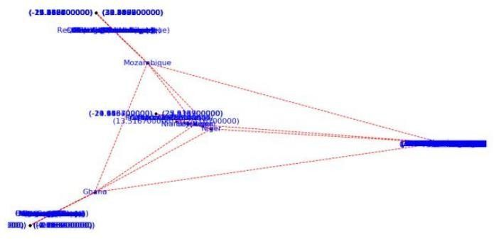

import sys import os

import pandas as pd from folium.plugins

import FastMarkerCluster, HeatMap from folium import Marker, Map import webbrowser

################################################################ Base='C:/VKHCG'

print('################################')

print('Working Base :',Base, ' using ', sys.platform)

print('################################') ################################################################

sFileName=Base+'/02-Krennwallner/01-Retrieve/01-EDS/02- Python/Retrieve_DE_Billboard_Locations.csv' df = pd.read_csv(sFileName,header=0,low_memory=False, encoding="latin-1") df.fillna(value=0, inplace=True)

print(df.shape) ################################################################ t=0 for i in

range(df.shape[0]): try:

sLongitude=df["Longitude"][i] sLongitude=float(sLongitude) except Exception: sLongitude=float(0.0) try:

sLatitude=df["Latitude"][i] sLatitude=float(sLatitude) except Exception:

sLatitude=float(0.0) try: s

Description=df["Place_Name"][i] + ' (' + df["Country"][i]+')' except Exception: sDescription='VKHCG'

if sLongitude != 0.0 and sLatitude != 0.0:

DataClusterList=list([sLatitude, sLongitude]) DataPointList=list([sLatitude, sLongitude, sDescription]) t+=1

if t==1:

DataCluster=[DataClusterList] DataPoint=[DataPointList]

else: DataCluster.append(DataClusterList) DataPoint.append(DataPointList) data=DataCluster pins=pd.DataFrame(DataPoint)

pins.columns = [ 'Latitude','Longitude','Description'] ################################################################

stops_map1 = Map(location=[48.1459806, 11.4985484], zoom_start=5) marker_cluster = FastMarkerCluster(data).add_to(stops_map1)

sFileNameHtml=Base+'/02-Krennwallner/06-Report/01-EDS/02-Python/Billboard1.html' stops_map1.save(sFileNameHtml) webbrowser.open('file://' + os.path.realpath(sFileNameHtml)) ################################################################

stops_map2 = Map(location=[48.1459806, 11.4985484], zoom_start=5) for name, row in pins.iloc[:100].iterrows():

Marker([row["Latitude"],row["Longitude"]], popup=row["Description"]).add_to(stops_map2)

sFileNameHtml=Base+'/02-Krennwallner/06-Report/01-EDS/02-Python/Billboard2.html' stops_map2.save(sFileNameHtml)

webbrowser.open('file://' + os.path.realpath(sFileNameHtml)) ################################################################

stops_heatmap = Map(location=[48.1459806, 11.4985484], zoom_start=5) stops_heatmap.add_child(HeatMap([[row["Latitude"],

row["Longitude"]] for name, row in pins.iloc[:100].iterrows()])) sFileNameHtml=Base+'/02- Krennwallner/06-Report/01-EDS/02-Python/Billboard_heatmap.html' stops_heatmap.save(sFileNameHtml) webbrowser.open('file://' + os.path.realpath(sFileNameHtml)) ################################################################

print('### Done!! ############################################')

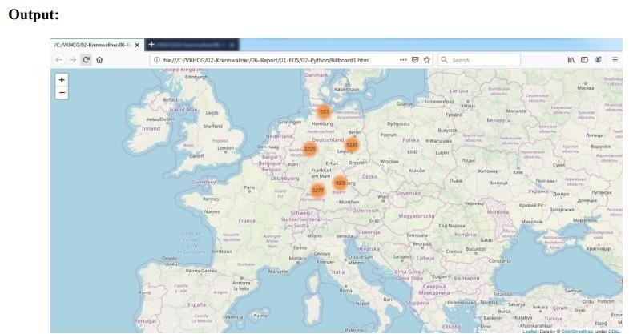

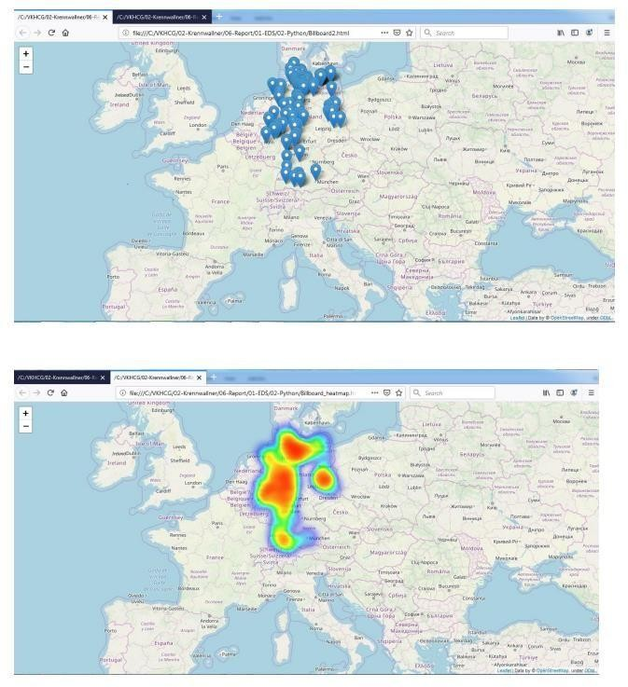

from time import time import numpy as np

import matplotlib.pyplot as plt from matplotlib import offsetbox from sklearn

import (manifold, datasets, decomposition, ensemble, discriminant_analysis, random_projection) digits = datasets.load_digits(n_class=6)

X = digits.data y = digits.target n_samples, n_features = X.shape n_neighbors = 30 def plot_embedding(X, title=None):

x_min, x_max = np.min(X, 0),

np.max(X, 0) X = (X - x_min) / (x_max - x_min) plt.figure(figsize=(10, 10))

ax = plt.subplot(111)

for i in range(X.shape[0]):

plt.text(X[i, 0], X[i, 1], str(digits.target[i]), color=plt.cm.Set1(y[i] / 10.), fontdict={'weight': 'bold', 'size': 9})

if hasattr(offsetbox, 'AnnotationBbox'): #

only print thumbnails with matplotlib > 1.0 shown_images = np.array([[1., 1.]]) # just something big

for i in range(digits.data.shape[0]):

dist = np.sum((X[i] - shown_images) ** 2, 1) if np.min(dist) < 4e-3:

# don't show points that are too close continue

shown_images = np.r_[shown_images, [X[i]]] imagebox = offsetbox.AnnotationBbox(offsetbox.OffsetImage(digits.images[i],

cmap=plt.cm.gray_r),X[i]) ax.add_artist(imagebox) plt.xticks([]), plt.yticks([])

if title is not None:

plt.title(title) n_img_per_row = 20

img = np.zeros((10 * n_img_per_row, 10 * n_img_per_row)) for i in range(n_img_per_row):

ix = 10 * i + 1 for j in range(n_img_per_row): iy = 10 * j + 1 img[ix:ix + 8, iy:iy + 8] = X[i * n_img_per_row + j].reshape((8, 8))

plt.figure(figsize=(10, 10)) plt.imshow(img, cmap=plt.cm.binary) plt.xticks([]) plt.yticks([])

plt.title('A selection from the 64-dimensional digits dataset')

print("Computing random projection") rp = random_projection.SparseRandomProjection(n_components=2, random_state=42)

X_projected = rp.fit_transform(X)

plot_embedding(X_projected, "Random Projection of the digits") print("Computing PCA projection")

t0 = time()

X_pca = decomposition.TruncatedSVD(n_components=2).fit_transform(X) plot_embedding(X_pca,"Principal Components projection of the digits (time %.2fs)"

%(time() - t0)) print("Computing Linear Discriminant Analysis projection")

X2 = X.copy() X2.flat[::X.shape[1] + 1] += 0.01 # Make X invertible t0 = time() X_lda =

discriminant_analysis.LinearDiscriminantAnalysis(n_components=2).fit_transform(X2, y) plot_embedding(X_lda,"Linear Discriminant projection of the digits (time %.2fs)" %(time() - t0)) print("Computing Isomap embedding")

t0 = time()

X_iso = manifold.Isomap(n_neighbors, n_components=2).fit_transform(X) print("Done.") plot_embedding(X_iso,"Isomap projection of the digits (time %.2fs)"

%(time() - t0)) print("Computing LLE embedding")

clf = manifold.LocallyLinearEmbedding(n_neighbors, n_components=2,method='standard') t0 = time() X_lle = clf.fit_transform(X)

print("Done. Reconstruction error: %g" % clf.reconstruction_error_)

plot_embedding(X_lle,"Locally Linear Embedding of the digits (time %.2fs)" %(time() - t0)) print("Computing modified LLE embedding")

clf = manifold.LocallyLinearEmbedding(n_neighbors, n_components=2, method='modified') t0 = time()

X_mlle = clf.fit_transform(X)

print("Done. Reconstruction error: %g" % clf.reconstruction_error_) plot_embedding(X_mlle,"Modified Locally Linear Embedding of the digits (time %.2fs)"

%(time() - t0))

print("Computing Hessian LLE embedding")

clf = manifold.LocallyLinearEmbedding(n_neighbors, n_components=2,method='hessian') t0 = time()

X_hlle = clf.fit_transform(X)

print("Done. Reconstruction error: %g" % clf.reconstruction_error_) plot_embedding(X_hlle,"Hessian Locally Linear Embedding of the digits (time %.2fs)"

%(time() - t0)) print("Computing LTSA embedding")

clf = manifold.LocallyLinearEmbedding(n_neighbors, n_components=2,method='ltsa') t0 = time()

X_ltsa = clf.fit_transform(X)

print("Done. Reconstruction error: %g" % clf.reconstruction_error_) plot_embedding(X_ltsa,"Local Tangent Space Alignment of the digits (time %.2fs)"

%(time() - t0)) print("Computing MDS embedding") clf = manifold.MDS(n_components=2,

n_init=1, max_iter=100) t0 = time()

X_mds = clf.fit_transform(X) print("Done. Stress: %f" % clf.stress_)

plot_embedding(X_mds,"MDS embedding of the digits (time %.2fs)" %(time() - t0)) print("Computing Totally Random Trees embedding")

hasher = ensemble.RandomTreesEmbedding(n_estimators=200, random_state=0, max_depth=5) t0 = time() X_transformed = hasher.fit_transform(X)

pca = decomposition.TruncatedSVD(n_components=2) X_reduced = pca.fit_transform(X_transformed)

plot_embedding(X_reduced,"Random forest embedding of the digits (time %.2fs)" %(time()

- t0)) print("Computing Spectral embedding")

embedder = manifold.SpectralEmbedding(n_components=2, random_state= eigen_solver="arpack")

t0 = time()

X_se = embedder.fit_transform(X)

plot_embedding(X_se,"Spectral embedding of the digits (time %.2fs)" %(time() - t0)) print("Computing t-SNE embedding")

tsne = manifold.TSNE(n_components=2, init='pca', random_state=0)

t0 = time()

X_tsne = tsne.fit_transform(X)

plot_embedding(X_tsne,"t-SNE embedding of the digits (time %.2fs)" %(time() - t0)) plt.show()

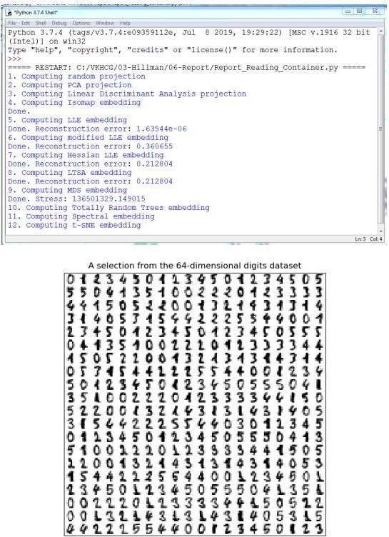

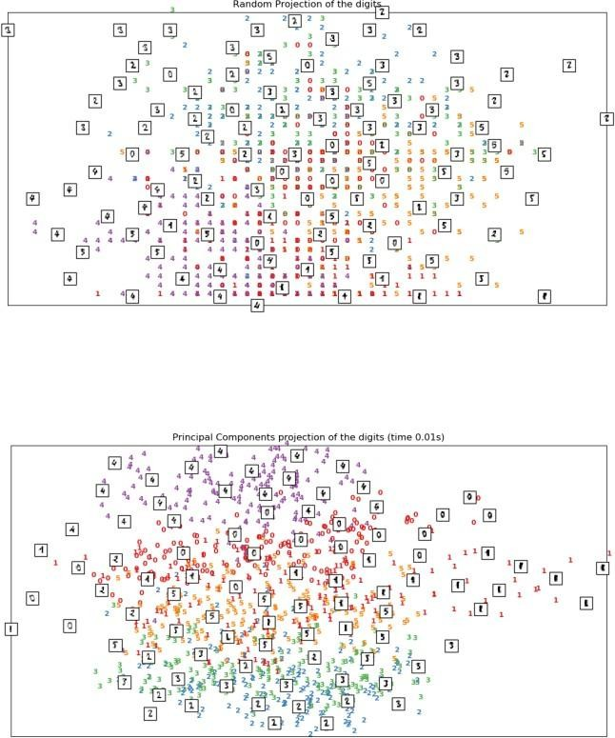

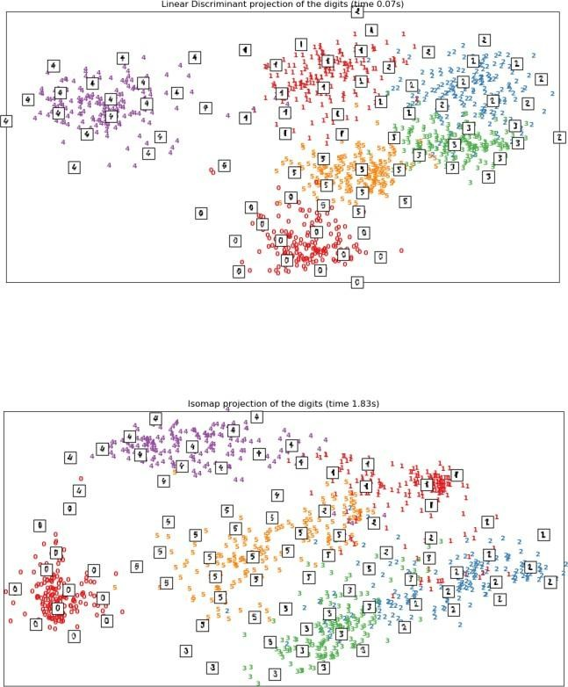

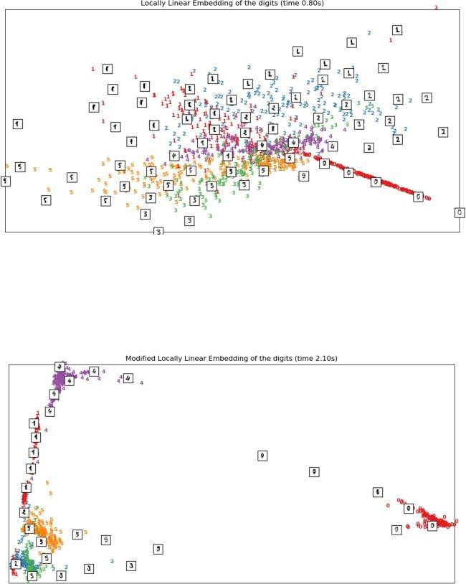

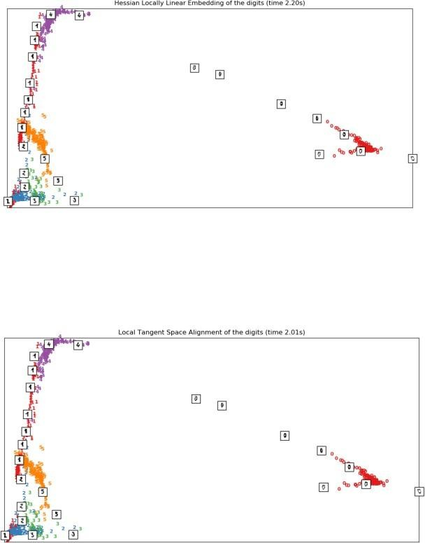

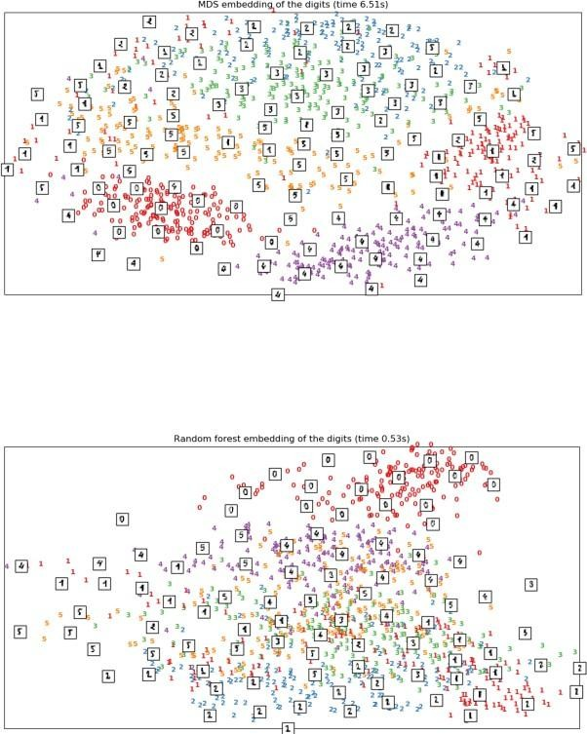

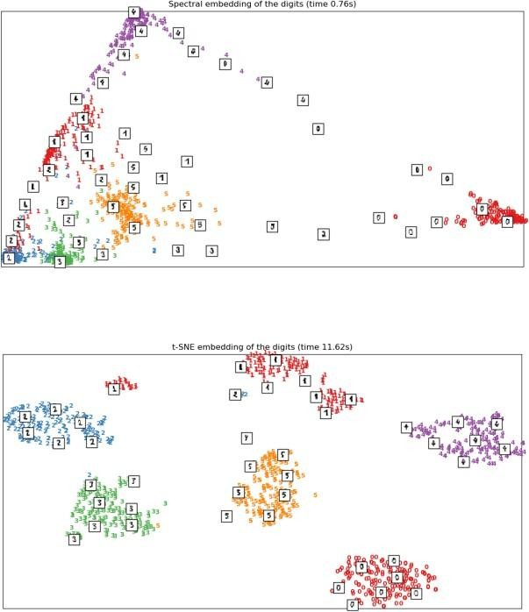

import sys import os

import pandas as pd import sqlite3 as sq import re from openpyxl

import load_workbook ################################################################

Base='C:/VKHCG' ################################################################ print('################################')

print('Working Base :',Base, ' using ', sys.platform)

print('################################') ################################################################

sInputTemplateName='00-RawData/Balance-Sheet-Template.xlsx' ################################################################

sOutputFileName='06-Report/01-EDS/02-Python/Report-Balance-Sheet'

Company='04-Clark' ################################################################

sDatabaseName=Base + '/' + Company + '/06-Report/SQLite/clark.db'

conn = sq.connect(sDatabaseName) #conn = sq.connect(':memory:') ################################################################

### Import Balance Sheet Data ################################################################

for y in range(1,13):

sInputFileName='00-RawData/BalanceSheets' + str(y).zfill(2) + '.csv' sFileName=Base + '/' + Company + '/' +

sInputFileName print('################################')

print('Loading :',sFileName)

print('################################')

ForexDataRaw=pd.read_csv(sFileName,header=0,low_memory=False, encoding="latin-1") print('################################') ################################################################

ForexDataRaw.index.names = ['RowID'] sTable='BalanceSheets print('Storing :',sDatabaseName,' Table:',sTable)

if y == 1:

print('Load Data')

ForexDataRaw.to_sql(sTable, conn, if_exists="replace") else: print('Append Data')

ForexDataRaw.to_sql(sTable, conn, if_exists="append") ################################################################

sSQL="SELECT \ Year, \ Quarter, \ Country, \ Company, \ CAST(Year AS INT) || 'Q' || CAST(Quarter AS INT) AS sDate, \ Company || ' (' || Country || ')' AS sCompanyName , \ CAST(Year AS INT) || 'Q' || CAST(Quarter AS INT) || '-' ||\ Company || '-' || Country AS

sCompanyFile \ FROM BalanceSheets \ GROUP BY \ Year, \ Quarter, \ Country, \ Company

\ HAVING Year is not null \ ;" sSQL=re.sub("\s\s+", " ", sSQL) sDatesRaw=pd.read_sql_query(sSQL, conn) print(sDatesRaw.shape)

sDates=sDatesRaw.head(5) ################################################################

## Loop Dates ################################################################ for i in

range(sDates.shape[0]): sFileName=Base + '/' + Company + '/' + sInputTemplateName wb = load_workbook(sFileName) ws=wb.get_sheet_by_name("Balance-Sheet") sYear=sDates['sDate'][i] sCompany=sDates['sCompanyName'][i] sCompanyFile=sDates['sCompanyFile'][i] sCompanyFile=re.sub("\s+", "", sCompanyFile)

ws['D3'] = sYear ws['D5'] =

sCompany sFields = pd.DataFrame( [ ['Cash','D16', 1], ['Accounts_Receivable','D17', 1],

['Doubtful_Accounts','D18', 1],

['Inventory','D19', 1],

['Temporary_Investment','D20', 1],

['Prepaid_Expenses','D21', 1],

['Long_Term_Investments','D24', 1],

['Land','D25', 1],

['Buildings','D26', 1],

['Depreciation_Buildings','D27', -1],

['Plant_Equipment','D28', 1],

['Depreciation_Plant_Equipment','D29', -1],

['Furniture_Fixtures','D30', 1],

['Depreciation_Furniture_Fixtures','D31', -1],

['Accounts_Payable','H16', 1],

['Short_Term_Notes','H17', 1],

['Current_Long_Term_Notes','H18', 1],

['Interest_Payable','H19', 1],

['Taxes_Payable','H20', 1],

['Accrued_Payroll','H21', 1],

['Mortgage','H24', 1],

['Other_Long_Term_Liabilities','H25', 1], ['Capital_Stock','H30', 1] ] )

nYear=str(int(sDates['Year'][i])) nQuarter=str(int(sDates['Quarter'][i])) sCountry=str(sDates['Country'][i]) sCompany=str(sDates['Company'][i]) sFileName=Base + '/' + Company + '/' + sOutputFileName + \ '-' + sCompanyFile + '.xlsx' print(sFileName)

for j in range(sFields.shape[0]):

sSumField=sFields[0][j] sCellField=sFields[1][j] nSumSign=sFields[2][j]

sSQL="SELECT \ Year, \ Quarter, \ Country, \ Company, \ SUM(" + sSumField + ") AS nSumTotal \ FROM BalanceSheets \ GROUP BY \ Year, \ Quarter, \ Country, \ Company \ HAVING \ Year=" + nYear + " \ AND \ Quarter=" + nQuarter + " \ AND \ Country='" + sCountry + "' \

AND \ Company='" + sCompany + "' \ ;" sSQL=re.sub("\s\s+", " ", sSQL) sSumRaw=pd.read_sql_query(sSQL, conn)

ws[sCellField] = sSumRaw["nSumTotal"][0] * nSumSign print('Set cell',sCellField,' to ', sSumField,'Total') wb.save(sFileName)

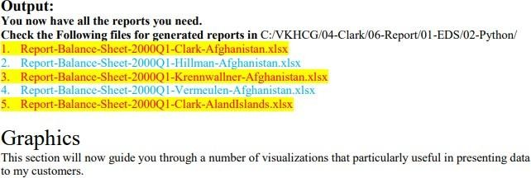

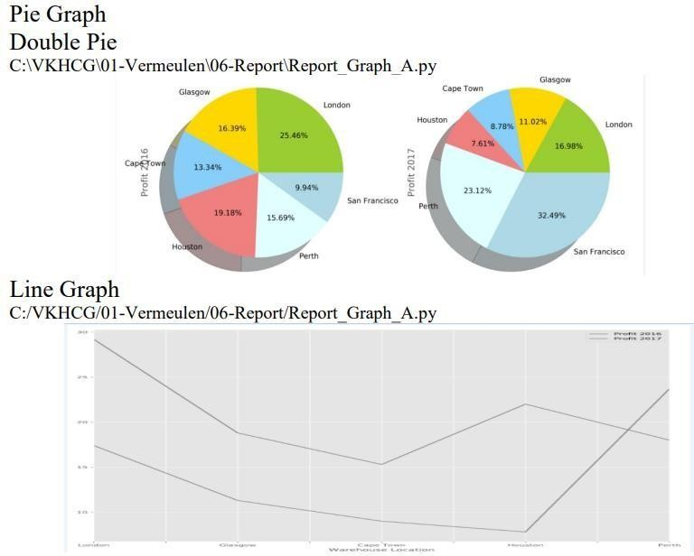

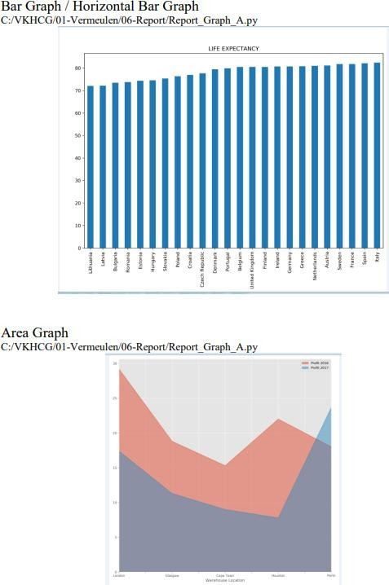

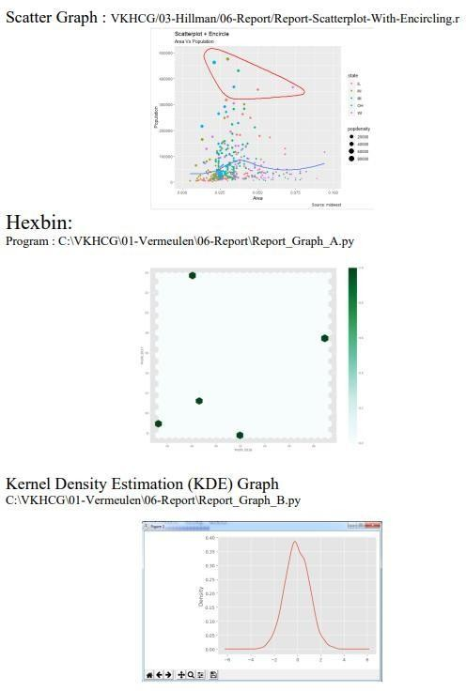

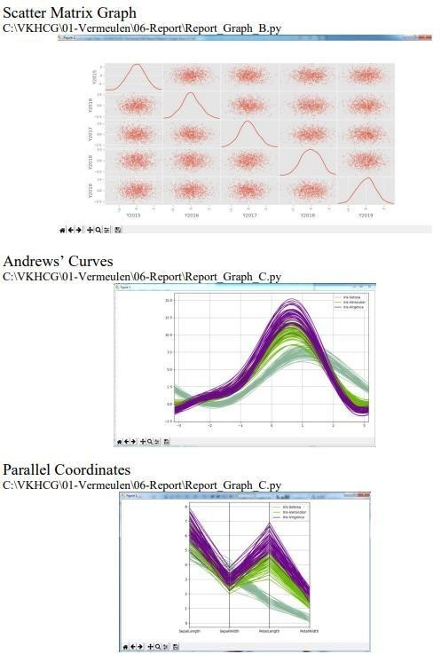

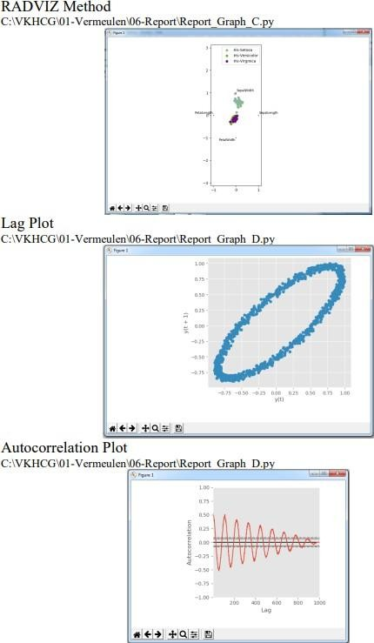

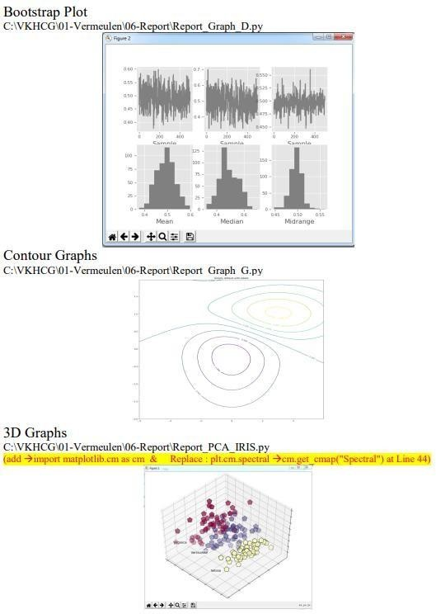

**Importing Excel Data**

# Practical 10

#### Launch Power BI Desktop.

1. **From the Home ribbon, select Get Data. Excel is one of the Most Common data connections, so you can select it directly from the Get Data menu**

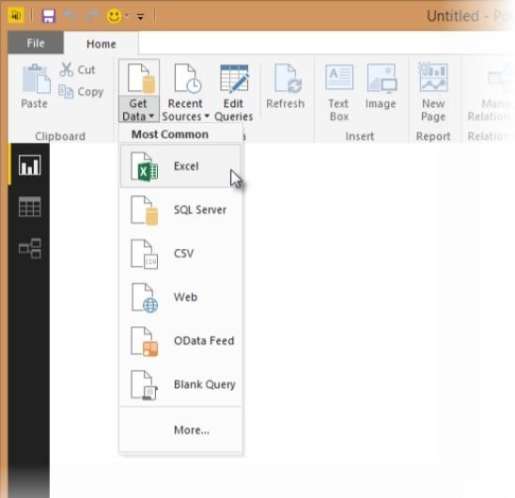

#### If you select the Get Data button directly, you can also select FIle > Excel and select Connect. 4) In the Open File dialog box, select the Products.xlsx file. 5) In the Navigator pane, select the Products table and then select Edit.

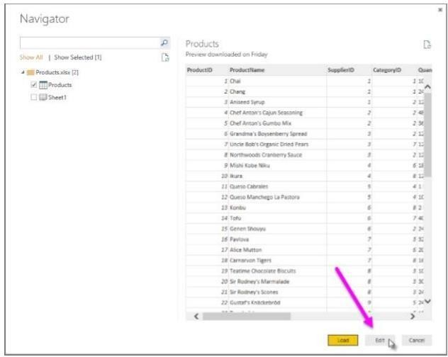

**Importing Data from OData Feed In this task, you'll bring in order data. This step represents connecting to a sales system.**

#### You import data into Power BI Desktop from the sample Northwind OData feed at the following URL, which you can copy (and then paste) in the steps below:

[**http://services.odata.org/V3/Northwind/Northwind.svc/**](http://services.odata.org/V3/Northwind/Northwind.svc/) **Connect to an OData feed**:

1. From the Home ribbon tab in Query Editor, select Get Data.
2. Browse to the OData Feed data source.
3. In the OData Feed dialog box, paste the URL for the Northwind OData feed.
4. Select OK. 5) In the Navigator pane, select the Orders table, and then select Edit

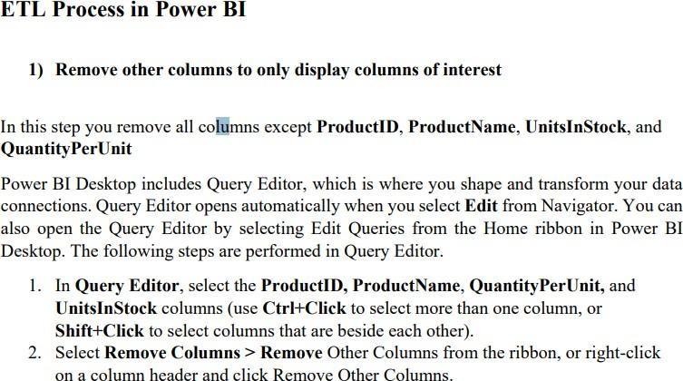

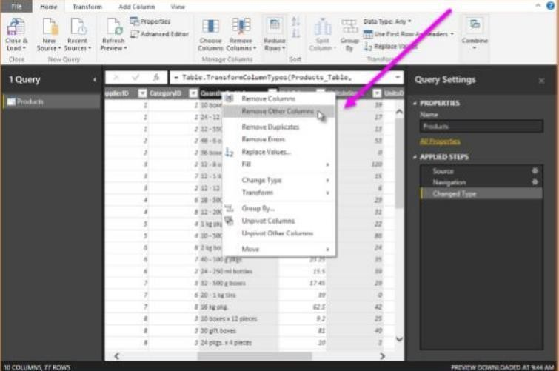

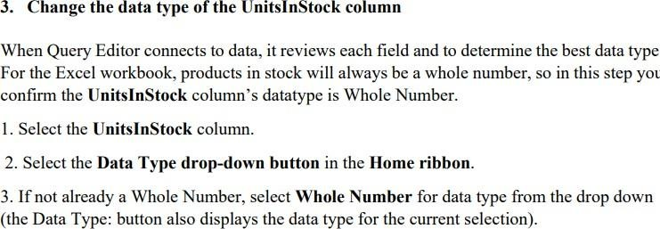

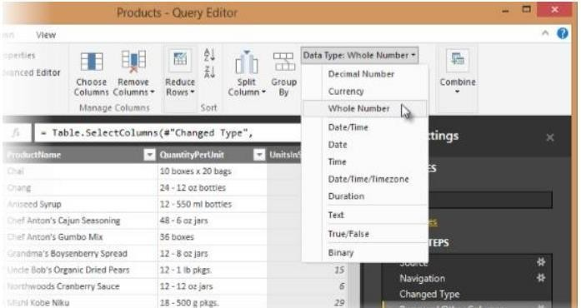

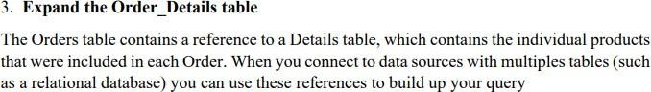

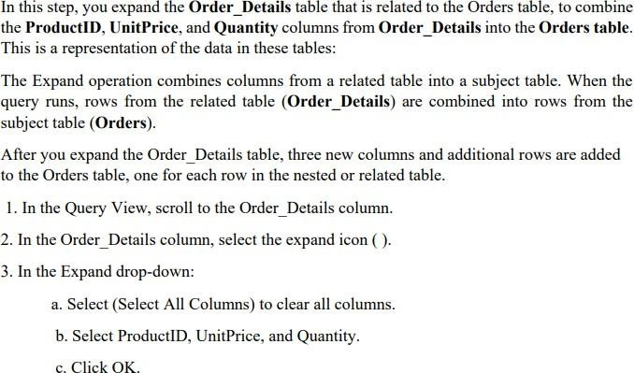

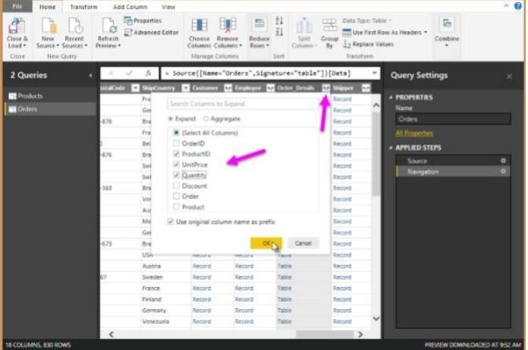

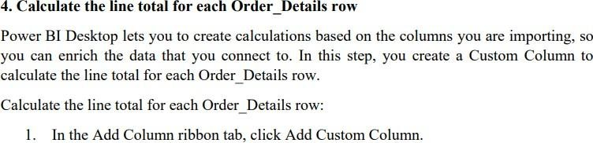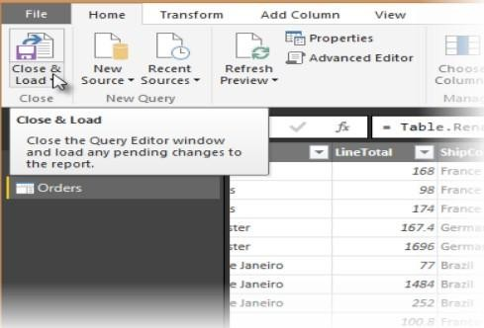

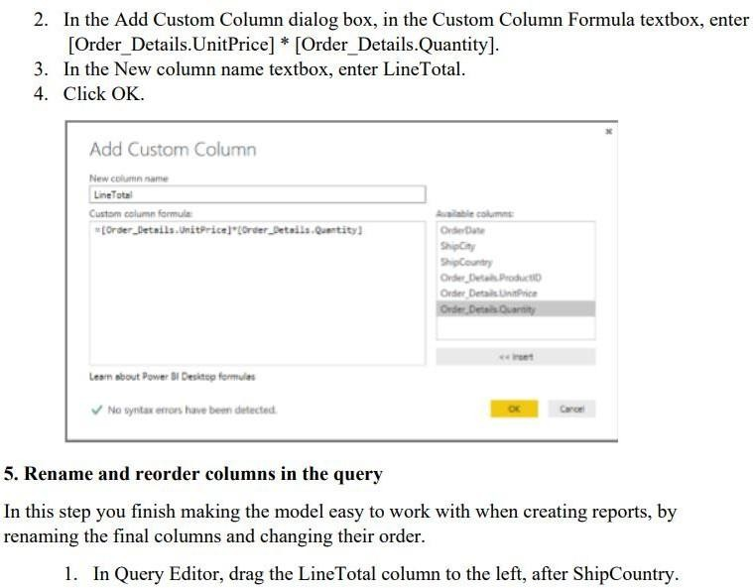

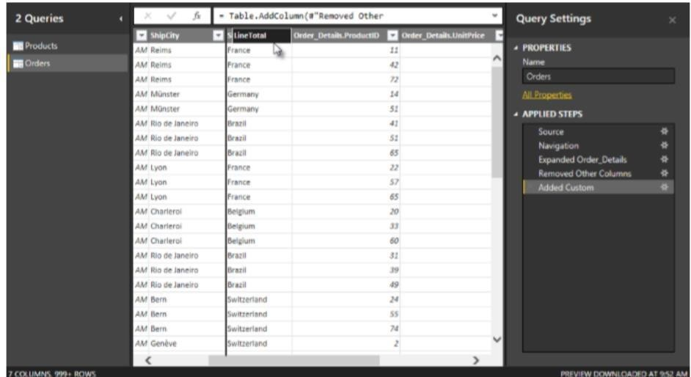



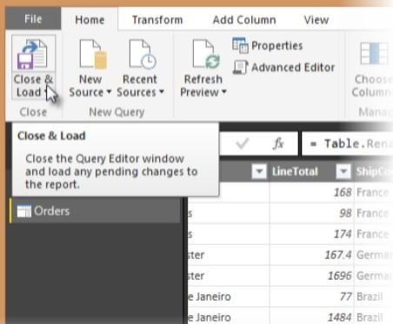

**2. Power BI Desktop loads the data from the two queries.**

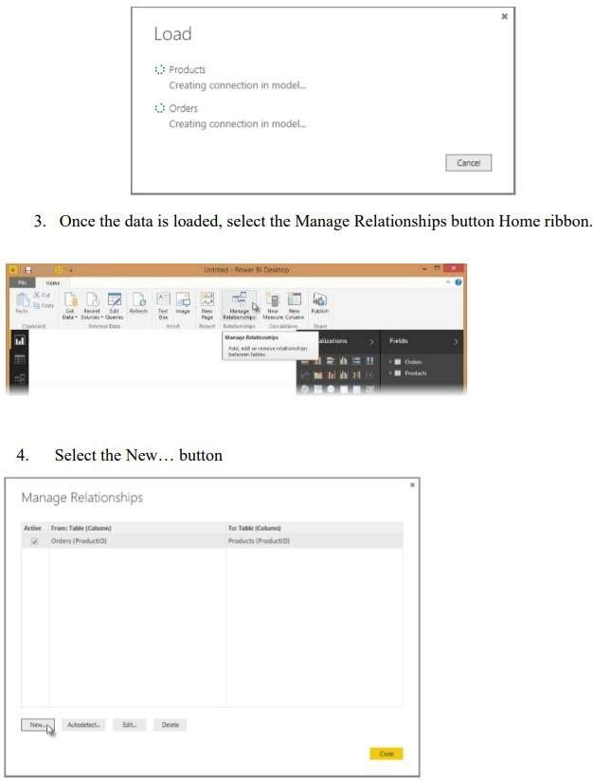



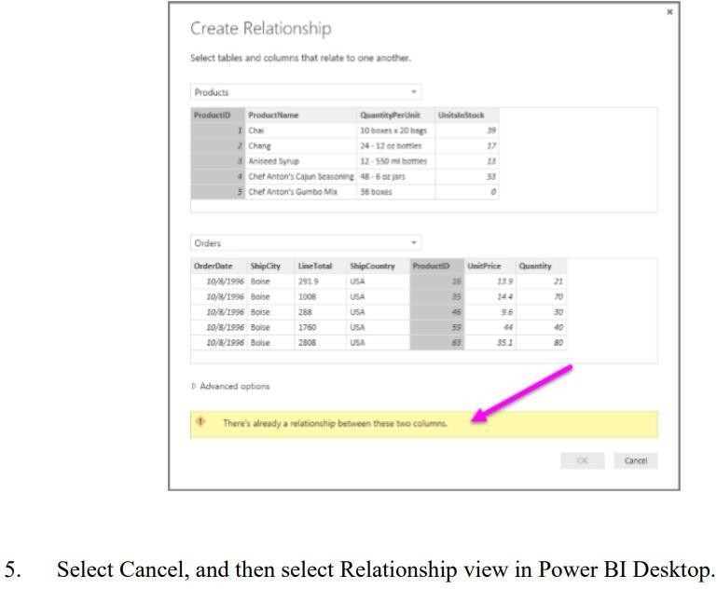

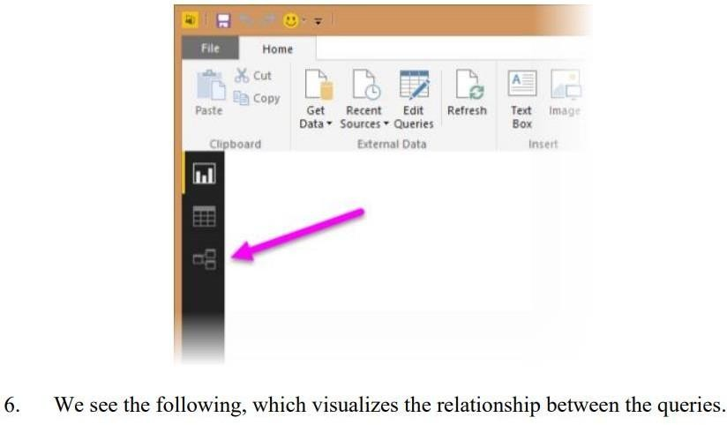

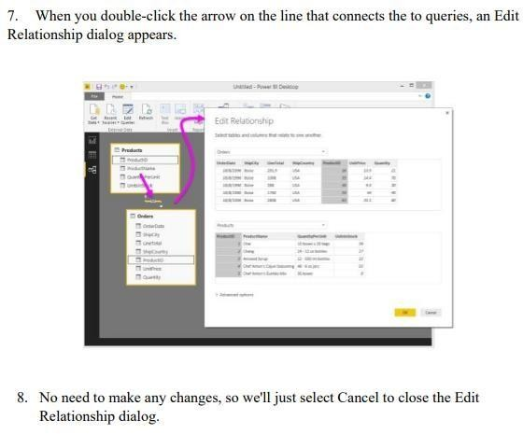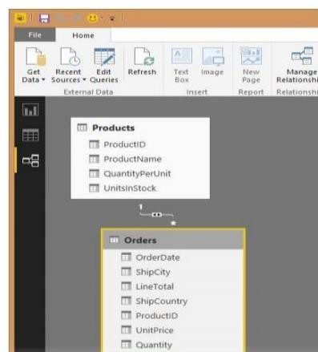

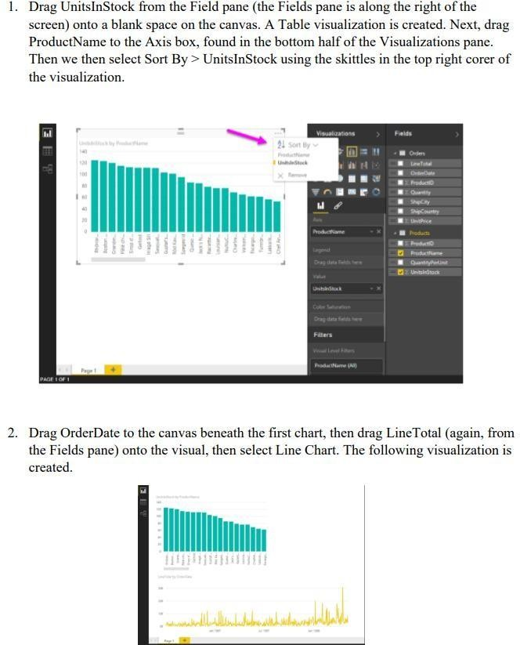

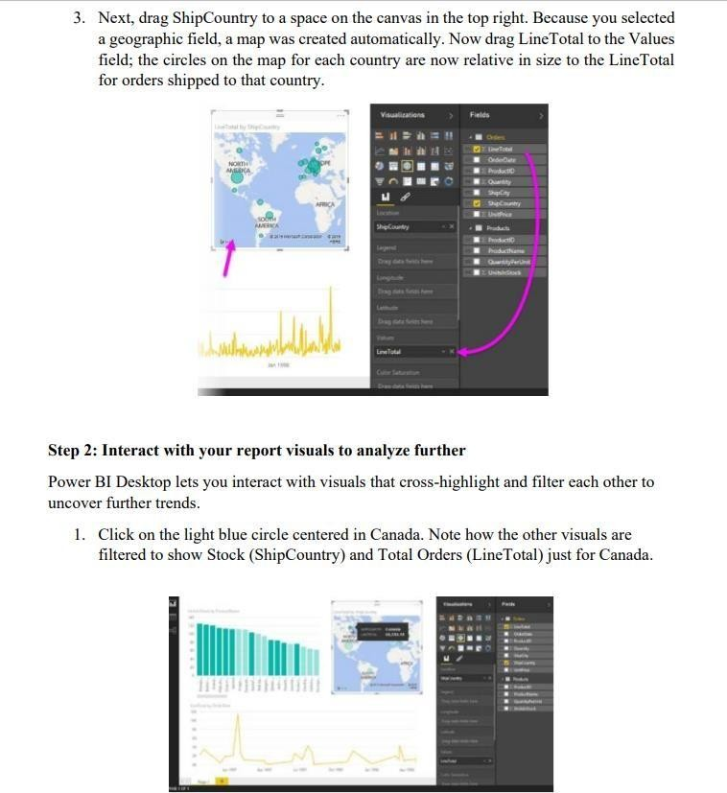

# PRACTICAL REPORT l

## On

**Soft Computing**

Submitted in fulfilment of the Requirement for the Award of the Degree of

## M.Sc. (Information Technology) - SEM I

### By

### 

**NAME : SHRADDHA BANDHU GHORAD**

**SEAT NO : 1310654**

**Department Of Information Technology**

**THE J.S.M COLLEGE OF HIGHER EDUCATION**

***(Affiliated to University of Mumbai)***

**SHIVALE**

**2023– 2024**

**Janseva shikshan Mandal’s**

**SHANTARAMBHAU GHOLAP ARTS ,SCIENCE AND**

**GOTIRAMBHAU PAWAR COMMERCE COLLEGE**

**SHIVLE**

***(Affiliated to University of Mumbai)***

**DEPARTMENT OF INFORMATION TECHNOLOGY/**

**COMPUTER SCIENCE**



**NAAC Re Accredited with “B” Grade**

**CERTIFICATE**

**2023-24**

This is to certify that the practical journal of the

Subject SOFT COMPUTING TECHNIQUES is bonafied work of Name of

student SHRADDHA BANDHU GHORAD bearing Seat number **1310654**

submitted in partial fulfillment of the requirements for the award of degree of

**Masters in Information Technology** from University of Mumbai in year

2023-24.

**Subject Teacher Coordinator**

**(HOD)**

**External Examiner**

**College Seal**

|  |  |  |  |
| --- | --- | --- | --- |
|  | **INDEX** | | |
|  | **Sr.No** | **Practical** | **Sign** |
|  | **1** | 1. Design a simple linear neural network model. 2. Calculate the output of neural network net using both binary and bipolar sigmoidal fuction. |  |
|  | **2** | 1. Generate AND/NOT function using McCulloh-Pits neural net. 2. Generate XOR function using McCulloh-Pits neural net. |  |
|  | **3** | 1. Write a program to implement Hebb’s Rule. 2. Write a program to implement Delta’s rule. |  |
|  | **4** | 1. Write a program for Back-Propagation Algorithm. 2. Write a program for Error Back-Propagation Algorithm. |  |
|  | **5** | 1. Kohonen-Self organizing map. 2. Adaptive Resonance Theory. |  |
|  | **6** | 1. Write a program for Linear Separation. 2. Write a program for Hopfield Network Model for Associative Memory. |  |
|  | **7** | 1. Membership and Identity Operators | in, not in. 2. Membership and Identity Operators | is, is not. |  |
|  | **8** | 1. Find ratios using Fuzzy Logic. 2. Solve Tipping problem using Fuzzy Logic. |  |
|  | **9** | 1. Write a program for Hopfield Network. 2. B Write a program for Radial Basis function |  |
|  | **10** | 1. Implementation of Simple genetic algorithm 2. Create two classes: City and Fitness using Genetic algorithm |  |
|  |  | | |

**Practical:1**

**1A: Design and simple linear neural network model. Code:**

print("enter x1 =") x1 =int(input()) print("enter x2 =") x2 =int(input()) print("enter w1 =") w1 =int(input()) print("enter w2 =") w2 =int(input()) yin = x1+x2*w2

print("net input to the output neuron=",yin) if yin <=0:

yout =0 else:

yout =1

print("the ouput of given neruron network =",yout)

**Output:**

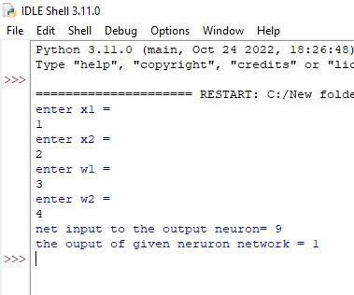

**1B: Calculate the output of neural network net using both binary and bipolar sigmoidal function.**

**Code:**

import math

n=int(input("Enter number of elements : ")) yin=0

for i in range(0,n): x=float(input("X = ")) w=float(input("W = ")) b=float(input("B = ")) yin = yin + x*w +b

print("Yin" , yin)

binary_sigmoidal = (1 / (1 + (math.e**(-yin)))) print("Binary Sigmoidal = " , round(binary_sigmoidal,3)) bipolar_sigmoidal = (2 / (1 + (math.e**(-yin))))+1 print("Bipolar Sigmoidal = " , round(bipolar_sigmoidal,3))

**Output:**

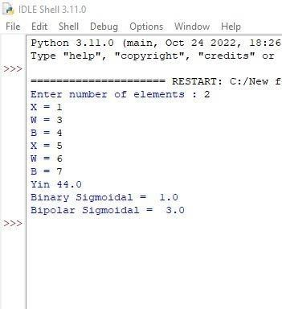

**Practical:2**

**2A: Generate AND/NOT function using McCulloh-pits neural net. Code:**

print("AND NOT function using Mc Culloch Pitts") print("Enter 4 binary inputs.");

x1inputs=[] x2inputs=[]

c=input("Press 1 to enter input values or press enter to use default values.") if(c=="1"):

for i in range(0,4): x1=int(input("Enter x1 : ")) x1inputs.append(x1) x2=int(input("Enter x2 : ")) x2inputs.append(x2)

else:

x1inputs=[1,1,0,0] x2inputs=[1,0,1,0]

print("Considering all weights as excitatory."); w1 = [1,1,1,1]

w2 = [1,1,1,1] y=[]

for i in range(0,4):

y.append(x1inputs[i]*w1[i] + x2inputs[i]*w2[i]) print("x1", " x2", " y")

for i in range(0,4):

print(x1inputs[i]," " ,x2inputs[i]," " , y[i])

print("Considering one weight as excitatory and other as inhibitory.");

w1 = [1,1,1,1]

w2 = [-1,-1,-1,-1] y=[]

for i in range(0,4):

y.append(x1inputs[i]*w1[i] + x2inputs[i]*w2[i]) print("x1", " x2 ", "y")

for i in range(0,4): print(x1inputs[i]," ",x2inputs[i]," " , y[i]) print("Applying Threshold = 1")

Y=[]

for i in range(0,4): if(y[i]>=1):

value=1 Y.append(value)

else:

value=0 Y.append(value) print("x1 ", "x2 ", "Y") for i in range(0,4):

print(x1inputs[i]," ", x2inputs[i]," ",Y[i])

**Output:**

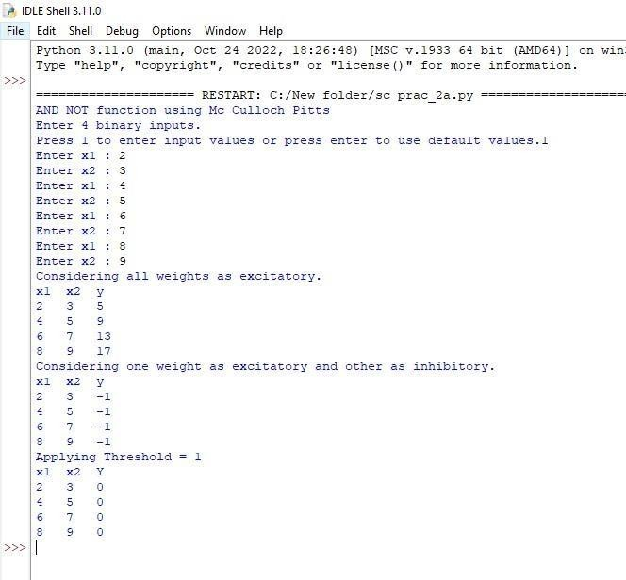

**2B: Generate XOR function using McCulloh-pits neural net. Code:**

print("XOR function using Mc-Culloch Pitts neuron") print()

print("Enter 4 binary inputs."); x1inputs=[]

x2inputs=[]

c=input("Press 1 to enter inputs or Enter to use default inputs.") if(c=="1"):

for i in range(0,4): x1=int(input("Enter x1 : ")) x1inputs.append(x1) x2=int(input("Enter x2 : ")) x2inputs.append(x2)

else:

x1inputs=[1,1,0,0] x2inputs=[1,0,1,0]

print("Calculating z1 = x1 x2'")

print("Considering one weight as excitatory and other as inhibitory."); w1 = [1,1,1,1]

w2 = [-1,-1,-1,-1] z1=[]

for i in range(0,4): z1.append(x1inputs[i]*w1[i] + x2inputs[i]*w2[i]) print("x1 " , "x2 " , "z1")

for i in range(0,4): print(x1inputs[i] ," ", x2inputs[i]," " , z1[i]) print("Calculating z2 = x1' x2")

print("Considering one weight as excitatory and other as inhibitory.");

w1 = [-1,-1,-1,-1]

w2 = [1,1,1,1] z2=[]

for i in range(0,4): z2.append(x1inputs[i]*w1[i] + x2inputs[i]*w2[i]) print("x1 " , "x2 " , "z2")

for i in range(0,4): print(x1inputs[i] ," " , x2inputs[i] ," ", z2[i]) print("Applying Threshold=1 for z1 and z2")

for i in range(0,4): if(z1[i]>=1): z1[i]=1 else: z1[i]=0 if(z2[i]>=1): z2[i]=1 else: z2[i]=0

print("z1 ","z2")

for i in range(0,4): print(z1[i] ," ", z2[i]) y = []

v1=1 v2=1

for i in range(0,4): y.append( z1[i]*v1 + z2[i]*v2 ) print("x1" , "x2" , " y")

for i in range(0,4): print(x1inputs[i] ," " , x2inputs[i] ," ", y[i])

**Output:**

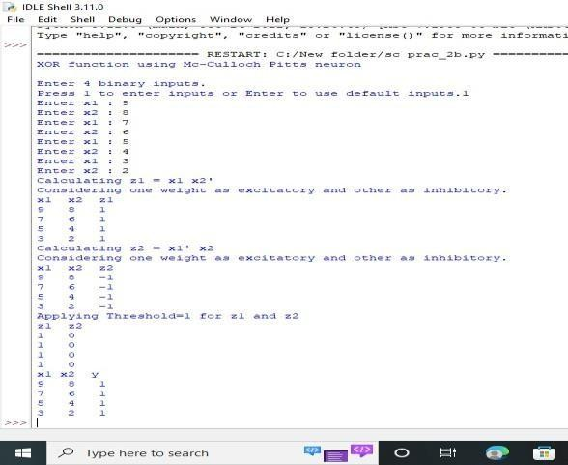

**Practical:3 3A: Write a program to implement Hebb’s rule.**

**Code:**

print("Enter 4 binary training pairs") w1=[0,0,0,0]

w2=[0,0,0,0]

for m in range(0,4):

print("Enter 4 binary input values") s=[]

t=[]

for i in range(0,4): x=int(input())

s.append(x)

print("Enter 2 binary target values") for i in range(0,2):

y=int(input()) t.append

print("s= ",s)

print("t= ",t) w1new=[]

for i in range(0,4): newweight1=w1[i] + s[i]*t[0] w1new.append(newweight1)

'''print new weights''' for i in range(0,4):

print("w",(i+1),"1 = ",w1new[i]) w2new=[]

for i in range(0,4):

newweight2=w2[i] + s[i]*t[1] w2new.append(newweight2)

for i in range(0,4): print("w",(i+1),"2 = ",w2new[i])

w1=w1new w2=w2new print(w1) print(w2)

print("The final weight matrix is : ") print("W = ")

for i in range(0,4): print(w1[i] , w2[i])

print("Done")

**Output:**

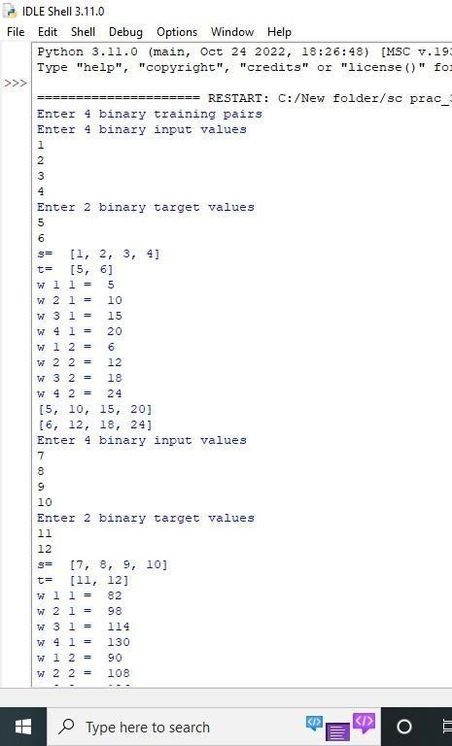

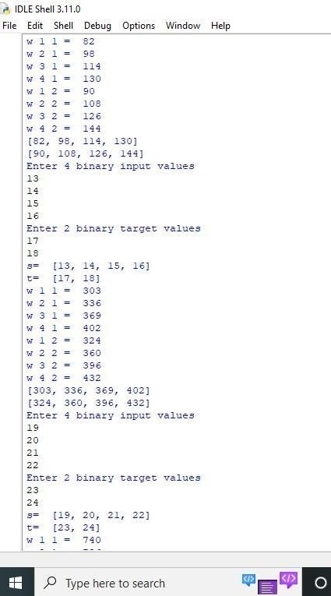

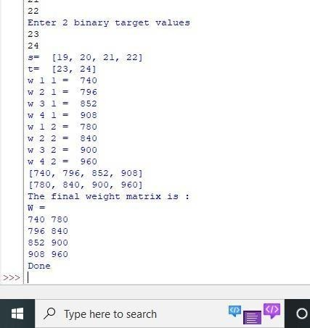

**3B: Write a program to implement Delta’s rule. Code:**

import math

print("Using 3 inputs 3 weights 1 output.") x1=[0.3,0.5,0.8] #inputs

w1=[0.1,0.1,0.1] #weights t=1 #TARGET

a=0.1 #alpha

diff=1 #initial difference yin=0 #initial net input

while(diff>0.4):

for i in range(0,3):

yin = yin + (x1[i]*w1[i]) yin = yin + 0.25 yin=round(yin,3)

print("Yin = ",yin) print("target = ",t)

diff=t-yin diff=round(diff,3) diff=math.fabs(diff)

print("error = ",diff) neww1=[]

for i in range(0,3): #update weights w1new=w1[i] + a*diff*x1[i] w1new=round(w1new,2) neww1.append(w1new)

print("w1new = ",neww1)

w1=neww1 print()

**Output:**

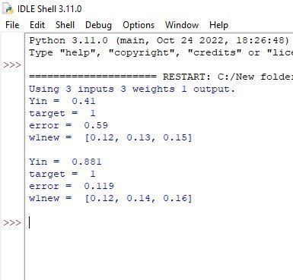

**Practical:4**

**4A: Write a program for Back-Propagation Algorithm. Code:**

import numpy as np X=np.array(([2,9],[1,5],[3,6]),dtype=float)

Y=np.array(([92],[86],[89]),dtype=float) #scale units

X=X/np.amax(X,axis=0) Y=Y/100;

class NN(object):

def _init_(self):

self.inputsize=2 self.outputsize=1 self.hiddensize=3

self.W1=np.random.randn(self.inputsize,self.hiddensize) self.W2=np.random.randn(self.hiddensize,self.outputsize)

def forward(self,X):

self.z=np.dot(X,self.W1) self.z2=self.sigmoidal(self.z) self.z3=np.dot(self.z2,self.W2) op=self.sigmoidal(self.z3) return op;

def sigmoidal(self,s):

return 1/(1+np.exp(-s)) obj=NN() op=obj.forward(X) print("actual output"+str(op)) print("expected output"+str(Y))

**Output:**

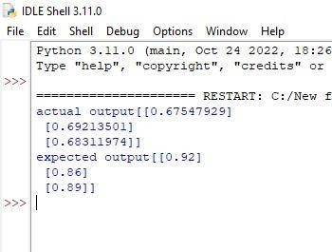

**4B: :Write a program for Error Back-Propagation Algorithm. Code:**

import numpy as np X=np.array(([2,9],[1,5],[3,6]),dtype=float)

Y=np.array(([92],[86],[89]),dtype=float) X=X/np.amax(X,axis=0)

Y=Y/100;

class NN(object): def _init_(self):

self.inputsize=2 self.outputsize=1 self.hiddensize=3

self.W1=np.random.randn(self.inputsize,self.hiddensize) self.W2=np.random.randn(self.hiddensize,self.outputsize)

def forward(self,X): self.z=np.dot(X,self.W1) self.z2=self.sigmoidal(self.z) self.z3=np.dot(self.z2,self.W2)

op=self.sigmoidal(self.z3) return op;

def sigmoidal(self,s): return 1/(1+np.exp(-s))

def sigmoidalprime(self,s): return s* (1-s)

def backward(self,X,Y,o): self.o_error=Y-o

self.o_delta=self.o_error * self.sigmoidalprime(o)

self.z2_error=self.o_delta.dot(self.W2.T) self.z2_delta=self.z2_error * self.sigmoidalprime(self.z2) self.W1 = self.W1 + X.T.dot(self.z2_delta)

self.W2= self.W2+ self.z2.T.dot(self.o_delta) def train(self,X,Y):

o=self.forward(X) self.backward(X,Y,o) obj=NN()

for i in range(2000): print("input"+str(X))

print("Actual output"+str(Y)) print("Predicted output"+str(obj.forward(X)))

print("loss"+str(np.mean(np.square(Y-obj.forward(X))))) obj.train(X,Y)

**Output:**

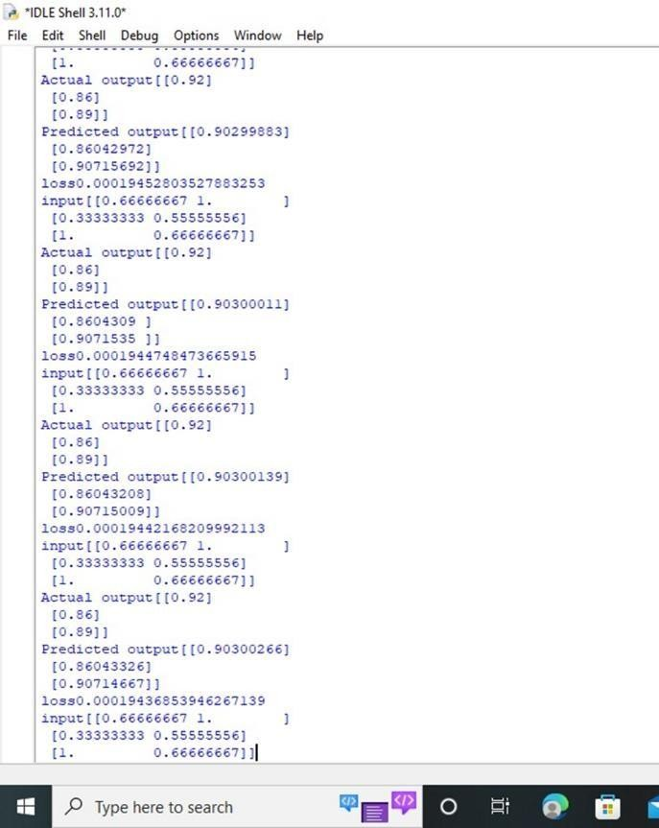

**Practical:5 5A:Kohonen-self organizing map.**

**Code:**

import math class SOM:

# Function here computes the winning vector # by Euclidean distance

def winner(self, weights, sample): D0 = 0

D1 = 0

for i in range(len(sample)):

D0 = D0 + math.pow((sample[i] - weights[0][i]), 2)

D1 = D1 + math.pow((sample[i] - weights[1][i]), 2) if D0 > D1:

return 0 else:

return 1

# Function here updates the winning vector def update(self, weights, sample, J, alpha):

for i in range(len(weights)):

weights[J][i] = weights[J][i] + alpha * (sample[i] - weights[J][i])

return weights # Driver code

def main():

# Training Examples ( m, n )

T = [[1, 1, 0, 0], [0, 0, 0, 1], [1, 0, 0, 0], [0, 0, 1, 1]]

m, n = len(T), len(T[0])

# weight initialization ( n, C )

weights = [[0.2, 0.6, 0.5, 0.9], [0.8, 0.4, 0.7, 0.3]]

# training ob = SOM()

epochs = 3

alpha = 0.5

for i in range(epochs): for j in range(m):

# training sample sample = T[j]

# Compute winner vector

J = ob.winner(weights, sample) # Update winning vector

weights = ob.update(weights, sample, J, alpha) # classify test sample

s = [0, 0, 0, 1]

J = ob.winner(weights, s)

print("Test Sample s belongs to Cluster : ", J) print("Trained weights : ", weights)

if _name_ == "_main_": main()

**Output:**



**5B: Adaptive resonance theory. Code:**

from _future_ import print_function from _future_ import division import numpy as np

class ART:

def _init_(self, n=5, m=10, rho=.5): # Comparison layer

self.F1 = np.ones

# Recognition layer self.F2 = np.ones(m)

# Feed-forward weights self.Wf = np.random.random((m,n))

# Feed-back weights

self.Wb = np.random.random((n,m)) # Vigilance

self.rho = rho

# Number of active units in F2 self.active = 0

def learn(self, X):

# Compute F2 output and sort them (I) self.F2[...] = np.dot(self.Wf, X)

I = np.argsort(self.F2[:self.active].ravel())[::-1] for i in I:

# Check if nearest memory is above the vigilance level d = (self.Wb[:,i]*X).sum()/X.sum()

if d >= self.rho: # Learn data

self.Wb[:,i] *= X

self.Wf[i,:] = self.Wb[:,i]/(0.5+self.Wb[:,i].sum()) return self.Wb[:,i], i

# No match found, increase the number of active units # and make the newly active unit to learn data

if self.active< self.F2.size: i = self.active

self.Wb[:,i] *= X

self.Wf[i,:] = self.Wb[:,i]/(0.5+self.Wb[:,i].sum()) self.active += 1

return self.Wb[:,i], i return None,None

if _name_ == '_main_': np.random.seed(1)

network = ART( 5, 10, rho=0.5) data = [" O ",

" OO",

" OO",

" OO",

" O",

" O",

" O",

" OO O",

" OO ",

" OO O",

" OO ",

"OOO ",

"OO ",

"O ",

"OO ",

"OOO ",

" O ",

" OO",

"OOOO ",

"OOOOO",

"O ",

" O ",

" O ",

" O",

" OO O",

" OO ",

"OOO ",

"OO ",

"OOOO ",

"OOOOO"]

X = np.zeros(len(data[0])) for i in range(len(data)):

for j in range(len(data[i])): X[j] = (data[i][j] == 'O')

Z, k = network.learn(X) print("|%s|"%data[i],"-> class", k)

**Output:**

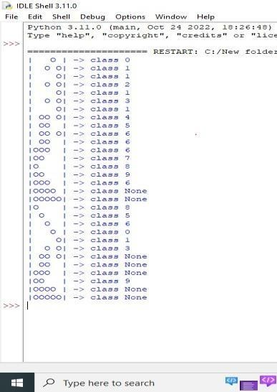

**Practical:6 6A: Write a program for Linear Separation. Code:**

import matplotlib.pyplot as plt import numpy as np

fig, ax= plt. subplots() xmin ,xmax = -0.2,1.4

X = np.arange(xmin,xmax,0.1) ax.scatter(0,0, color="c") ax.scatter(0,1, color="g") ax.scatter(1,0, color="g") ax.scatter(1,1, color="g") ax.set_xlim([xmin,xmax]) ax.set_ylim([-0.1,1.1])

m = -1

ax.plot(X, m*X + 0.6, label="decision boundary") plt.show()

#plt.plot()

**Output:**

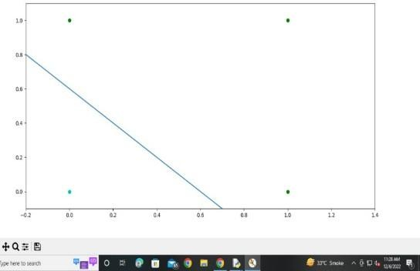

**6B: Write a program for Hopfield network model for Associative memory. Code:**

import matplotlib.pyplot as plt

from neurodynex.hopfield_network import network, pattern_tools, plot_tools pattern_size = 5

# create an instance of the class HopfieldNetwork

hopfield_net = network.HopfieldNetwork(nr_neurons= pattern_size**2) # instantiate a pattern factory

factory = pattern_tools.PatternFactory(pattern_size, pattern_size) # create a checkerboard pattern and add it to the pattern list checkerboard = factory.create_checkerboard()

pattern_list = [checkerboard]

# add random patterns to the list pattern_list.extend(factory.create_random_pattern_list(nr_patterns=3, on_probability=0.5)) plot_tools.plot_pattern_list(pattern_list)

# how similar are the random patterns and the checkerboard? Check the overlaps overlap_matrix = pattern_tools.compute_overlap_matrix(pattern_list) plot_tools.plot_overlap_matrix(overlap_matrix)

# let the hopfield network "learn" the patterns. Note: they are not stored # explicitly but only network weights are updated ! hopfield_net.store_patterns(pattern_list)

# create a noisy version of a pattern and use that to initialize the network noisy_init_state = pattern_tools.flip_n(checkerboard, nr_of_flips=4) hopfield_net.set_state_from_pattern(noisy_init_state)

# from this initial state, let the network dynamics evolve. states = hopfield_net.run_with_monitoring(nr_steps=4)

# each network state is a vector. reshape it to the same shape used to create the patterns. states_as_patterns = factory.reshape_patterns(states)

# plot the states of the network

plot_tools.plot_state_sequence_and_overlap(states_as_patterns, pattern_list, reference_idx=0, suptitle="Network dynamics")

**Output:**

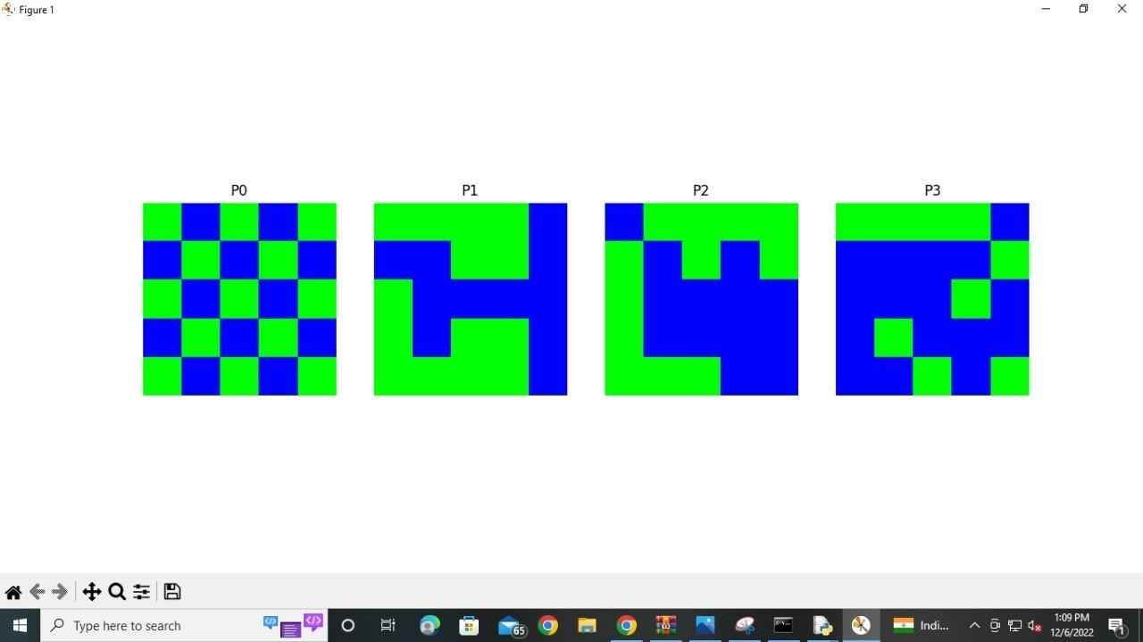

**Practical:7 7A:Membership and identity Operation | in, not in. Code:**

list1=[]

c=int(input("Enter the number of elements for list1")) for i in range(0,c):

ele=int(input("Enter the element:")) list1.append(ele)

a=int(input("Enter the number you want to find in list1")) if a not in list1:

print("The list does not contain ",a) else:

print("The list contains ",a)

**Output:**

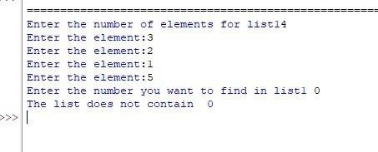

**7B: Membership and identity Operation | is, is not. Code:**

a = 10

b = 20

list = [1,2,3,4,5];

if a in list:

print ("Line 1 - a is available in the given list") else:

print ("Line 1 - a is not available in the given list") if b not in list:

print ("Line 2 - a is not available in the given list") else :

print ("Line 2 - a is available in the given list") a = 2

if a in list:

print ("Line 3 - a is available in the given list") else:

print ("Line 3 - a is not available in the given list")

**Output:**

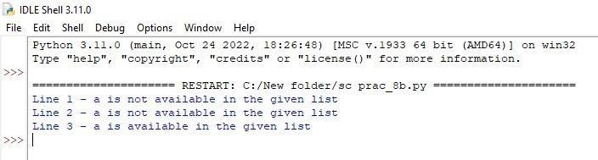

**Practical:8 8A:Find Rations using Fuzzy logic.**

**Code:**

from fuzzywuzzy import fuzz from fuzzywuzzy import process s1="I like SC"

s2="I like HC"

print ("FuzzyWuzzy Ratio:", fuzz.ratio(s1, s2))

print ("FuzzyWuzzyPartialRatio:", fuzz.partial_ratio(s1, s2))

print ("FuzzyWuzzyTokenSortRatio:", fuzz.token_sort_ratio(s1, s2)) print ("FuzzyWuzzyTokenSetRatio:", fuzz.token_set_ratio(s1, s2)) print ("FuzzyWuzzyWRatio:", fuzz.Wratio(s1, s2),'\n\n')

**Output:**

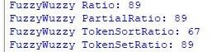

**8B: Solve Tipping problem using Fuzzy logic. Code:**

import numpy as np import skfuzzy as fuzz

from skfuzzy import control as ctrl

# New Antecedent/Consequent objects hold universe variables and membership # functions

quality = ctrl.Antecedent(np.arange(0, 11, 1), 'quality')

service = ctrl.Antecedent(np.arange(0, 11, 1), 'service')

tip = ctrl.Consequent(np.arange(0, 26, 1), 'tip')

# Auto-membership function population is possible with .automf(3, 5, or 7) quality.automf(3)

service.automf(3)

# Custom membership functions can be built interactively with a familiar, # Pythonic API

tip['low'] = fuzz.trimf(tip.universe, [0, 0, 13])

tip['medium'] = fuzz.trimf(tip.universe, [0, 13, 25])

tip['high'] = fuzz.trimf(tip.universe, [13, 25, 25]

**Output:**

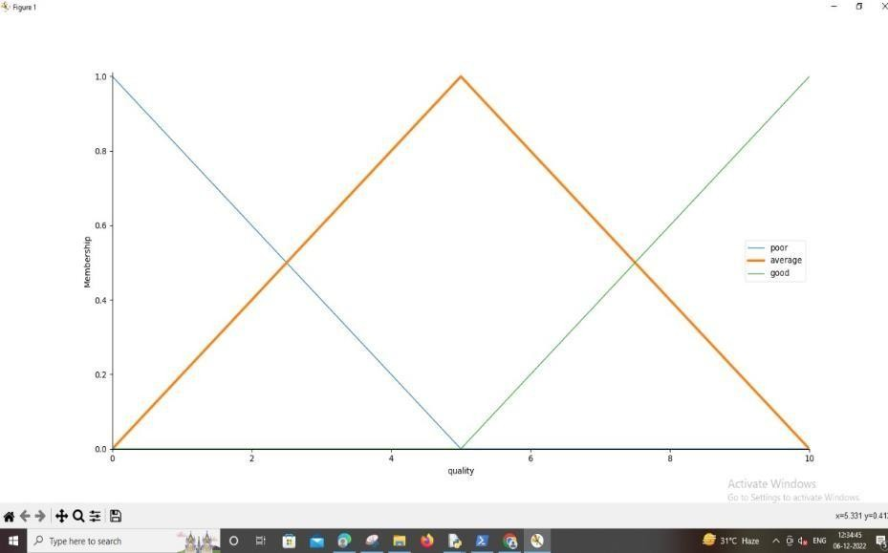

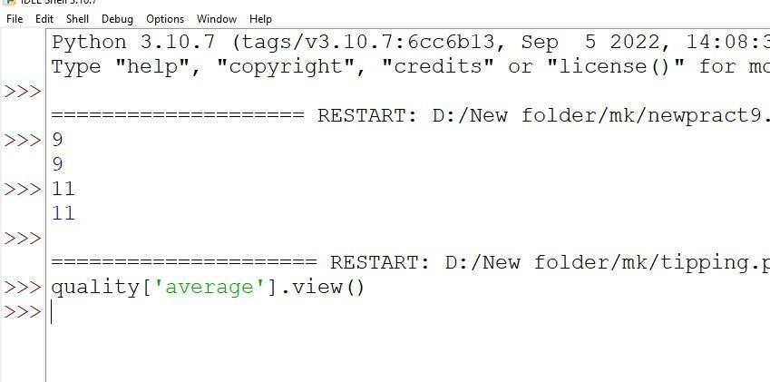

### Practical 9

**9A) Write a program for Hopfield Network.**

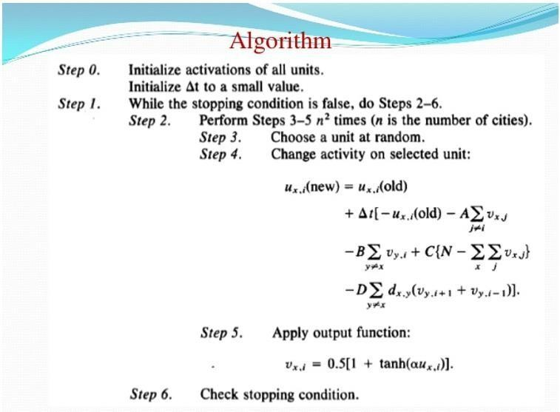

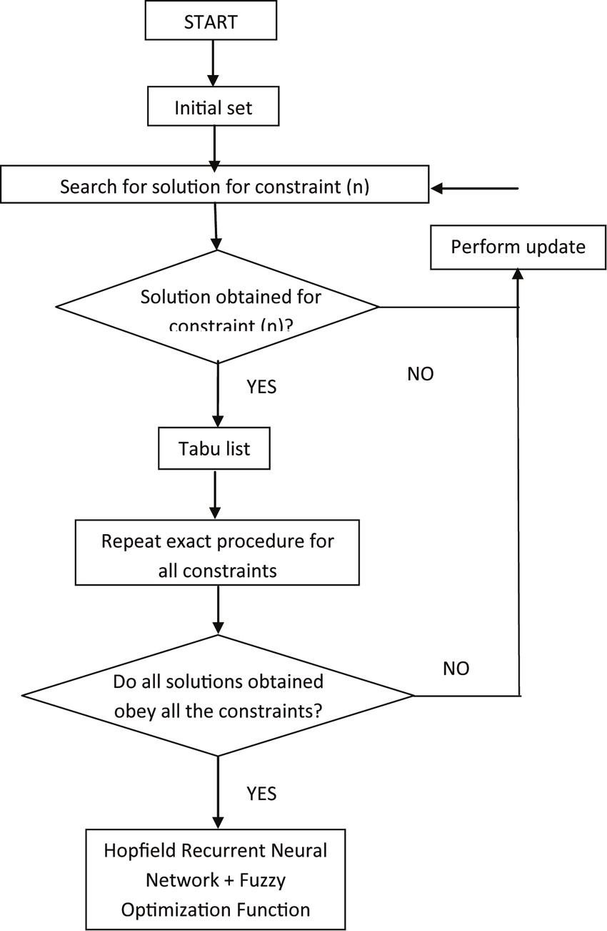

#include "hop.h" neuron::neuron(int *j)

{

int i; for(i=0;i<4;i++)

{

weightv[i]= *(j+i);

}

}

int neuron::act(int m, int *x)

{

int i; int a=0;

for(i=0;i<m;i++)

{

a += x[i]*weightv[i];

}

return a;

}

int network::threshld(int k)

{

if(k>=0)

return (1); else

return (0);

}

network::network(int a[4],int b[4],int c[4],int d[4])

{

nrn[0] = neuron(a) ; nrn[1] = neuron(b) ; nrn[2] = neuron(c) ; nrn[3] = neuron(d) ;

}

void network::activation(int *patrn)

{

int i,j; for(i=0;i<4;i++)

{

for(j=0;j<4;j++)

{

cout<<"\n nrn["<<i<<"].weightv["<<j<<"] is "

<<nrn[i].weightv[j];

}

nrn[i].activation = nrn[i].act(4,patrn); cout<<"\nactivation is "<<nrn[i].activation; output[i]=threshld(nrn[i].activation);

cout<<"\noutput value is "<<output[i]<<"\n";

}

}

void main ()

{

int patrn1[]= {1,0,1,0},i;

int wt1[]= {0,-3,3,-3};

int wt2[]= {-3,0,-3,3};

int wt3[]= {3,-3,0,-3};

int wt4[]= {-3,3,-3,0};

cout<<"\nTHIS PROGRAM IS FOR A HOPFIELD NETWORK WITH A SINGLE LAYER OF";

cout<<"\n4 FULLY INTERCONNECTED NEURONS. THE NETWORK SHOULD RECALL

THE";

cout<<"\nPATTERNS 1010 AND 0101 CORRECTLY.\n";

//create the network by calling its constructor.

// the constructor calls neuron constructor as many times as the number of

// neurons in the network. network h1(wt1,wt2,wt3,wt4);

//present a pattern to the network and get the activations of the neurons h1.activation(patrn1);

//check if the pattern given is correctly recalled and give message for(i=0;i<4;i++)

{

if (h1.output[i] == patrn1[i]) cout<<"\n pattern= "<<patrn1[i]<<

" output = "<<h1.output[i]<<" component matches"; else

cout<<"\n pattern= "<<patrn1[i]<< " output = "<<h1.output[i]<<

" discrepancy occurred";

}

cout<<"\n\n";

int patrn2[]= {0,1,0,1}; h1.activation(patrn2); for(i=0;i<4;i++)

{

if (h1.output[i] == patrn2[i]) cout<<"\n pattern= "<<patrn2[i]<<

" output = "<<h1.output[i]<<" component matches"; else

cout<<"\n pattern= "<<patrn2[i]<< " output = "<<h1.output[i]<<

" discrepancy occurred";

}

}

======== End code of main program=============

//Hop.h

//Single layer Hopfield Network with 4 neurons

#include <stdio.h> #include <iostream.h> #include <math.h> class neuron

{

protected:

int activation;

friend class network; public:

int weightv[4]; neuron() {}; neuron(int *j) ; int act(int, int*);

};

class network

{

public:

neuron nrn[4]; int output[4];

int threshld(int) ;

void activation(int j[4]); network(int*,int*,int*,int*);

};

### Practical 9b: Write a program for Radial Basis function

Radial Basis Function Networks (RBF)

RBF networks have three layers: input layer, hidden layer and output layer. One neuron in the input layer corresponds to each predictor variable. With respects to categorical variables, *n*-1 neurons are used where *n* is the number of categories. Hidden layer has a variable number of neurons. Each neuron consists of a radial basis function centered on a point with the same dimensions as the predictor variables. The output layer has a weighted sum of outputs from the hidden layer to form the network outputs.

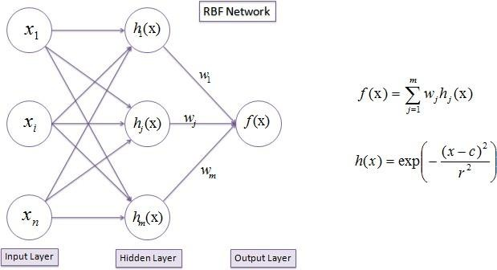

Algorithm

*h*(*x*) is the Gaussian activation function with the parameters *r* (the radius or standard deviation) and *c* (the center or average taken from the input space) defined separately at each RBF unit. The

learning process is based on adjusting the parameters of the network to reproduce a set of input-output patterns. There are three types of parameters; the weight *w* between the hidden nodes and the output nodes, the center *c* of each neuron of the hidden layer and the unit width *r*.

#### Unit Center (*c*)

Any clustering algorithm can be used to determine the RBF unit centers (e.g., K-means clustering). A set of clusters each with *r*-dimensional centers is determined by the number of input variables or nodes of the input layer. The cluster centers become the centers of the RBF units. The number of clusters, *H*, is a design parameter and determines the number of nodes in the hidden layer. The K-means clustering algorithm proceeds as follows:

1. Initialize the center of each cluster to a different randomly selected training pattern.
2. Assign each training pattern to the nearest cluster. This can be accomplished by calculating the Euclidean distances between the training patterns and the cluster centers.
3. When all training patterns are assigned, calculate the average position for each cluster center. They then become new cluster centers.
4. Repeat steps 2 and 3, until the cluster centers do not change during the subsequent iterations.

#### Unit width (*r*)

When the RBF centers have been established, the width of each RBF unit can be calculated using the K-nearest neighbors algorithm. A number K is chosen, and for each center, the K nearest centers is

found. The root-mean squared distance between the current cluster center and its K nearest neighbors is calculated, and this is the value chosen for the unit width (*r*). So, if the current cluster center is *cj*,

the *r* value is:

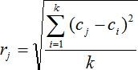

A typical value for K is 2, in which case s is set to be the average distance from the two nearest neighboring cluster centers.

#### Weights (*w*)

Using the linear mapping, **w** vector is calculated using the output vector (**y**) and the design matrix **H**.

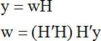

The basis functions are (unnormalized) gaussians, the output layer is linear and the weights are learned by a simple pseudo-inverse.

from scipy import *

from scipy.linalg import norm, pinv from matplotlib import pyplot as plt class RBF:

def init (self, indim, numCenters, outdim): self.indim = indim

self.outdim = outdim self.numCenters = numCenters

self.centers = [random.uniform(-1, 1, indim) for i in xrange(numCenters)] self.beta = 8

self.W = random.random((self.numCenters, self.outdim)) def _basisfunc(self, c, d):

assert len(d) == self.indim

return exp(-self.beta * norm(c-d)**2)

def _calcAct(self, X):

# calculate activations of RBFs

G = zeros((X.shape[0], self.numCenters), float) for ci, c in enumerate(self.centers):

for xi, x in enumerate(X): G[xi,ci] = self._basisfunc(c, x)

return G

def train(self, X, Y):

""" X: matrix of dimensions n x indim

y: column vector of dimension n x 1 """

# choose random center vectors from training set

rnd_idx = random.permutation(X.shape[0])[:self.numCenters] self.centers = [X[i,:] for i in rnd_idx]

print "center", self.centers

# calculate activations of RBFs G = self._calcAct(X)

print G

# calculate output weights (pseudoinverse) self.W = dot(pinv(G), Y)

def test(self, X):

""" X: matrix of dimensions n x indim """

G = self._calcAct(X) Y = dot(G, self.W) return Y

if name == ' main ':

# 1D Example

n = 100

x = mgrid[-1:1:complex(0,n)].reshape(n, 1) # set y and add random noise

y = sin(3*(x+0.5)**3 - 1)

# y += random.normal(0, 0.1, y.shape)

# rbf regression

rbf = RBF(1, 10, 1)

rbf.train(x, y) z = rbf.test(x)

# plot original data

plt.figure(figsize=(12, 8)) plt.plot(x, y, 'k-')

# plot learned model plt.plot(x, z, 'r-', linewidth=2)

# plot rbfs

plt.plot(rbf.centers, zeros(rbf.numCenters), 'gs')

for c in rbf.centers:

# RF prediction lines

cx = arange(c-0.7, c+0.7, 0.01)

cy = [rbf._basisfunc(array([cx_]), array([c])) for cx_ in cx] plt.plot(cx, cy, '-', color='gray', linewidth=0.2)

plt.xlim(-1.2, 1.2) plt.show()

Using R

Radial Basis Functions

A radial basis function, RBF, ϕ(x)ϕ(x) is a function with respect to the origin or a certain point cc, ie, ϕ(x)=f(∥x−c∥)ϕ(x)=f(‖x−c‖) where the norm is usually the Euclidean norm but can be other type of measure.

The RBF learning model assumes that the

dataset D=(xn,yn),n=1…N D=(xn,yn),n=1…N influences the hypothesis set h(x)h(x), for a new observation xx, in the following way:

h(x)=∑n=1Nwn×exp(−γ∥x−xn∥2)h(x)=∑n=1Nwn×exp(−γ‖x−xn‖2)

which means that each xixi of the dataset influences the observation in a gaussian shape. Of course, if a datapoint is far away from the observation its influence is residual (the exponential decay of the tails of the gaussian make it so). It is an example of a localized function (x→∞⟹ϕ(x)→0x→∞⟹ϕ(x)→0). Notice that other type of radial functions can be used. Some egs:

* Multi-quadratic: ϕ(x)=x2+γ2−−−−−−√ϕ(x)=x2+γ2
* Thin plate spline: ϕ(x)=x2ln(x)

rbf.gauss <- **function**(gamma=1.0) {

**function**(x) {

exp(-gamma * norm(as.matrix(x),"F")^2 )

}

}

D <- matrix(c(-3,1,4), ncol=1) *# 3 datapoints*

N <- length(D[,1])

xlim <- c(-5,7) plot(NULL,xlim=xlim,ylim=c(0,1.25),type="n") points(D,rep(0,length(D)),col=1:N,pch=19) x.coord = seq(-7,7,length=250)

gamma <- 1.5

**for** (i **in** 1:N) {

points(x.coord, lapply(x.coord - D[i,], rbf.gauss(gamma)), type="l", col=i)

}

plot(NULL,xlim=xlim,ylim=c(0,1.25),type="n") points(D,rep(0,length(D)),col=1:N,pch=19) x.coord = seq(-7,7,length=250)

gamma <- 0.25

**for** (i **in** 1:N) {

points(x.coord, lapply(x.coord - D[i,], rbf.gauss(gamma)), type="l", col=i)

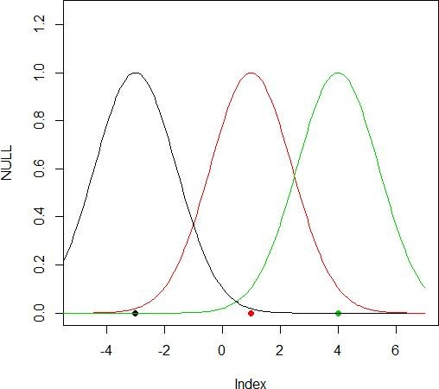

### 10A) Implementation of Simple genetic algorithm

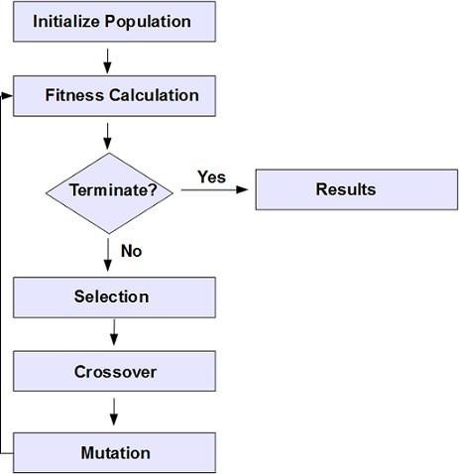

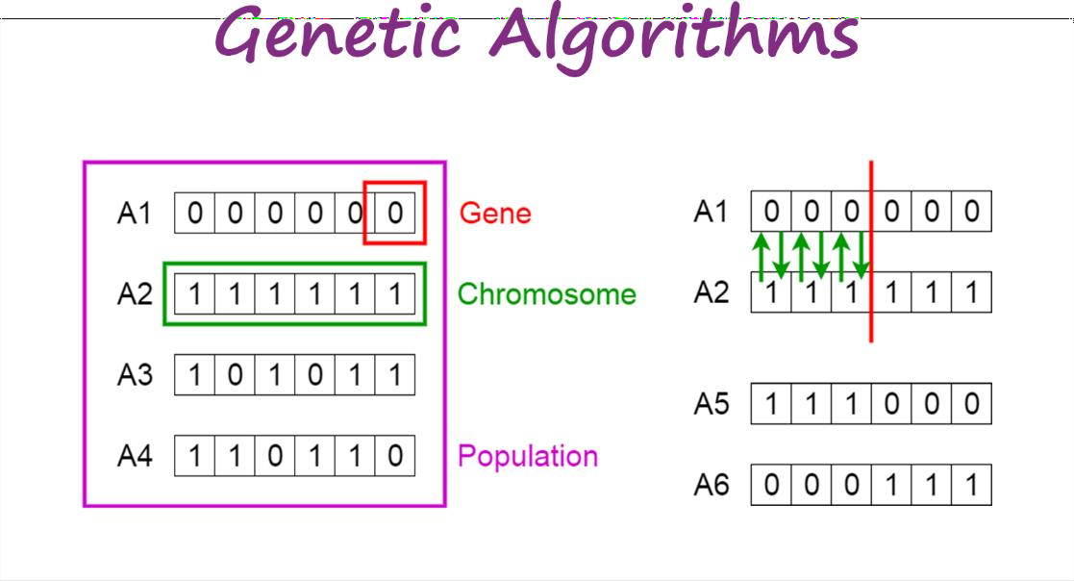

import random

# Number of individuals in each generation POPULATION_SIZE = 100

# Valid genes

GENES = '''abcdefghijklmnopqrstuvwxyzABCDEFGHIJKLMNOP QRSTUVWXYZ 1234567890, .-;:_!"#%&/()=?@${[]}'''

# Target string to be generated TARGET = "I love GeeksforGeeks"

class Individual(object): '''

Class representing individual in population '''

def init (self, chromosome): self.chromosome = chromosome self.fitness = self.cal_fitness()

@classmethod

def mutated_genes(self): '''

create random genes for mutation '''

global GENES

gene = random.choice(GENES) return gene

@classmethod

def create_gnome(self): '''

create chromosome or string of genes '''

global TARGET gnome_len = len(TARGET)

return [self.mutated_genes() for _ in range(gnome_len)]

def mate(self, par2): '''

Perform mating and produce new offspring '''

# chromosome for offspring child_chromosome = []

for gp1, gp2 in zip(self.chromosome, par2.chromosome):

# random probability prob = random.random()

# if prob is less than 0.45, insert gene # from parent 1

if prob < 0.45: child_chromosome.append(gp1)

# if prob is between 0.45 and 0.90, insert # gene from parent 2

elif prob < 0.90: child_chromosome.append(gp2)

# otherwise insert random gene(mutate), # for maintaining diversity

else:

child_chromosome.append(self.mutated_genes())

# create new Individual(offspring) using # generated chromosome for offspring return Individual(child_chromosome)

def cal_fitness(self): '''

Calculate fittness score, it is the number of characters in string which differ from target string.

'''

global TARGET fitness = 0

for gs, gt in zip(self.chromosome, TARGET): if gs != gt: fitness+= 1

return fitness

# Driver code def main():

global POPULATION_SIZE

#current generation generation = 1

found = False population = []

# create initial population

for _ in range(POPULATION_SIZE): gnome = Individual.create_gnome()

population.append(Individual(gnome)) while not found:

# sort the population in increasing order of fitness score population = sorted(population, key = lambda x:x.fitness)

# if the individual having lowest fitness score ie.

# 0 then we know that we have reached to the target # and break the loop

if population[0].fitness <= 0: found = True

break

# Otherwise generate new offsprings for new generation new_generation = []

# Perform Elitism, that mean 10% of fittest population # goes to the next generation

s = int((10*POPULATION_SIZE)/100)

new_generation.extend(population[:s])

# From 50% of fittest population, Individuals # will mate to produce offspring

s = int((90*POPULATION_SIZE)/100)

for _ in range(s):

parent1 = random.choice(population[:50]) parent2 = random.choice(population[:50]) child = parent1.mate(parent2) new_generation.append(child)

population = new_generation print("Generation: {}\tString: {}\tFitness: {}".\

format(generation, "".join(population[0].chromosome), population[0].fitness))

generation += 1

print("Generation: {}\tString: {}\tFitness: {}".\ format(generation, "".join(population[0].chromosome), population[0].fitness))

if name == ' main ': main()

Output:

Generation: 1 String: tO{"-?=jH[k8=B4]Oe@} Fitness: 18

Generation: 2 String: tO{"-?=jH[k8=B4]Oe@} Fitness: 18 Generation: 3 String: .#lRWf9k_Ifslw #O$k_ Fitness: 17

Generation: 4

Generation: 5

Generation: 6

Generation: 7

Generation: 8

String: .-1Rq?9mHqk3Wo]3rek_

String: .-1Rq?9mHqk3Wo]3rek_

Fitness: 16

Fitness: 16

Fitness: 14

Fitness: 14

Fitness: 13

Generation: 29

Generation: 30

Generation: 31

Generation: 32

Generation: 33

Generation: 34

String: A#ldW) #lIkslw cVek) String: A#ldW) #lIkslw cVek) String: (, o x _x%Rs=, 6Peek3

.

.

.

String: I lope Geeks#o, Geeks Fitness: 3 String: I loMe GeeksfoBGeeks Fitness: 2 String: I love Geeksfo0Geeks Fitness: 1 String: I love Geeksfo0Geeks Fitness: 1 String: I love Geeksfo0Geeks Fitness: 1

String: I love GeeksforGeeks Fitness: 0

### 10B)Create two classes: City and Fitness using Genetic algorithm

first create a City class that will allow us to create and handle our cities.

class City:

def init (self, x, y): self.x = x

self.y = y

def distance(self, city): xDis = abs(self.x - city.x) yDis = abs(self.y - city.y)

distance = np.sqrt((xDis ** 2) + (yDis ** 2)) return distance

def repr (self):

return "(" + str(self.x) + "," + str(self.y) + ")"

class Fitness:

def init (self, route): self.route = route self.distance = 0

self.fitness= 0.0

def routeDistance(self): if self.distance ==0:

pathDistance = 0

for i in range(0, len(self.route)): fromCity = self.route[i] toCity = None

if i + 1 < len(self.route): toCity = self.route[i + 1]

else:

toCity = self.route[0]

pathDistance += fromCity.distance(toCity) self.distance = pathDistance

return self.distance def routeFitness(self):

if self.fitness == 0:

self.fitness = 1 / float(self.routeDistance()) return self.fitness

Create Population

[https://towardsdatascience.com/evolution-of-a-salesman-a-complete-genetic-algorithm-](https://towardsdatascience.com/evolution-of-a-salesman-a-complete-genetic-algorithm-tutorial-for-python-6fe5d2b3ca35) [tutorial-for-python-6fe5d2b3ca35](https://towardsdatascience.com/evolution-of-a-salesman-a-complete-genetic-algorithm-tutorial-for-python-6fe5d2b3ca35)